Experiment No. ____
Online Cab Booking System
(SRS Report)
JAMIA MILLIA ISLAMIA
Department of Computer Engineering
Bachelor of Technology
Members:
1. Abdul Nasood Roll No. 2
2. Md Nehal Roll No. 38

Table of Contents
1. Introduction 1
1.1 Purpose 1
1.2 Product Scope 1
1.3 Technologies to be Used 1
1.4 Definitions, Acronyms and Abbreviations 1
2. Overall Description 1
2.1 Product Perspective 1
2.2 User Classes and Characteristics 1
2.3 Operating Environment 1
2.4 Software Interfaces 2
2.5 Hardware Requirements 2
2.6 Functionalities 2
2.7 General Constraints 2
2.8 Assumptions and Dependencies 2
3. System Features 2
3.1 Functional Requirements 2
3.2 Technical Issues 3
3.3 Non-Functional Requirements 3
3.4 Business Rules 3
3.5 Fare Calculation 3
4. External Interface Requirements 4
4.1 User Interfaces 4
4.2 Hardware Interfaces 4
4.3 Communication Interfaces 4
4.4 API Endpoints 4
5. Design 5
5.1 Use Case Diagram 5
5.2 Use Case Descriptions 6
5.3 Ride Status Flow 6
5.4 Activity Diagram: Booking a Ride 7
5.5 Activity Diagram: Handling a Ride 8
5.6 Data Flow Diagrams (DFD 0 and DFD 1) 9
5.7 DFD Level 2: Ride Management 10
6. Database Design 11
6.1 Tables 11
6.2 Relationships 11
7. Testing 11
7.1 Test Cases 11
7.2 Requirement Traceability 12
8. Risk Analysis 12
9. Future Scope 12
10. Conclusion 12
11. References 12

1. Introduction

1.1 Purpose
This SRS describes what our Online Cab Booking System should do. We wrote it so that everyone working on the project, and anyone reviewing it, has one clear reference for its features, rules and design.

1.2 Product Scope
The app lets people book a cab without calling anyone or waiting on the road. A user enters the pickup and drop points, picks a vehicle, watches the cab arrive on the map and pays when the ride ends. Drivers get ride requests on their phone, and an admin looks after accounts, payments and bookings.

1.3 Technologies to be Used
Part | What We Use
Front-end | React.js with HTML, CSS and JavaScript
Back-end | Node.js with Express
Database | PostgreSQL
Live Updates | Socket.IO for live location and ride status
Maps | Google Maps API
Payments | Razorpay (UPI, cards, wallets) and cash
Notifications | SMS, email and push alerts

1.4 Definitions, Acronyms and Abbreviations
Term | Meaning
SRS | Software Requirements Specification
FR / NFR | Functional / Non-Functional Requirement
API | Application Programming Interface
JWT | JSON Web Token, used to keep users logged in
DFD | Data Flow Diagram
GPS | Global Positioning System
ETA | Estimated Time of Arrival
OTP | One-Time Password

2. Overall Description

2.1 Product Perspective
It's a standalone web app. Things that usually need a phone call or a trip to a taxi stand, like finding a cab, agreeing on the fare and paying, all happen in one place.

2.2 User Classes and Characteristics
- User: books, tracks and pays for rides. Basic phone skills are enough.
- Driver: accepts rides, follows the directions and collects cash. They use the app while driving, so the screens have to be simple.
- Administrator: manages accounts, payments and bookings from an admin panel.

2.3 Operating Environment
Any modern browser (Chrome, Firefox, Safari or Edge) on a phone or computer. The server runs on a Linux cloud machine, for example on AWS.

2.4 Software Interfaces
PostgreSQL stores the data, the React front-end talks to the server through a REST API, Google Maps handles locations and Razorpay handles online payments.

2.5 Hardware Requirements
- Server: 4-core CPU, 16 GB RAM and 500 GB SSD.
- Client: any phone or computer with internet. Drivers need GPS turned on.

2.6 Functionalities
The main features are signing up with an OTP, booking a ride with a fare estimate, sending the request to the nearest free driver, live tracking, paying online or in cash, cancelling rides and rating drivers.

2.7 General Constraints
- Personal, location and payment data must stay private.
- The app has to cope with rush-hour traffic.
- Only drivers with a valid licence and vehicle papers can take rides.
- Online payments must go through an RBI-approved gateway.

2.8 Assumptions and Dependencies
- Users and drivers have smartphones with internet and GPS.
- Google Maps, Razorpay and the SMS service are up and running.
- Drivers keep their location on while they are online.
- The admin checks every driver's documents before approving them.

3. System Features

3.1 Functional Requirements
ID | Area | Requirement
FR-01 | Account | Users sign up with their name, phone and password, verified by OTP.
FR-02 | Account | Drivers also upload licence, RC and insurance and need admin approval.
FR-03 | Account | Everyone can log in, log out and reset a forgotten password.
FR-04 | Booking | The user sets pickup and drop by typing an address or dropping a pin on the map.
FR-05 | Booking | Before booking, the app shows the fare and ETA for each vehicle type.
FR-06 | Booking | After booking, the user sees the driver's name, photo, car number and rating.
FR-07 | Booking | The user can cancel any time before the ride starts.
FR-08 | Ride | The request goes to the nearest online driver with the right vehicle type.
FR-09 | Ride | The driver accepts or rejects. No reply in time means the next driver gets it.
FR-10 | Ride | The ride starts only after the driver enters the OTP shown on the user's phone.
FR-11 | Tracking | The user sees the cab live on the map, and the driver gets turn-by-turn directions.
FR-12 | Payment | The final fare is based on the actual distance and time.
FR-13 | Payment | The user pays by UPI, card, wallet or cash and gets a receipt.
FR-14 | Feedback | The user rates the driver from 1 to 5 stars and can leave a comment.
FR-15 | History | Users and drivers can look back at their past rides.
FR-16 | Admin | The admin manages accounts, payments, refunds and bookings.

3.2 Technical Issues
- Live location needs a constant connection, so we use WebSockets instead of polling the server.
- Google Maps charges after a free limit, so routes and searches are cached.
- GPS can drift near tall buildings, so users can drag the pickup pin to the right spot.

3.3 Non-Functional Requirements
ID | Type | Requirement
NFR-01 | Security | Passwords are hashed with bcrypt and all traffic uses HTTPS.
NFR-02 | Privacy | Phone numbers are hidden, and calls go through the app.
NFR-03 | Performance | A driver is assigned within 30 seconds on a normal day.
NFR-04 | Performance | The cab's position on the map updates every 3 to 5 seconds.
NFR-05 | Performance | Pages open within 3 seconds on 4G.
NFR-06 | Reliability | 99.9% uptime, daily backups, and nobody is charged twice for one ride.
NFR-07 | Usability | Someone using the app for the first time can book a ride in under a minute.
NFR-08 | Scalability | Handles 1,000 requests at once and grows by adding more servers.
NFR-09 | Maintainability | Login, booking, rides and payments are separate modules.

3.4 Business Rules
Rule | Details
Search radius | 3 km around the pickup first, then 5 km if nobody is free.
Driver reply time | 15 seconds, then the request moves to the next driver.
Search timeout | After 2 minutes the user is told no cab is available.
Free cancellation | Within 2 minutes of booking, or if the driver is more than 10 minutes late.
Cancellation fee | Rs. 50 in other cases, added to the user's next ride.
Waiting charge | The first 3 minutes at pickup are free, then Rs. 1 per minute.
Login OTP | Works for 5 minutes, with at most 3 wrong tries.
Surge pricing | Up to 2x at peak times, and the user sees it before booking.
Driver rating | Drivers who fall below 3.5 stars on average get reviewed by the admin.

3.5 Fare Calculation
The fare is worked out when the ride ends:
Fare = Base Fare + (Distance × Rate per km) + (Ride Time × Rate per min)
Total = (Fare × Surge) + Waiting Charge + Tolls + Taxes
These are the sample rates we used for the project:
Vehicle | Seats | Base Fare | Per km | Per min
Auto | 3 | Rs. 30 | Rs. 12 | Rs. 1.00
Mini | 4 | Rs. 50 | Rs. 14 | Rs. 1.50
Sedan | 4 | Rs. 70 | Rs. 17 | Rs. 2.00
SUV | 6 | Rs. 100 | Rs. 22 | Rs. 2.50

So a 10 km Mini ride that takes 25 minutes costs 50 + (10 × 14) + (25 × 1.5) = Rs. 227.50, before taxes and tolls.

4. External Interface Requirements

4.1 User Interfaces
Screen | Used By | What It Shows
Login / Sign up | User, Driver | Phone number, password and OTP
Home map | User | Pickup, drop, nearby cabs, and each vehicle type with its fare and ETA
Live ride | User | Driver details, live map and ride OTP
Payment | User | Final fare, payment options and receipt
Driver screens | Driver | Online switch, requests, directions, OTP entry, start and end ride
History | User, Driver | Past rides and receipts, plus earnings for drivers
Admin panel | Admin | Accounts, payments and live bookings

The layout is simple with big buttons, since drivers use it on the road, and actions like cancelling or ending a ride ask for confirmation first.

4.2 Hardware Interfaces
The app uses the phone's GPS, the camera for photos of driver documents, and SMS for OTPs. Nothing else is needed.

4.3 Communication Interfaces
- HTTPS (REST): normal requests between the app and the server, sent as JSON.
- WebSockets: live location and ride status.
- SMS and email: OTPs, receipts and account alerts.
- Push notifications: ride accepted, driver arriving and ride finished.

4.4 API Endpoints
Method | Endpoint | Purpose
POST | /api/auth/register | Sign up (an OTP is sent to the phone)
POST | /api/auth/login | Log in and get a token
GET | /api/fare-estimate | Fare and ETA for each vehicle type
POST | /api/bookings | Book a ride
PATCH | /api/bookings/{id}/cancel | Cancel a booking
POST | /api/rides/{id}/respond | Driver accepts or rejects
POST | /api/rides/{id}/start | Start the ride after the OTP check
POST | /api/rides/{id}/end | End the ride and get the final fare
POST | /api/payments | Pay for a ride
POST | /api/rides/{id}/rating | Rate the driver

5. Design

5.1 Use Case Diagram
Our three actors are the User, the Driver and the Administrator. The diagram shows what each of them can do in the app.
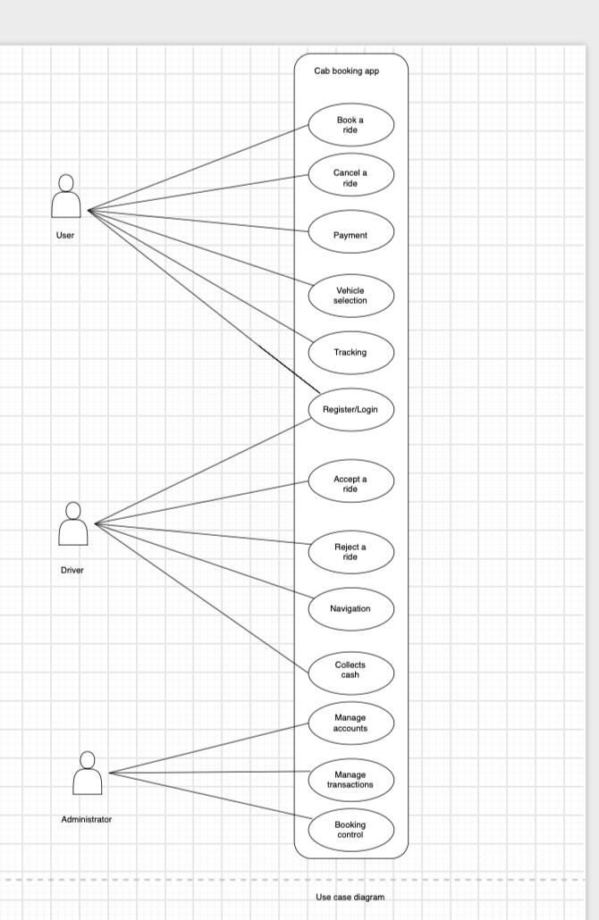
Fig. 5.1 Use Case Diagram

5.2 Use Case Descriptions
Here are the main use cases from the diagram in a bit more detail.
Use Case | Actor | Main Flow | Alternate Flow
UC-01: Register / Login | User, Driver | Enter name, phone and password → get an OTP → enter it → logged in | Wrong OTP: ask for a new one. Number already used: log in instead.
UC-02: Book a Ride | User | Enter pickup and drop → pick a vehicle → confirm → driver assigned → ride starts after the OTP | No driver accepts within 2 minutes: the user is told no cab is available.
UC-03: Cancel a Ride | User | Tap Cancel → pick a reason → rules checked → booking cancelled | Cancelled late: Rs. 50 is added to the next ride.
UC-04: Accept / Reject a Ride | Driver | See the request → tap Accept → user gets the driver's details → drive to pickup | Rejected or no reply: the request goes to the next driver.
UC-05: Make Payment | User, Driver | See the fare → choose a method → pay, or the driver marks cash → receipt | Payment fails: try again or pay in cash.
UC-06: Manage Accounts | Admin | Open users or drivers → check documents → approve or block | Unclear documents: the driver uploads them again.

5.3 Ride Status Flow
A booking moves through these statuses, and both the user and the driver can see the current one.
Status | Meaning
Requested | Booking confirmed, looking for a driver
Driver Assigned | A driver accepted and is on the way
Arrived | The driver is at the pickup point and waiting time starts
In Progress | OTP checked and the ride is going on
Completed | Ride ended and the fare is calculated
Paid | Payment received
Cancelled | Cancelled before the ride started
No Driver Found | Nobody accepted before the timeout

5.4 Activity Diagram: Booking a Ride
This is the user's side: checking if they're registered, entering the locations, waiting for a driver, then tracking the ride, paying and giving feedback.
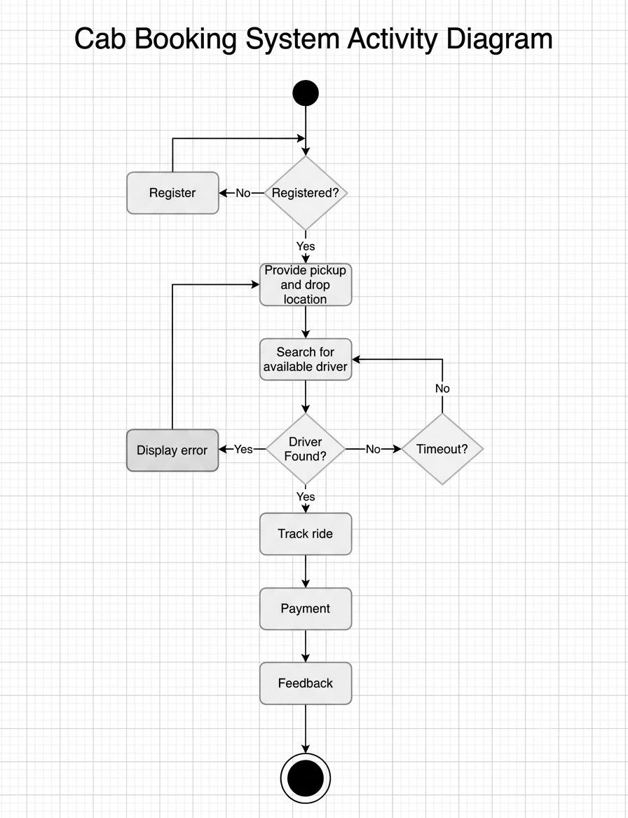
Fig. 5.2 Activity Diagram (User: booking a ride)

5.5 Activity Diagram: Handling a Ride
This one shows the driver's side, from going online and accepting a request to collecting the fare and going offline.
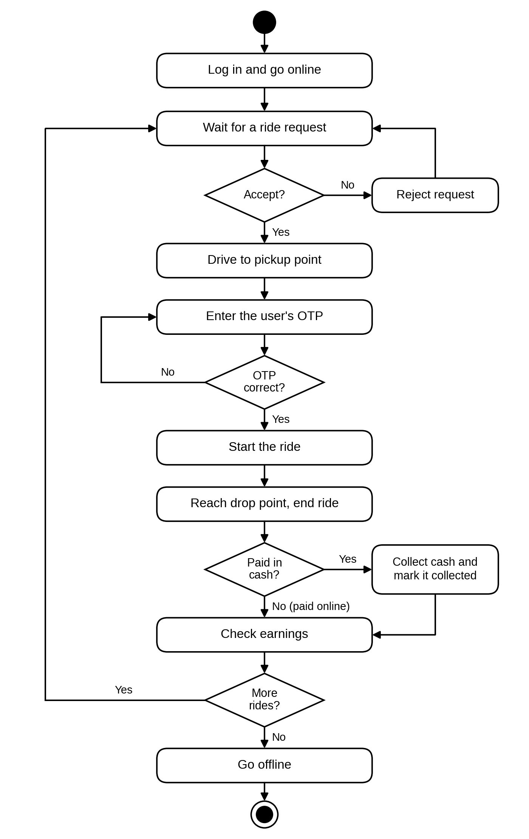
Fig. 5.3 Activity Diagram (Driver: handling a ride)

5.6 Data Flow Diagrams (DFD 0 and DFD 1)
DFD 0 treats the whole system as one process that talks to the User and the Driver. DFD 1 splits it into five processes (registration, booking, ride, driver and payment management) and shows where each one stores its data.
DFD 0 — Context Level
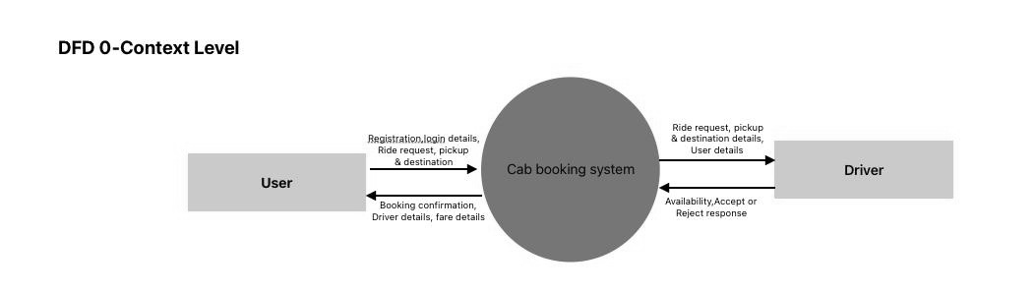
Fig. 5.4 DFD Level 0 (Context Diagram)
DFD 1 — Level 1
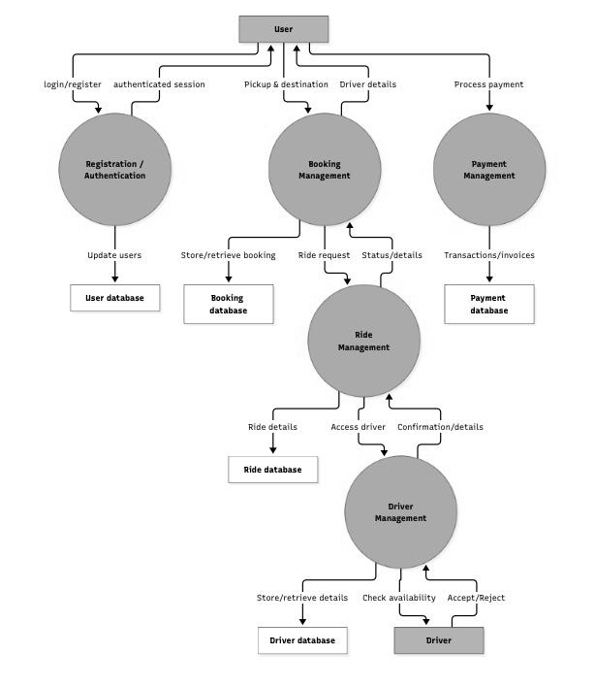
Fig. 5.5 DFD Level 1

5.7 DFD Level 2: Ride Management
DFD 2 zooms into Ride Management, the busiest process in DFD 1. We numbered it as process 4, so its parts are 4.1 to 4.5. It shows how a ride request turns into an assigned driver, then a started ride and finally a completed ride with a fare. Its inputs and outputs match the ones Ride Management has in DFD 1.
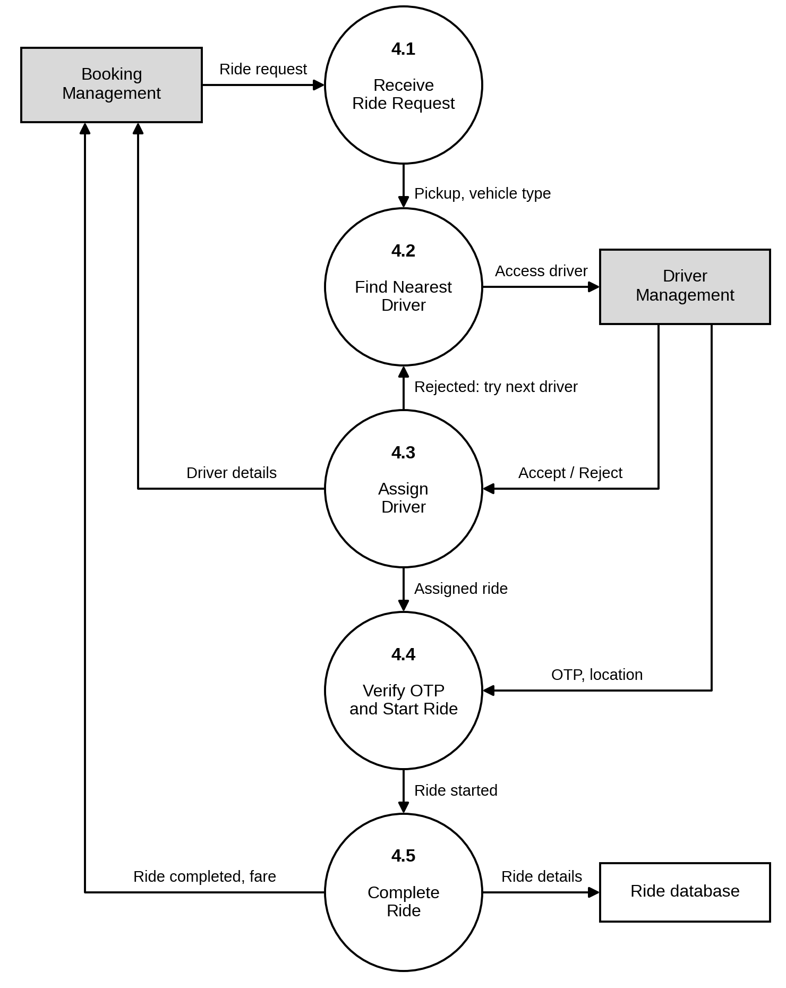
Fig. 5.6 DFD Level 2 (Ride Management)

6. Database Design

6.1 Tables
We need seven tables. Five of them match the data stores in DFD 1, and Vehicles and Ratings are extra. IDs are auto-generated, money is stored as NUMERIC(8,2) and times as TIMESTAMP.
Table | Main Fields | Stores
Users | user_id (PK), name, phone, email, password_hash, role | Riders and admins
Drivers | driver_id (PK), name, phone, licence_no, status, is_online, location, avg_rating | Driver profiles and live status
Vehicles | vehicle_id (PK), driver_id (FK), vehicle_no, type, model | Each driver's car or auto
Bookings | booking_id (PK), user_id (FK), pickup, drop, vehicle_type, estimated_fare, status | Ride requests
Rides | ride_id (PK), booking_id (FK), driver_id (FK), ride_otp, start_time, end_time, distance_km, final_fare, status | Actual trips
Payments | payment_id (PK), ride_id (FK), amount, method, status, transaction_ref | Payments and receipts
Ratings | rating_id (PK), ride_id (FK), stars, comment | Feedback on drivers

6.2 Relationships
- A user can make many bookings (1 : N).
- A booking becomes at most one ride (1 : 1).
- A driver has one vehicle (1 : 1) and does many rides (1 : N).
- A ride has one payment and at most one rating (1 : 1).

7. Testing

7.1 Test Cases
ID | Test | What We Do | What Should Happen
TC-01 | Sign up | Enter correct details and OTP | Account created and logged in
TC-02 | Wrong OTP | Enter a wrong OTP 3 times | Blocked until a new OTP is sent
TC-03 | Fare estimate | Pick two places 10 km apart | Fare and ETA for every vehicle
TC-04 | Same pickup and drop | Enter the same place twice | Booking not allowed
TC-05 | Book a ride | Book with drivers nearby | Nearest driver assigned
TC-06 | No drivers | Book when all drivers are offline | "No cab available" after 2 minutes
TC-07 | Driver rejects | Driver taps Reject | Request goes to the next driver
TC-08 | Wrong ride OTP | Driver types a wrong OTP | Ride doesn't start
TC-09 | Late cancel | Cancel after the driver arrives | Rs. 50 fee added
TC-10 | Payment fails | Gateway returns an error | Retry or pay cash, no double charge
TC-11 | Rate driver | Give 4 stars | Average rating updated
TC-12 | Blocked driver | A blocked driver logs in | Access denied

7.2 Requirement Traceability
This links each requirement to its use case and the tests that check it, so nothing is left untested.
Area | Requirements | Use Case | Test Cases
Sign up and login | FR-01, FR-03 | UC-01 | TC-01, TC-02
Fare estimate | FR-04, FR-05 | UC-02 | TC-03, TC-04
Booking and matching | FR-06, FR-08 | UC-02 | TC-05, TC-06
Accept / reject | FR-09 | UC-04 | TC-07
Ride OTP | FR-10 | UC-02 | TC-08
Cancellation | FR-07 | UC-03 | TC-09
Payment | FR-12, FR-13 | UC-05 | TC-10
Rating | FR-14 | UC-05 | TC-11
Admin approval | FR-02, FR-16 | UC-06 | TC-12

8. Risk Analysis
Risk | Effect | How We Handle It
Payment gateway down | Can't pay online | Cash still works, and unpaid rides can be paid later from history.
Rush-hour load | Slow or crashing server | A load balancer and auto-scaling on the cloud.
Driver doesn't show up | User is left waiting | Free cancellation after 10 minutes. Drivers who do this often get fewer requests.
Fake bookings | Drivers waste time and fuel | Cancellation fee, and the admin blocks repeat offenders.
Internet drops mid-ride | Tracking stops | The driver's app keeps the GPS points and sends them later, so the fare is still right.

9. Future Scope
- Ride sharing, so people going the same way can split the fare.
- Separate Android and iOS apps.
- Electric cabs, with nearby charging points shown to drivers.
- Safety features like an SOS button and live trip sharing.
- Using past ride data to predict busy areas and send drivers there early.

10. Conclusion
This SRS sums up what our cab booking app needs to do and how it should behave. The requirements, diagrams, database design and test cases together give us a clear plan for building the app, and a checklist to test the finished version against.

11. References
- IEEE Std 830-1998, IEEE Recommended Practice for Software Requirements Specifications
- Roger S. Pressman, Software Engineering: A Practitioner's Approach
- PostgreSQL Documentation, www.postgresql.org/docs
- developers.google.com/maps
- www.geeksforgeeks.org

