# Git Code Location

<https://github.com/nehalankala-1442/ExchangeRateAddIn/tree/master/ExchangeRate/ExchangeRate>

# Pre-Requisites

1. MS-Office should be installed to verify this add-in
2. This add-in is tested for 64-bit OS

# Code Design

1. Created an UDF ‘Exchange’ using c# class library

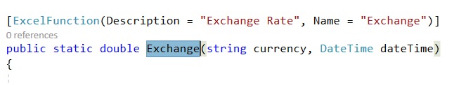

1. Structure of solution

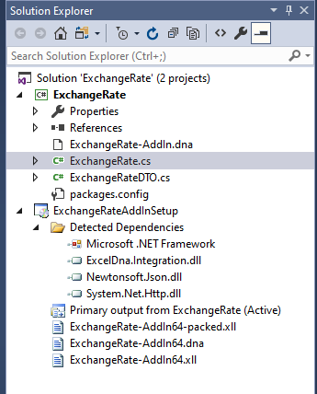

1. Used External DLL ‘Excel-DNA’ for creating XLL file
2. Used ‘https://api.ratesapi.io/api/’ for fetching exchange rates
3. Used External DLL ‘Newtonsoft.JsON’ for Serializing and deserializing JSON objects
4. Created an installer for 64-bit, and can be installed on any machine
5. Excel-DNA is an independent project to integrate .NET into Excel. For reference [Excel-DNA](https://archive.codeplex.com/?p=exceldna)

# Steps for Installation

1. Installer location: <https://github.com/nehalankala-1442/ExchangeRateAddIn/blob/master/ExchangeRate/ExchangeRateAddInSetup/Release/ExchangeRateAddInSetup.msi>
2. Download and Click on the setup file ‘ExchangeRateAddInSetup’ on respective machine

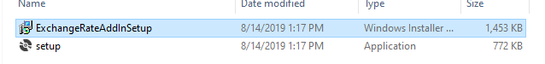

1. Following screen will be opened

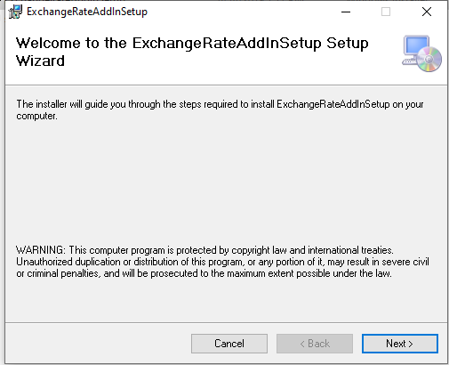

1. Click on ‘Next’ and following screen will be opened

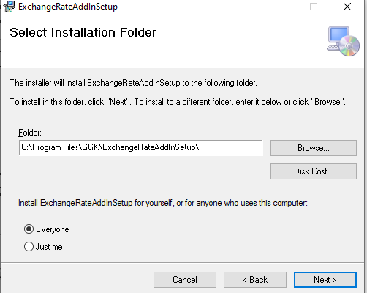

1. Select the location, where you want to install this add-in. Also, select the users for whom, the add-in should be installed.
2. Click on ‘Next’ and confirm Installation screen appears

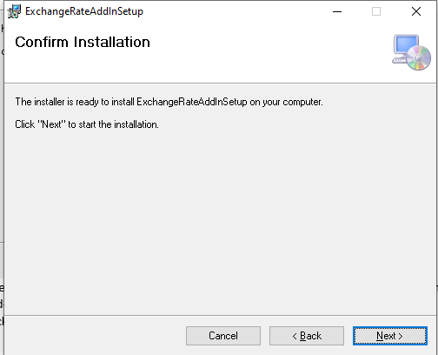

1. Click on Next and the installation starts
2. Once, installation is complete, following screen appears

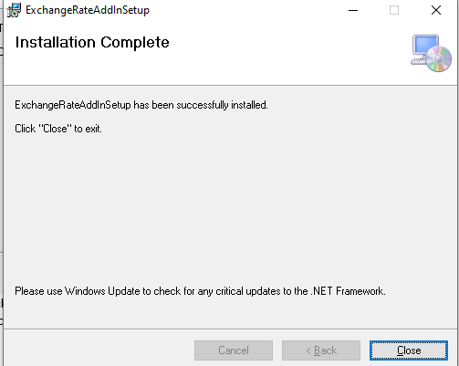

1. Close the screen and you are ready to use the add-in in Excel

# Steps for adding ‘ExchangeRate’ add-in to Excel

1. Open Excel in respective machine
2. Click on ‘File’ from menu and then click on ‘Options’

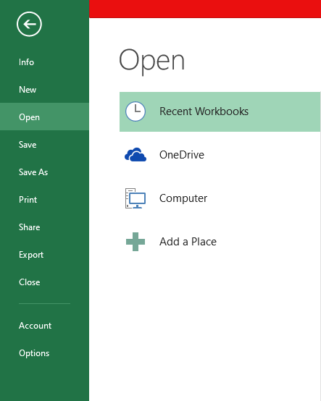

1. Click on ‘Add-Ins’ and following screen will be opened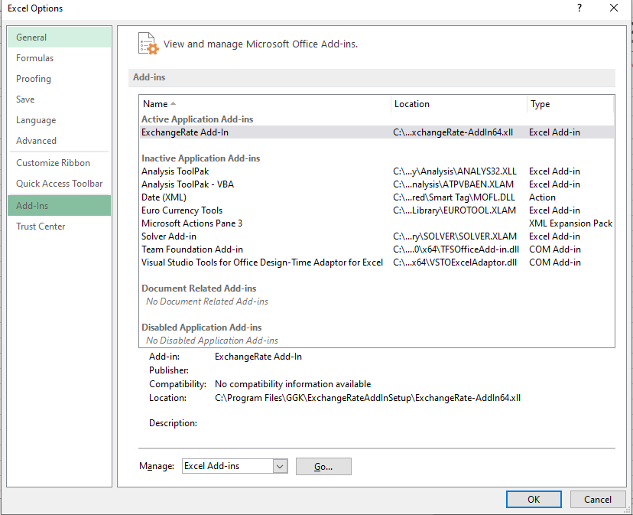
2. Click on ‘Go’. ‘Add-in’ screen will be opened. Browse the location of add-in and select ‘ExchangeRate-AddIn64’ file.
3. The file will be located at following location ‘C:\Program Files\GGK\ExchangeRateAddInSetup’
4. The Add-in will appear in Add-in’s list

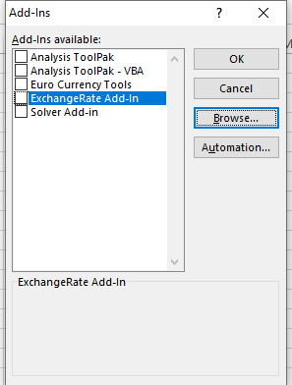

1. Select the ‘ExchangeRate Add-In’ and click ‘OK’
2. Once the Excel workbook is opened, type function name, and you will be ready to use it

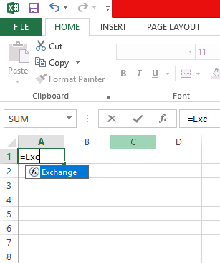

# Function Syntax

Function Name: Exchange

Parameters:

1. Currency: Currency name, for which the exchange rate to be displayed

Validation: The currency should be of minimum 3 characters ex., USD

1. Date(Optional): Date, for which exchange rate is required

Validation: should be in proper date format ex., YYYY-MM-DD or YYYY/MM/DD etc

If not supplied, current date will be considered

Examples:

1. =Exchange("GBP","2019-01-18")
2. =Exchange("USD")

# Error

In case of errors, following screen will be displayed

