SERVERLESS ARCHITECTURE USING AWS FOR FINTRACKER: A PERSONAL FINANCE TRACKING SYSTEM

Prepared in partial fulfillment of the Summer Internship Program on AWS

AT



Under the guidance of

Mrs. Sumana Bethala, APSSDC
Mr. Lovababu, APSSDC
Submitted by
MEKA NEHA LATHA,24BQ1A42K9,VVIT NAMBUR,(Batch-1)
MANNAVA YUVA RAM,24BQ1A42K4,VVIT NAMBUR,(Batch-1)
M.pavana Pranathi,24bQ1A42l8,VVIT NAMBUR,(Batch-1)
Vissamsetti Navya sri,24BQ1A54I6,VVIT NAMBUR,(Batch-1)
Bonthada Bhavana,24BQ1A0554,VVIT NAMBUR,(Batch-1)

ACKNOWLEDGEMENT

I would like to express my heartfelt gratitude to all those who have contributed to the successful completion of my summer internship project at Andhra Pradesh Skill Development Corporation (APSSDC). This opportunity has been an enriching and transformative experience for me, and I am truly thankful for the support, guidance, and encouragement I have received along the way.
First and foremost, I extend my sincere regards to Mrs Sumana Bethala and Mr Anil Kumar Varanasi, my supervisors and mentors, for providing me with valuable insights, constant guidance, and unwavering support throughout the duration of the internship. Their expertise and encouragement have been instrumental in shaping the direction of this project.
I would like to thank the entire team at Andhra Pradesh Skill Development Corporation (APSSDC) for fostering a collaborative and innovative environment. The camaraderie, knowledge sharing, and feedback I received from my colleagues significantly contributed to the development and success of this project.
In conclusion, I am honoured to have been a part of this internship program, and I look forward to leveraging the skills and knowledge gained to contribute positively to future endeavours.
Thank you. Sincerely,
Meka Neha Latha,24BQ1AA42K9,nehalatha31@gmail.com,
Mannava Yuva Ram,24BQ1A42K4,yuvaram127@gmail.com,
M pavana Pranathi,24bq1a42l8,mulugupranathi@gmail.com,
Vissamsetti Navya sri,24BQ1A54I6,vissamsettinavyasri@gmail.com,
Bonthada Bhavana,,24BQ1A0554,bonthada2006@gmail.com.

ABSTRACT
This project presents the design and implementation of FinTracker, a serverless personal finance tracking system built on Amazon Web Services (AWS) that helps individuals plan and monitor their monthly salary, expenses, and savings without manual spreadsheets. The goal is to leverage serverless computing to build a scalable, secure, and event-driven solution that removes the overhead of managing infrastructure while giving users a clear, real-time view of their finances.
At the start of each month, the user records their salary, a savings goal, and a set of expense categories (such as rent, food, travel, and bills) through a web front end. These requests are routed through Amazon API Gateway to AWS Lambda functions, which validate the data and store it in Amazon DynamoDB. As the month progresses, the user logs individual expenses against these categories, again through the same API-driven flow. At the end of the month, a Lambda function aggregates the stored records to generate a summary that compares planned figures against actual spending and savings.
The system is fully serverless, using API Gateway for request routing, Lambda for all business logic, DynamoDB for fast NoSQL storage of financial records, S3 for storing exportable monthly reports, and IAM for enforcing least-privilege access between services. Amazon CloudWatch is used to monitor Lambda executions and troubleshoot issues.
By automating data capture and providing on-demand, month-end insight into spending patterns, FinTracker reduces the manual effort and errors associated with traditional budgeting methods and demonstrates how a modern serverless architecture on AWS can be applied to a practical, everyday personal-finance problem. The report also outlines directions for future enhancement, including a mobile client, spending analytics dashboards.

TABLE OF CONTENTS

No Content Pg.No

- Introduction 5
- Methodology 6
- Technology Stack 8
- System Design / Architecture 9
- Implementation 12
- Results 14
- Conclusion 15

INTRODUCTION

Managing personal finances well requires consistent tracking of income, spending, and savings — something most people attempt with spreadsheets or notebooks and quickly abandon because it takes ongoing manual effort. This project, titled FinTracker, applies serverless computing on Amazon Web Services (AWS) to deliver a lightweight, automated, and scalable system for tracking monthly salary, categorized expenses, and savings goals, removing the friction that causes manual budgeting habits to fail.
At the start of every month, users typically know their salary and have a rough plan for expenses and savings, but rarely revisit that plan until the month is already over — by which point it is too late to course-correct. FinTracker addresses this gap by giving users a simple way to record their monthly plan up front, log expenses as they occur under clear categories such as rent, food, travel, and bills, and receive an accurate month-end summary comparing what was planned against what actually happened.
The system is built entirely on managed, serverless AWS services. A user interacts with a web front end that calls a REST API exposed through Amazon API Gateway. Each API call triggers an AWS Lambda function that contains the relevant business logic — creating a new month's budget, recording an expense, or generating a summary. All financial records are stored in Amazon DynamoDB, a fast and flexible NoSQL database well suited to per-user, per-month, per-category records. Generated monthly reports can be exported and stored in Amazon S3 for the user's records.
What makes this approach attractive is the complete absence of server provisioning or capacity planning. Each Lambda function runs only when invoked, scaling automatically with usage and incurring cost only for actual requests processed. AWS Identity and Access Management (IAM) governs every interaction between services under the principle of least privilege, and Amazon CloudWatch provides visibility into function executions, errors, and performance for ongoing monitoring.
This report documents the methodology, technology stack, system architecture, implementation details, and results of the FinTracker project, and closes with a discussion of possible future enhancements such as a mobile client, visual spending analytics

METHODOLOGY

The development of FinTracker followed a structured, iterative methodology spanning requirements gathering, system design, implementation, testing, deployment, and refinement. Each phase was aligned with best practices for cloud-native, serverless development. The following subsections describe each phase in detail.

Requirements Gathering

The project began with an analysis of the core problem: individuals lack a simple, low-effort way to plan a monthly budget and track it consistently. Discussions around common personal-finance pain points shaped the core requirements — the ability to record salary and a savings goal at the start of a month, log expenses under categories throughout the month, and view an accurate planned-versus-actual summary at month end, all without any server management.

Design
Based on these requirements, an event-driven, cloud-native architecture was designed using AWS managed services. Amazon API Gateway was chosen as the entry point for all client requests, AWS Lambda for the processing logic, Amazon DynamoDB for data storage, and Amazon S3 for storing exported monthly reports. IAM roles were planned up front to keep every service-to-service interaction scoped to the minimum permissions required, and the components were deliberately decoupled to support independent scaling and easier maintenance.

2.3 .Implementation Planning
The implementation phase translated the design into working Lambda functions behind API Gateway endpoints. Separate functions were planned for creating a month's budget, adding an expense entry, and generating the month-end summary, each mapped to its own API route and IAM execution role. All logic was implemented in Python using the AWS SDK (Boto3) to interact with DynamoDB.

Database Management
A NoSQL approach was adopted for fast, flexible storage using Amazon DynamoDB. The table schema was designed around a per-user, per-month partition so that all records for a given user and month — salary, savings goal, category budgets, and individual expense entries — can be retrieved efficiently in a single query. Attribute-level validation is performed inside each Lambda function before any write, to keep the stored data consistent.

Testing
Testing was carried out at multiple levels. Unit-level checks inside each Lambda function validated input parsing, data validation, and summary calculations. Integration testing confirmed that API Gateway, Lambda, and DynamoDB worked together correctly end to end. Functional testing simulated a full monthly cycle — creating a budget, logging a series of expenses, and generating a summary — to confirm the numbers reconciled correctly.

Deployment
The system was deployed on AWS using the console and CLI tooling. IAM roles were configured with least-privilege policies scoped to each Lambda function's actual needs. Environment variables were used to keep configuration (such as table names) separate from code. Amazon CloudWatch was set up to capture logs and metrics for every function invocation, supporting fast troubleshooting during development.

2.7.Iterative Refinement

Throughout development, feedback loops were used to refine validation rules, summary formatting, and error handling. The architecture was periodically reviewed against serverless best practices to keep the system maintainable and ready for future enhancements such as a dashboard .

TECHNOLOGY STACK

FinTracker was built using a modern, cloud-native technology stack that supports event-driven request handling, real-time data access, and automatic scaling. The following technologies and services were used throughout the implementation.

Cloud Platform
    - Amazon Web Services (AWS): the entire system is hosted on AWS, using managed serverless services for API hosting, computation, database management, and storage.

AWS Services
    - Amazon API Gateway: exposes secure REST endpoints that the front end calls to create budgets, log expenses, and fetch summaries.
    - AWS Lambda: executes all business logic — validating input, reading and writing DynamoDB records, and computing month-end summaries.
    - Amazon DynamoDB: a fully managed NoSQL database that stores salary, category, and expense records per user and month.
    - Amazon S3: stores exported monthly reports and statements generated by the system.
    - AWS IAM (Identity and Access Management): defines least-privilege roles and policies that control access between services.
    - Amazon CloudWatch: monitors Lambda execution, captures logs, and supports debugging and performance tracking.

Programming C Scripting
    - Python 3.12 (Lambda runtime): used to implement all serverless backend logic.
    - Boto3 SDK: the AWS SDK for Python, used within Lambda functions to interact with DynamoDB and S3.

Data Format
    - JSON: used as the request/response format for all REST API calls between the client and API Gateway.

Security C Access
    - IAM Roles and Policies: configured so each Lambda function can access only the specific DynamoDB table and S3 bucket it needs, following the principle of least privilege.

Monitoring & Logging
    - CloudWatch Logs: captures execution logs from every Lambda invocation for tracking and troubleshooting.
    - CloudWatch Metrics: provides real-time data on function invocations, errors, and duration.

SYSTEM DESIGN / ARCHITECTURE

FinTracker is designed as an event-driven, cloud-native solution that automates monthly budget tracking and expense monitoring. The architecture follows a serverless model to ensure scalability, minimal infrastructure maintenance, and cost efficiency, structured as a multi-tier design comprising a client layer, an API layer, processing logic, and a data storage layer, all backed by managed AWS services. This section outlines the core components and their inter actions.

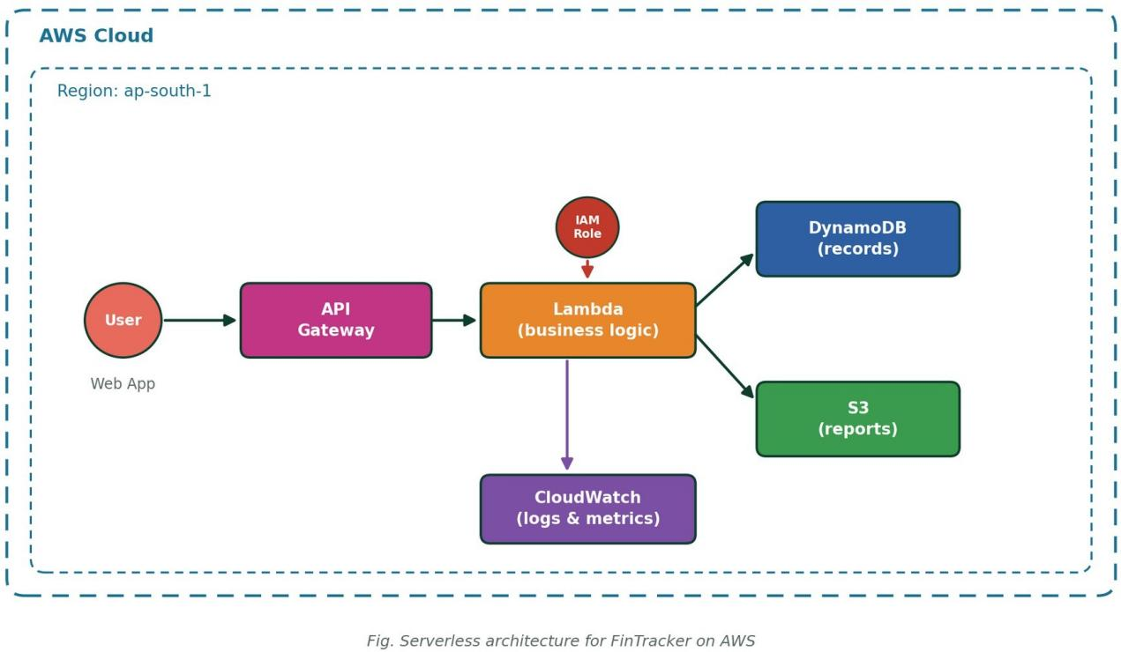

Client Layer – Web Application
The user interacts with a web-based front end where they enter their monthly salary, savings goal, and expense-category budgets at the start of the month, and log individual expenses as they occur. All actions are sent as authenticated REST requests to the backend.

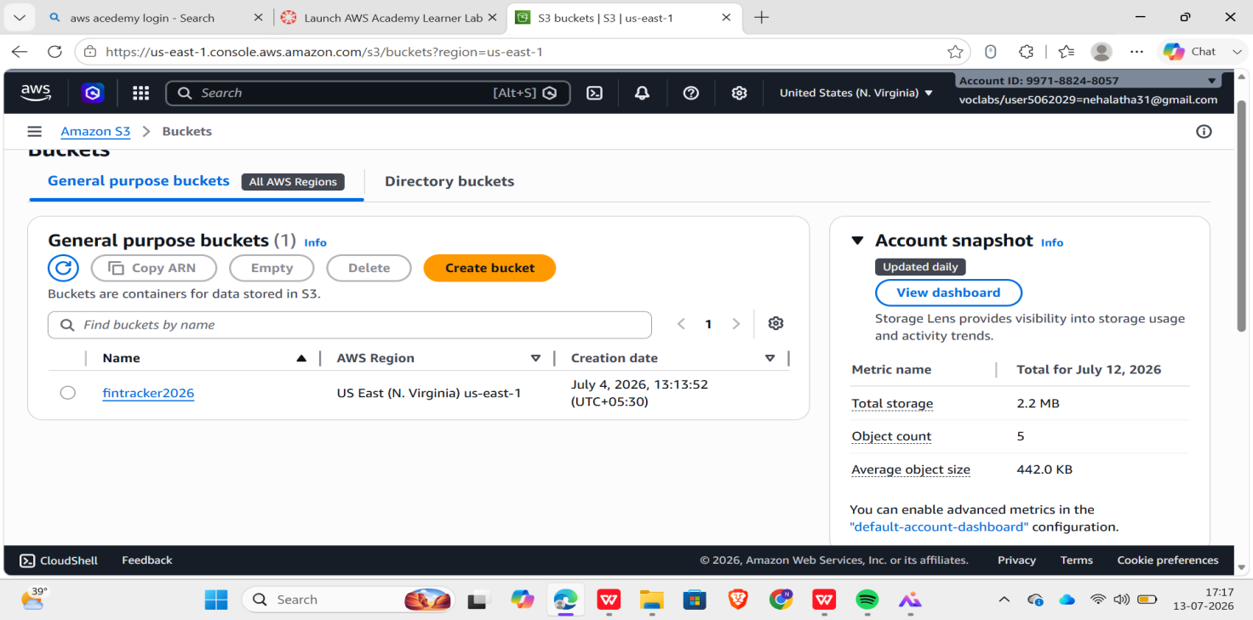

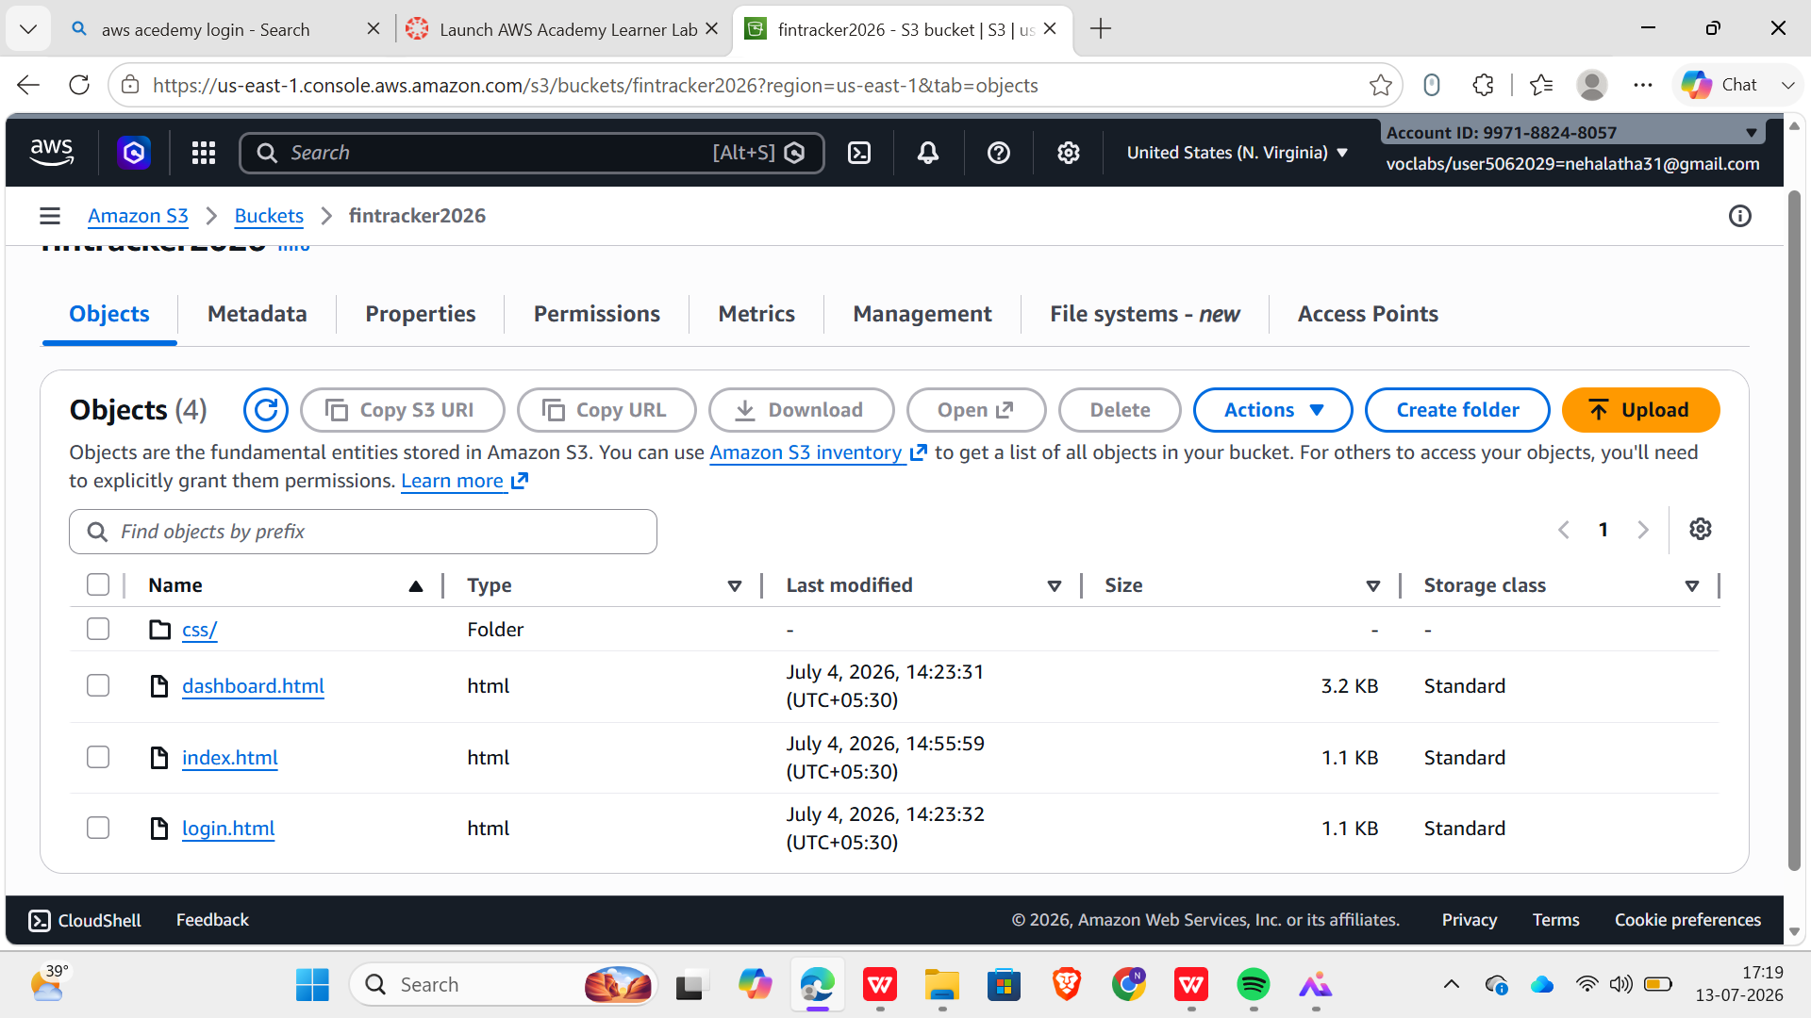

Figure 2.csv file uploaded into s3 bucket

API Layer – Amazon API Gateway
Amazon API Gateway exposes a REST API with routes for creating a monthly budget, logging an expense, and retrieving a month-end summary. Each route is mapped to its own Lambda function, and API Gateway handles request validation, throttling, and routing before invoking the backend.
    - POST /budget – creates the salary, savings goal, and category budgets for a new month
    - POST /expense – logs a new expense entry against a category
    - GET /summary/{month} – returns the planned-vs-actual summary for a given month

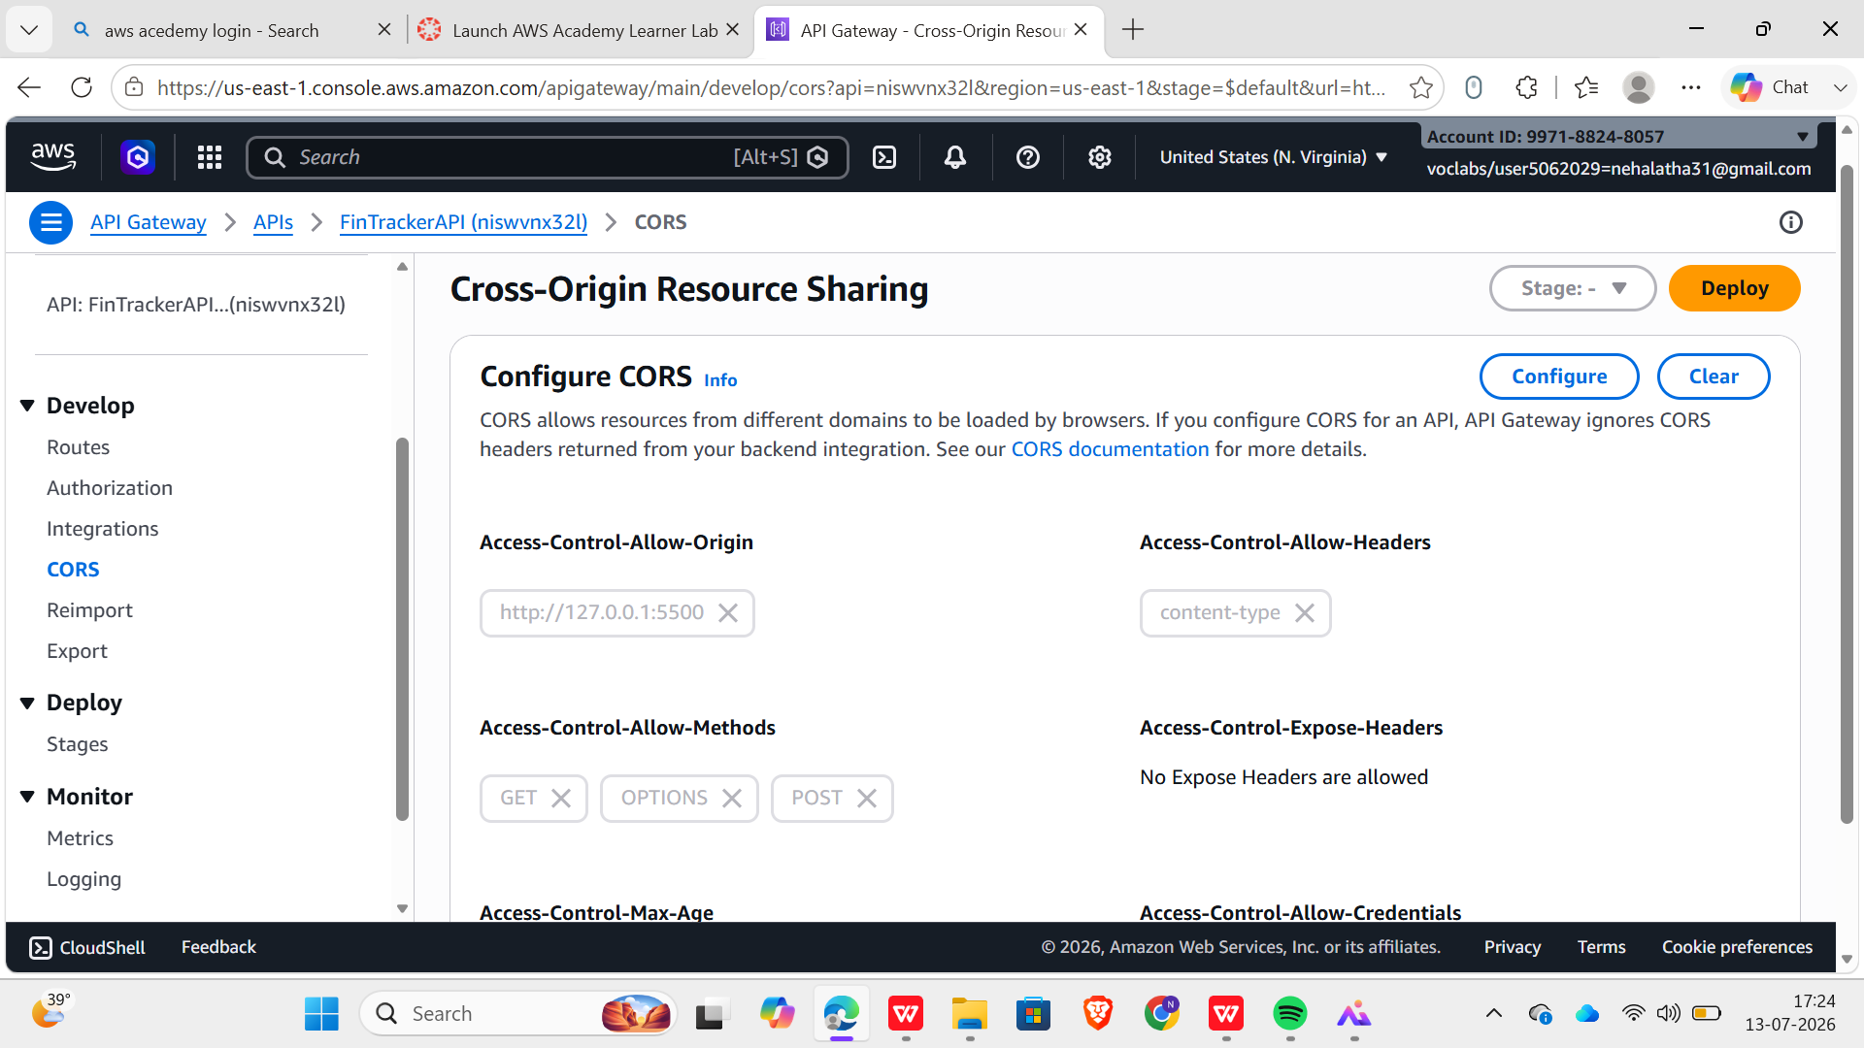

4.3.Processing Logic – AWS Lambda
AWS Lambda functions, written in Python, are triggered by API Gateway. These functions validate incoming data, read and write DynamoDB records, and compute aggregated totals for the month-end summary — comparing planned salary, savings, and category budgets against what was actually spent and saved.

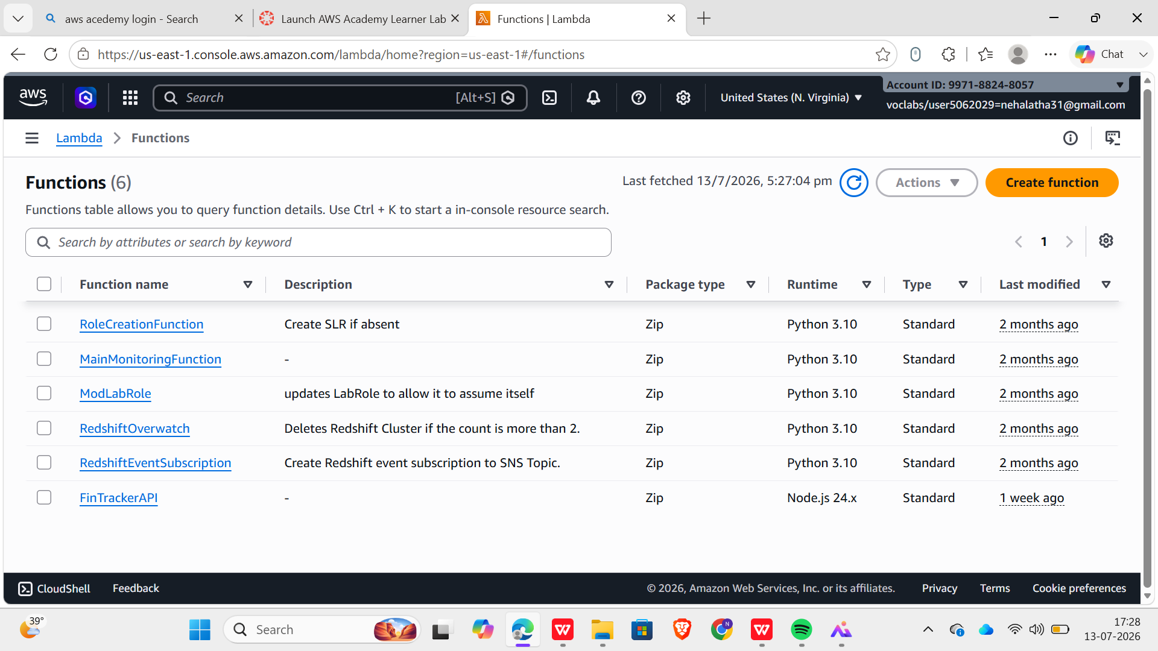

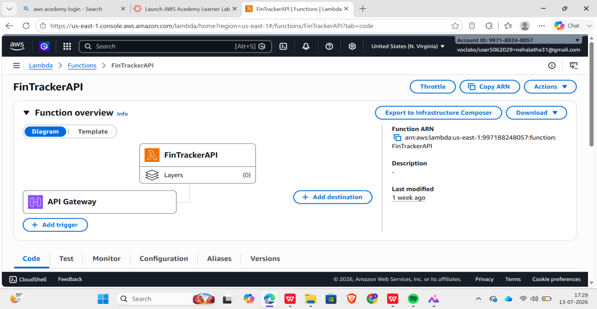

4.4.Data Storage – Amazon DynamoDB
Financial records are stored in Amazon DynamoDB, a fast, fully managed NoSQL database. Each entry includes:
    - UserId (Partition Key)
    - MonthCategory, e.g. "2026-07#Rent" (Sort Key)
    - EntryType — Salary, SavingsGoal, CategoryBudget, or Expense
    - Amount
    - Timestamp
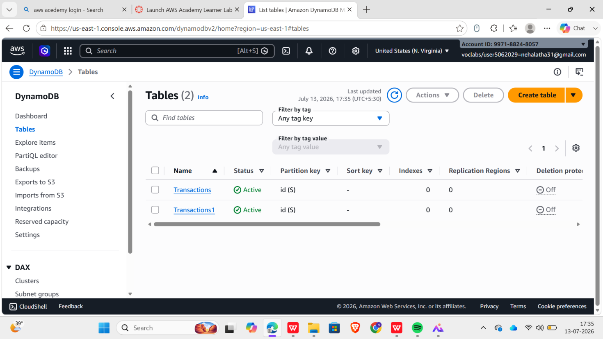

4.5.Security and Access Control – AWS IAM
AWS Identity and Access Management (IAM) is used to securely grant permissions between services:
    - Lambda functions can read and write only the FinTracker DynamoDB table
    - Lambda functions can write exported reports to the designated S3 bucket only
    - Least-privilege access policies are enforced for every role to enhance security

Monitoring and Logging – Amazon CloudWatch
Amazon CloudWatch is integrated for:
    - Real-time monitoring of Lambda execution
    - Viewing logs for debugging and error tracing
    - Setting alerts for function failures or unusual activity

IMPLEMENTATION
This section describes how each AWS service and component was configured and developed to work together as an automated, event-driven system. The implementation focused on enabling real-time budget and expense tracking, automated summary generation, and secure access — all without managing any physical servers.

DynamoDB Table Setup
A DynamoDB table, FinTrackerTable, was created with UserId as the partition key and MonthCategory as the sort key. This design allows all records for a given user and month to be retrieved in a single query, which keeps the month-end summary calculation fast even as the number of stored entries grows.

REST API with Amazon API Gateway
A REST API was configured in API Gateway with three routes — /budget, /expense, and /summary/{month}
— each integrated with its own Lambda function. Request validation was enabled at the API Gateway level to reject malformed payloads before they reach the backend.

Lambda Functions for Business Logic
Three Lambda functions (Python 3.12) implement the core logic:
    - createBudget — stores the salary, savings goal, and category budgets submitted at the start of a month
    - addExpense — validates and stores a new expense entry against a category
    - getSummary — queries all entries for a user and month, and computes totals: planned vs. actual expense per category, and salary minus total expenses vs. the savings goal
A simplified excerpt of the addExpense function is shown below:
import boto3, json, os, time
table = boto3.resource('dynamodb').Table(os.environ['TABLE_NAME']) def lambda_handler(event, context):
body = json.loads(event['body'])
user_id = event['requestContext']['authorizer']['userId'] month, category = body['month'], body['category']

table.put_item(Item={ 'UserId': user_id,
'MonthCategory': f"{month}#{category}#{int(time.time())}", 'EntryType': 'Expense',
'Amount': body['amount'],
'Timestamp': int(time.time()),
})

return {'statusCode': 200, 'body': json.dumps({'status': 'recorded'})}

IAM Roles and Security
Every Lambda function runs under its own IAM execution role, scoped only to the actions it needs. An example policy granting the addExpense function access to DynamoDB is shown below

{
"Version": "2012-10-17",
"Statement": [
{
"Effect": "Allow",
"Action": ["dynamodb:PutItem", "dynamodb:Query"],
"Resource": "arn:aws:dynamodb:<region>:<account-id>:table/FinTrackerTable"
},
{
"Effect": "Allow",
"Action": ["logs:CreateLogGroup", "logs:CreateLogStream", "logs:PutLogEvents"],
"Resource": "*"
}
]
}

Frontend Integration
The web front end calls the three API Gateway routes using standard HTTPS requests. On load, it fetches the current month's summary; when the user submits a budget or logs an expense, the corresponding route is called and the view is refreshed with the latest totals.

Monitoring with Amazon CloudWatch
Every Lambda invocation is logged to Amazon CloudWatch, capturing execution duration, errors, and custom log statements. This provided visibility during development and remains available for ongoing operational monitoring after deployment.

RESULTS
The implementation of FinTracker was tested against realistic monthly-budgeting scenarios to validate functionality, scalability, and reliability. The following results summarize the effectiveness of the serverless architecture for personal finance tracking.

Automated Monthly Budget Setup
Submitting a salary, savings goal, and category budgets through the /budget endpoint reliably created the corresponding DynamoDB records, with validation correctly rejecting incomplete or malformed submissions.

Real-Time Category-Wise Expense Tracking
Expenses logged through the /expense endpoint were immediately reflected in subsequent summary queries, confirming that the system provides an accurate, up-to-date view of spending throughout the month rather than only at month end.

Scalable Serverless Architecture
The system handled varying request volumes without manual scaling or downtime, since API Gateway, Lambda, and DynamoDB all scale automatically with demand. Testing included submitting multiple expense entries in quick succession and querying summaries for months with a large number of recorded entries, both of which were handled without performance degradation.

Secure and Controlled Service Access
Using IAM roles scoped to each Lambda function, access between services was restricted to only what each function required — confirming adherence to the principle of least privilege throughout the system.

System Monitoring and Logging
Amazon CloudWatch logs confirmed successful Lambda execution across test scenarios and provided execution-time and error data that was useful both during development and for ongoing operational monitoring.

User Experience and Functionality
From the user's perspective, the system requires only two simple actions: submitting a month's budget once at the start of the month, and logging expenses as they occur. All summary calculations happen automatically, with results available on demand — confirming the system's potential for everyday, real-world use.
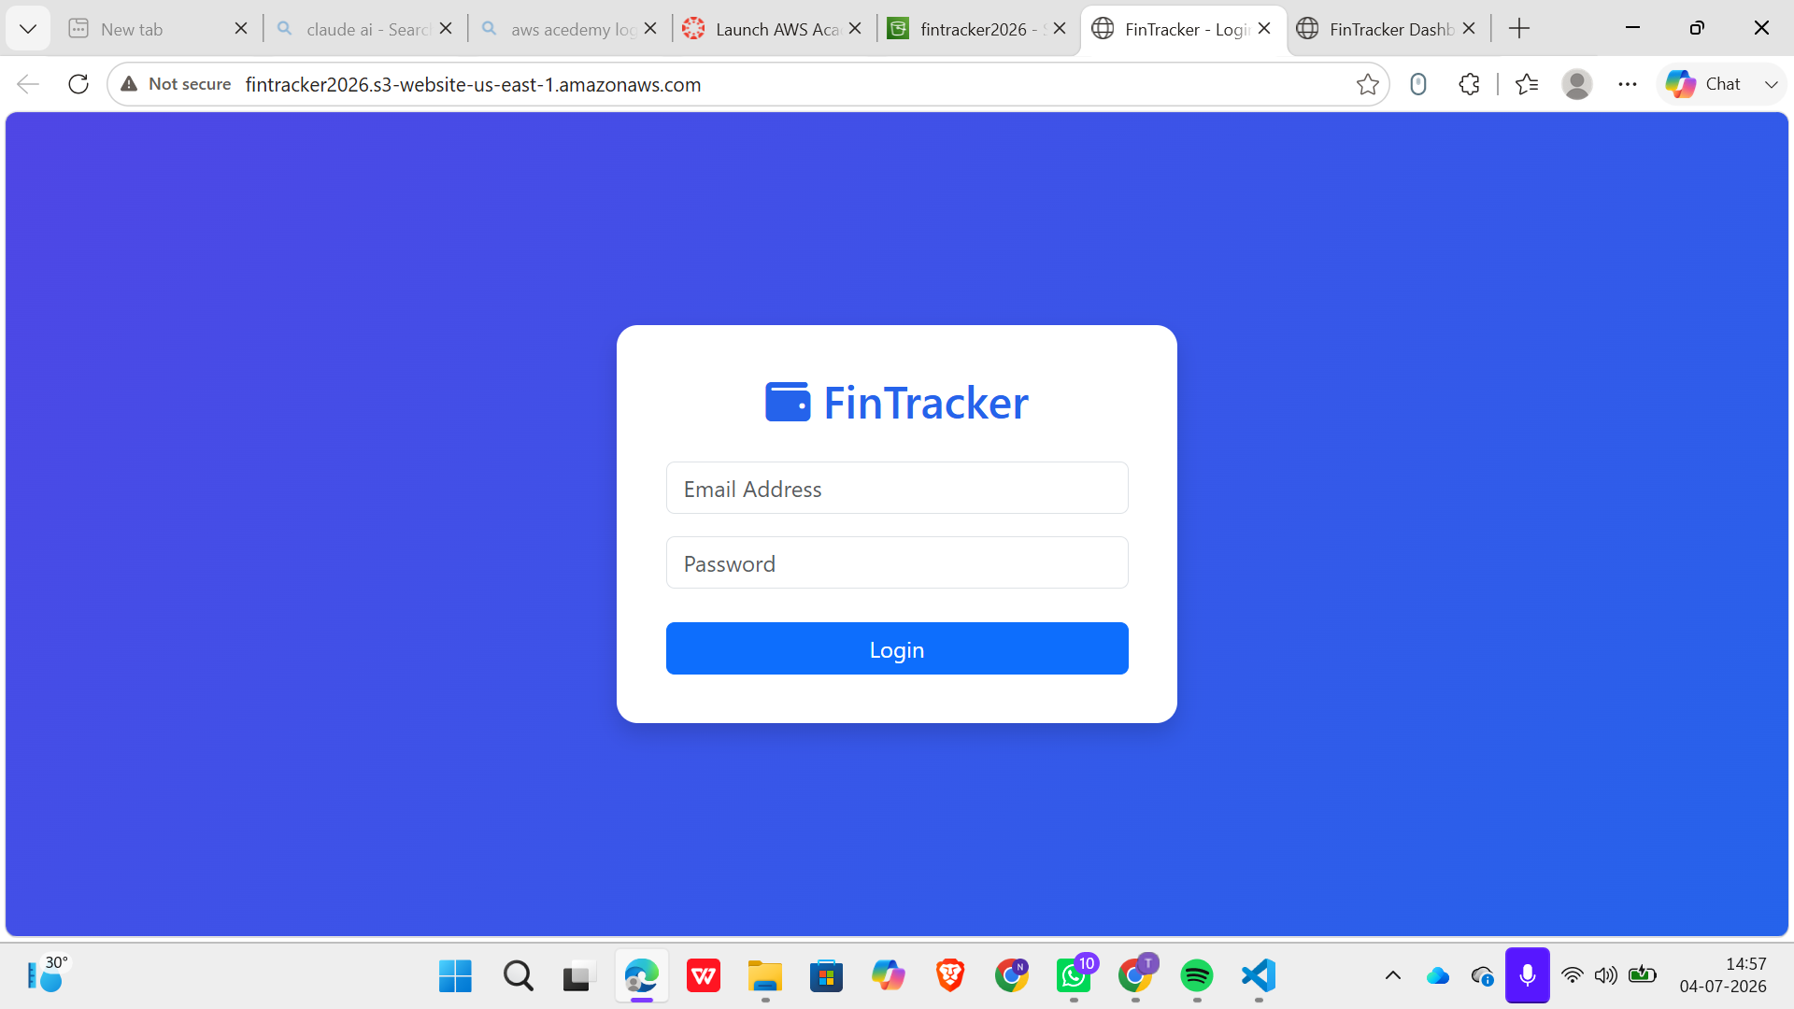
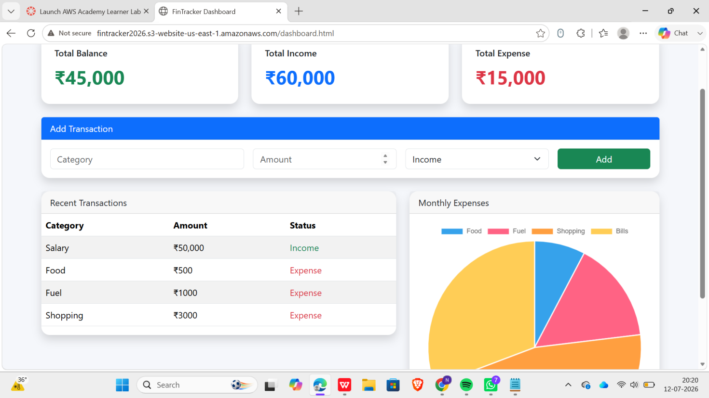

Overall, the results demonstrate that FinTracker meets its intended goals of automation, efficiency, scalability, and ease of use, providing a stable foundation for real-time personal budget tracking with clear opportunities for further enhancement.

CONCLUSION
The development of FinTracker demonstrates how a serverless, event-driven architecture on AWS can turn everyday personal-finance tracking into a simple, low-effort, and automated process. By combining Amazon API Gateway, AWS Lambda, Amazon DynamoDB, Amazon S3, and AWS IAM, the system automates monthly budget setup, expense logging, and month-end summary generation without requiring any physical server management.
The project highlights key benefits of serverless computing, including automatic scaling, cost efficiency, and reduced operational complexity. Lambda enables on-demand processing of every budget and expense action, while DynamoDB provides fast, reliable storage for financial records. Together, these services give users a clear, timely picture of where their money goes each month, supporting better saving habits and more informed financial decisions.
Throughout development, attention was given to security, performance, and modularity — with least-privilege IAM permissions, CloudWatch-based logging, and a decoupled, API-driven design. Testing confirmed the system reliably handles realistic monthly-budgeting workloads.
Beyond its current functionality, this project lays a solid foundation for future enhancements, including:
- A mobile app for on-the-go budget and expense tracking
- Push notifications reminding users to log expenses regularly
- Visual analytics and charts showing spending trends over time
- Budget when a category approaches its spending limit
In conclusion, FinTracker serves as a practical and scalable blueprint for applying serverless AWS architecture to a real, everyday problem — showing how cloud-native design can deliver an efficient, secure, and future-ready personal finance tool with minimal operational overhead.

