Practice 10.1.1
Write a Python program to remove all punctuation marks from a given string and print the resulting string.
Algorithm:-
- Start.
- Input: Read a string from the user and store it in the variable s.
- Initialization: Create an empty string variable called result to hold the filtered characters.
- Iteration (Looping): For each character ch in the input string s:
- Selection (Condition): Check if ch is an alphanumeric character (a-z, A-Z, or 0-9) OR if ch is a space.
- Action: If the condition is met, append (add) the character ch to the result string.
- Skip: If the condition is not met (e.g., it's a comma, period, or hashtag), do nothing and move to the next character.
- Output: Once the loop has finished checking every character, print the final result.
- Stop
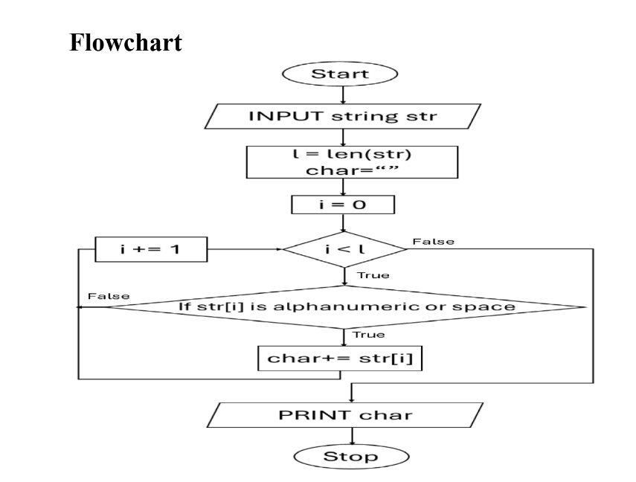

Code:-
