Practice 9.1.2
Write a Python program to take a string as input and check whether the given string is a palindrome or not. A palindrome is a string that reads the same forwards and backward.
Algorithm:-
- Start.
- Input: Accept a string from the user and store it in variable s.
- Reverse: Generate the reverse of the string s. (In the code, this is handled by the slice s[::-1]).
- Comparison: Compare the original string s with the reversed string.
- Conditional Branching:
- If the original string is equal to the reversed string, Then display "Palindrome".
- Else, display "Not a Palindrome".
- Stop.

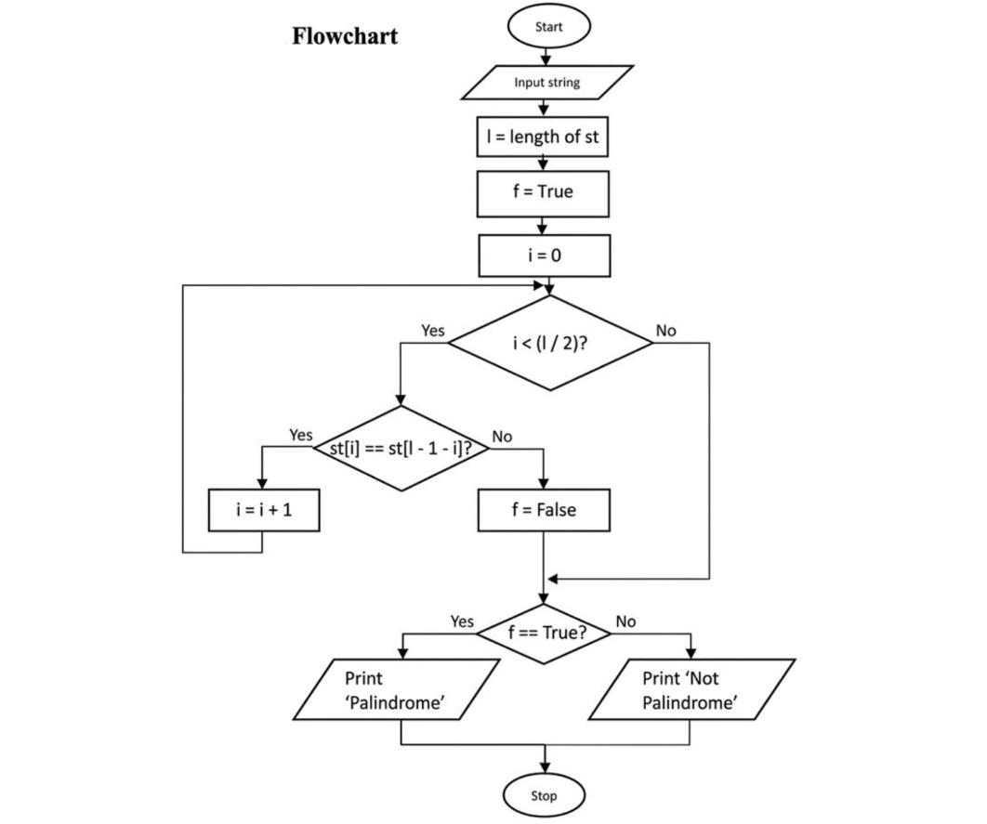
Code:-
