Practice 10.1.2
Write a Python program that prints the reverse of a given input string. The program uses a reverse_string() function that takes a string as input and returns its reversed string.
Algorithm:-
- Start.
- Define Function: Create a function named reverse_string that accepts a single parameter s.
- Inside the function:
  - Create a variable reversed_s and assign it the value of the string s reversed (using the slice s[::-1]).
  - Return the value of reversed_s back to the main program.
- Input: Prompt the user to "Enter a string" and store the input in the variable user_input.
- Function Call: Call the reverse_string function, passing user_input as the argument.
- Store Result: Assign the value returned by the function to a variable named result.
- Output Original: Display the original string stored in user_input.
- Output Reversed: Display the reversed string stored in result.
- Stop.
FlowChart:-
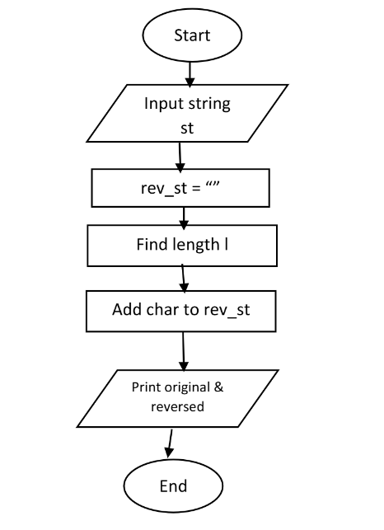

Code:-
