6.1.1 Incremented Date
Write a Python program to check if a given date is valid. If the date is valid, print the next day's date (incremented date). If the date is invalid, print 'Invalid Date'.

Algorithm
Step 1 Start
Step 2 Read day, month, year
Step 3 Check if month is between 1 and 12
Step 4 Find maximum days in month (check leap year for February)
Step 5 Check if day is valid
Step 6 If invalid display 'Invalid Date' and Stop
Step 7 day = day + 1
Step 8 If day > max days then day = 1 and month = month + 1
Step 9 If month > 12 then month = 1 and year = year + 1
Step 10 Display next date
Step 11 Stop

Flowchart
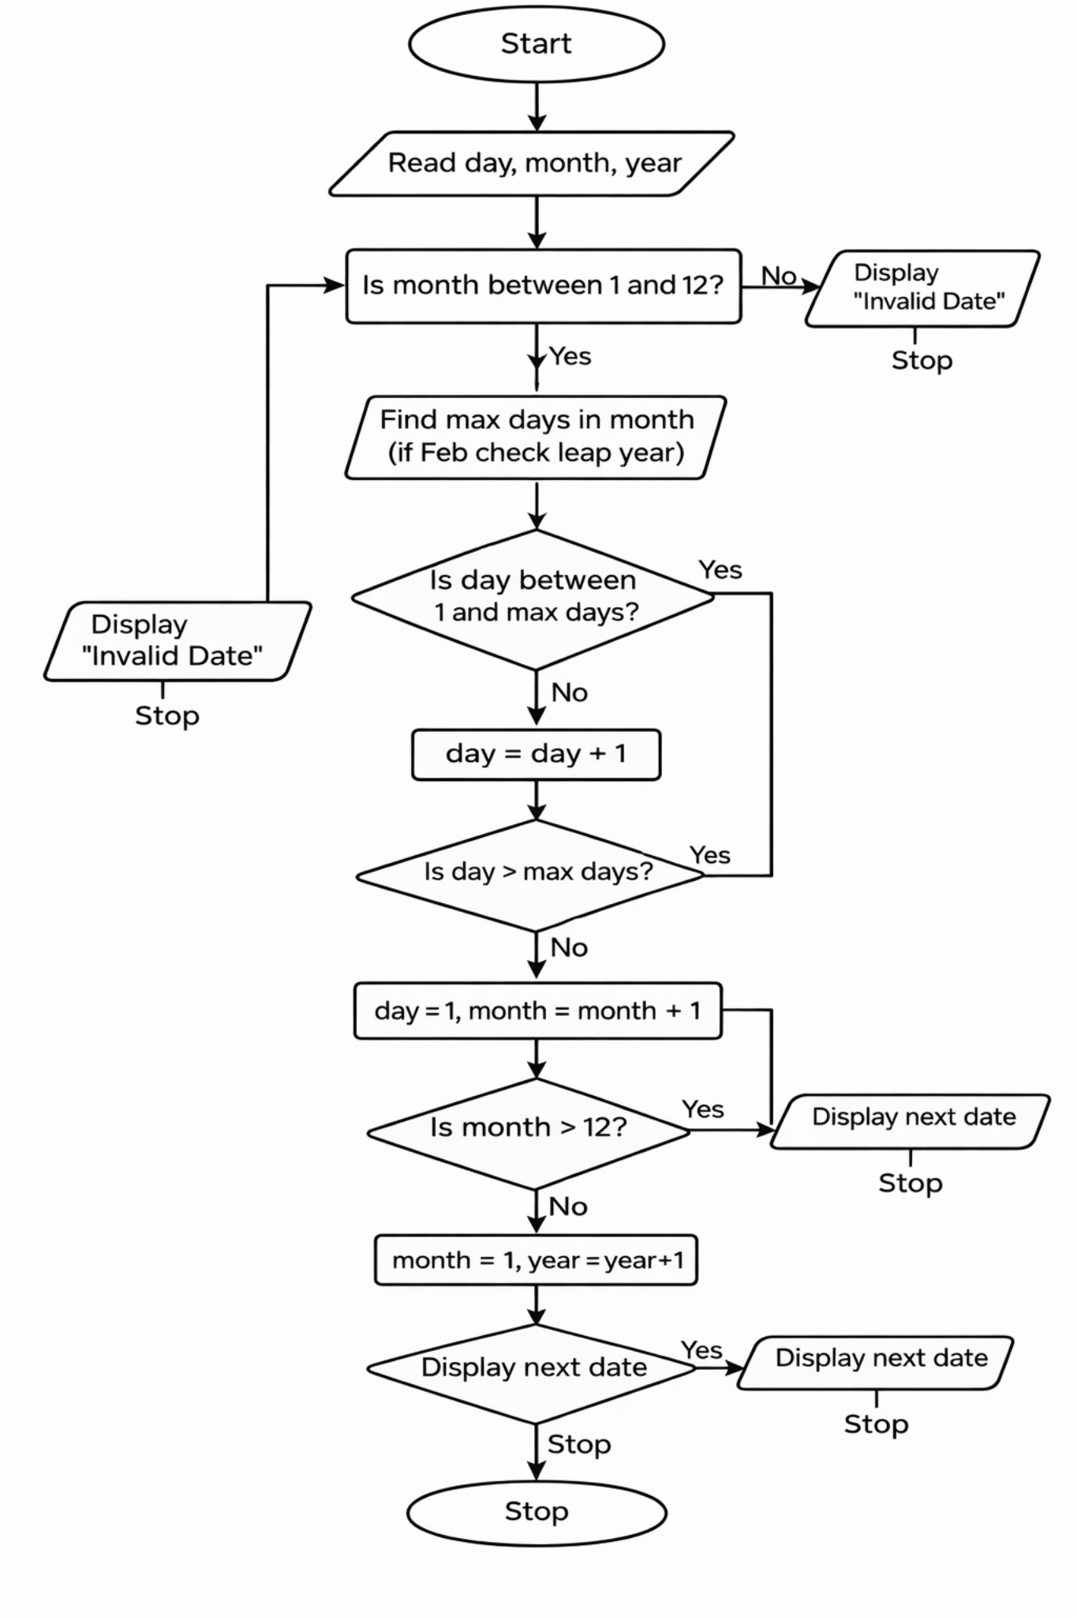

Code
