13.1.1 Write a Python program using modular programming to generate the Fibonacci sequence up to a given maximum value.
Algorithm
Step-1: Start
Step-2: Import fibonacci_module
Step-3: Input integer n from user
Step-4: Check if n > 0
Step-5: If yes, call generate_fibonacci_sequence(n)
Step-6: Store result in fib_series
Step-7: Convert elements of fib_series to string
Step-8: Join elements with space " "
Step-9: Print the Fibonacci sequence
Step-10: Else print "Please enter a positive integer"
Step-11: Stop
Flowchart
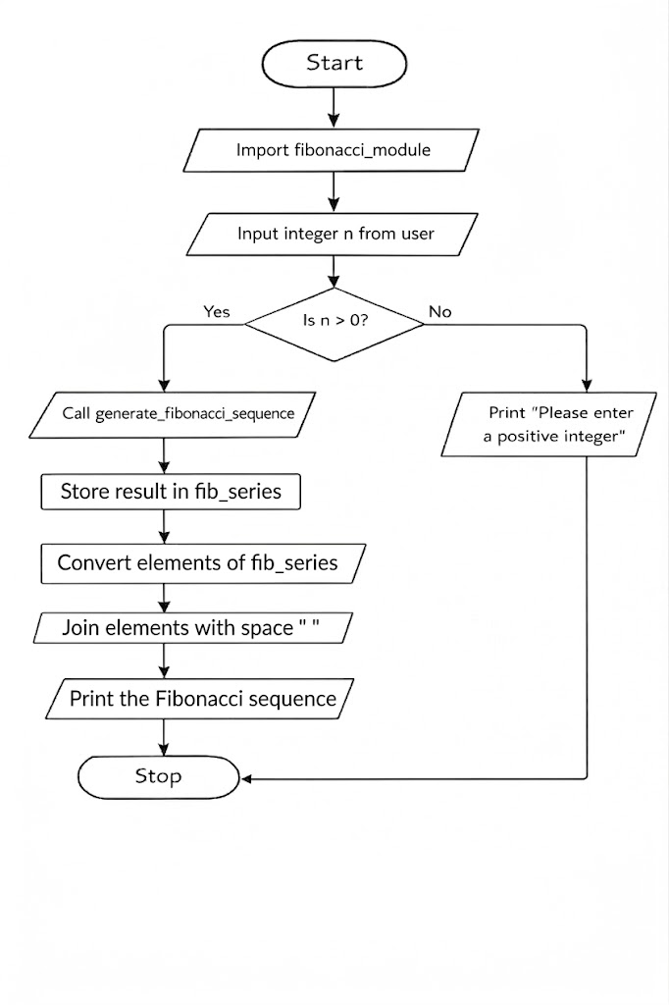
Code
