14.1.1Write a Python program using a class named Complex to add two complex numbers.
Algorithm
Step 1: Start
Step 2: Create three complex number objects c1, c2, c3
Step 3: Input real and imaginary part for c1
Step 4: Store the values in c1
Step 5: Input real and imaginary part for c2
Step 6: Store the values in c2
Step 7: Calculate sum:
c3.real = c1.real + c2.real
c3.imag = c1.imag + c2.imag
Step 8: Check if c3.imag ≥ 0
Step 9: If yes, print c3.real + c3.imag i
Step 10: Else, print c3.real - |c3.imag| i
Step 11: End
Flowchart
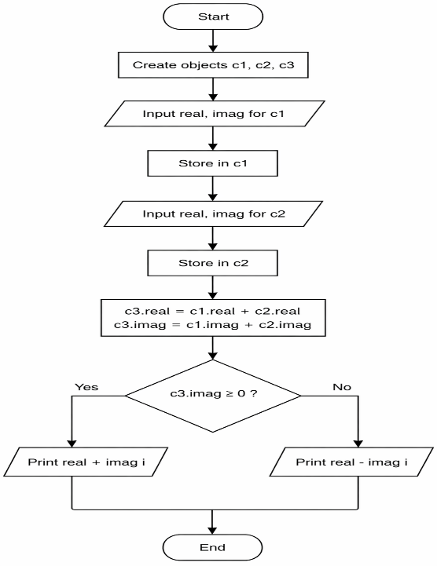
Code
