15.1.1 Write a Python program to model a car dealership sales system using object-oriented programming. Create a base class Car and two derived classes Car1 and Car2 to represent different car types.
Algorithm
Step 1: Start
Step 2: Input car1 data: brand, price, model, color
Step 3: Extract values for car1
Step 4: Input car2 data: brand, price, model, color
Step 5: Extract values for car2
Step 6: Call constructor for car1
Step 7: Initialize brand, price, model, color for car1
Step 8: Call constructor for car2
Step 9: Initialize brand, price, model, color for car2
Step 10: Call car1.display_details()
Step 11: Access attributes (brand, price, model, color) of car1
Step 12: Print car1 details
Step 13: Call car2.display_details()
Step 14: Access attributes (brand, price, model, color) of car2
Step 15: Print car2 details
Step 16: End
Code
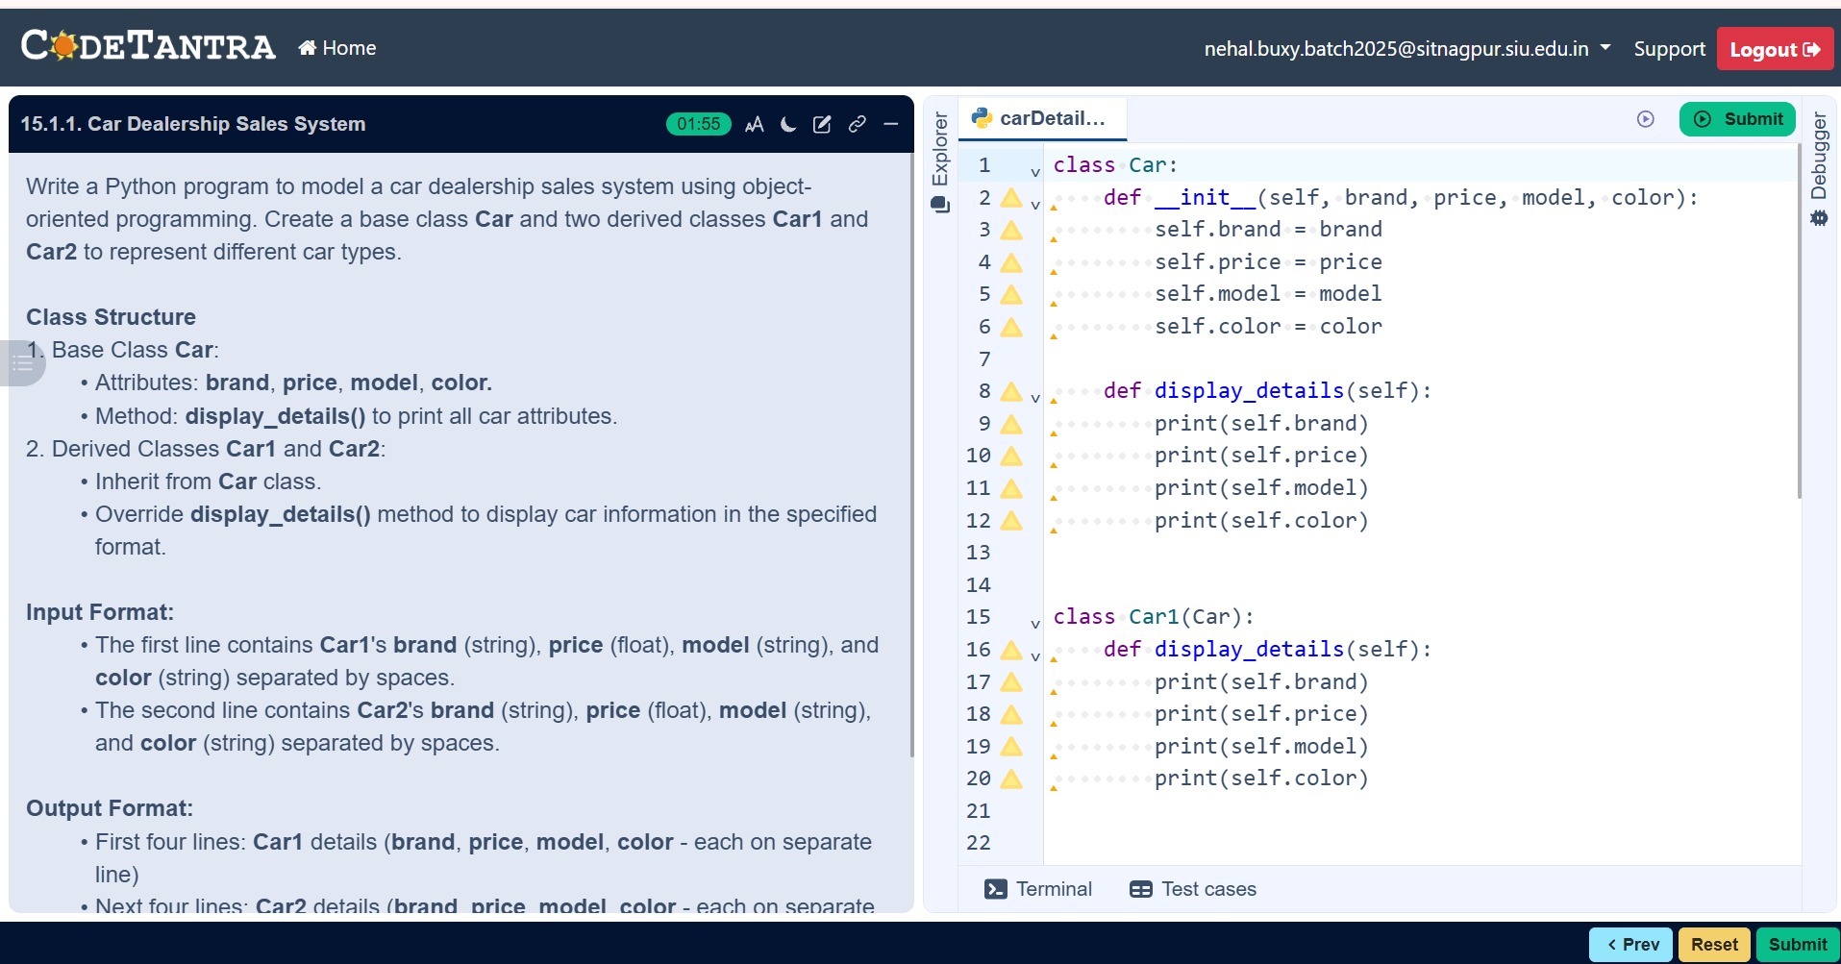

Flowchart
