6.1.2 Factorial of a Number
Write a Python program to calculate the factorial of a number using loops.

Algorithm
Step 1 Start
Step 2 Input n
Step 3 If n < 0 display 'Error' and Stop
Step 4 factorial = 1, i = 1
Step 5 Repeat while i ≤ n
Step 6 factorial = factorial × i
Step 7 i = i + 1
Step 8 Display factorial
Step 9 Stop

Flowchart
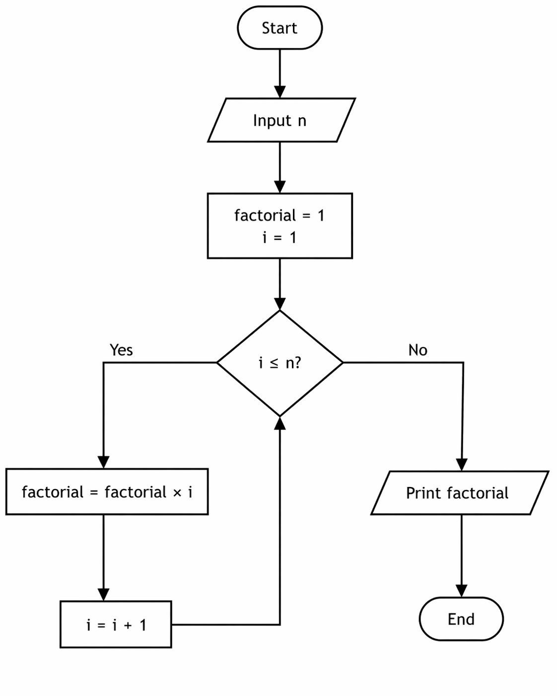

Code
