4.1.1 Write a Python program to perform union, intersection and difference operations on Set A and Set B.

Algorithm
Step 1 Start
Step 2 Read Set A
Step 3 Read Set B
Step 4 Find Union of Set A and Set B
Step 5 Display Union
Step 6 Find Intersection of Set A and Set B
Step 7 Display Intersection
Step 8 Find Difference of Set A and Set B
Step 9 Display Difference
Step 10 Stop

Flowchart
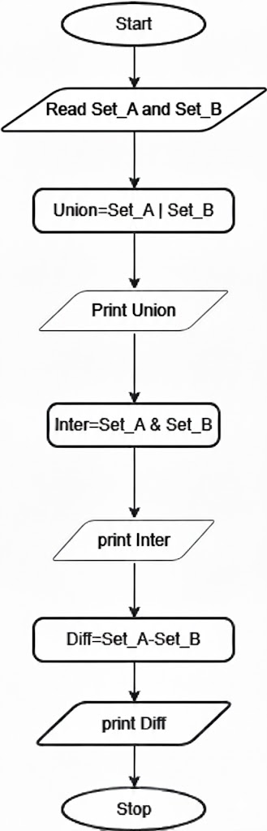

Code
