5.1.1 Leap Year Checker
Write a Python program that prompts the user to enter a year. The program should determine if the year is a leap year or not and print the appropriate message.

Algorithm
Step 1 Start
Step 2 Read year
Step 3 If year % 400 == 0 then display 'Leap Year'
Step 4 Else if year % 100 == 0 then display 'Not a Leap Year'
Step 5 Else if year % 4 == 0 then display 'Leap Year'
Step 6 Else display 'Not a Leap Year'
Step 7 Stop

Flowchart
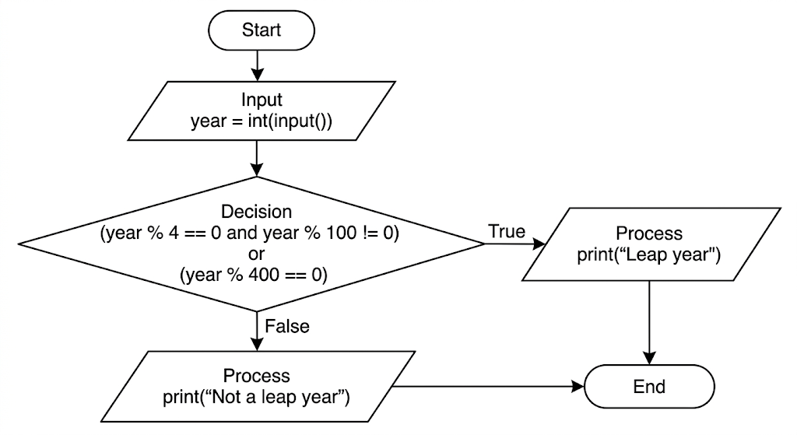

Code
