12.1.1 Write a Python program to manage a phone number database using a dictionary. The dictionary stores contact names as keys and phone numbers as values.
Algorithm
Step 1: Start the program
Step 2: Read an integer n to determine the number of operations to perform.
Step 3: Initialize an empty dictionary named contacts to store names and phone numbers.
Step 4: Repeat the following sub-steps n times:
- Read the operation input and split it into parts.
- If the operation is "ADD", store or update the phone number for the given name in the dictionary.
- If the operation is "REMOVE", delete the name and its associated phone number from the dictionary if it exists.
- If the operation is "DISPLAY", check if the dictionary is empty.
  - If empty, print "No contacts".
  - If not empty, sort the names alphabetically and print each name with its phone number.
Step 5: Stop the program.
Flowchart
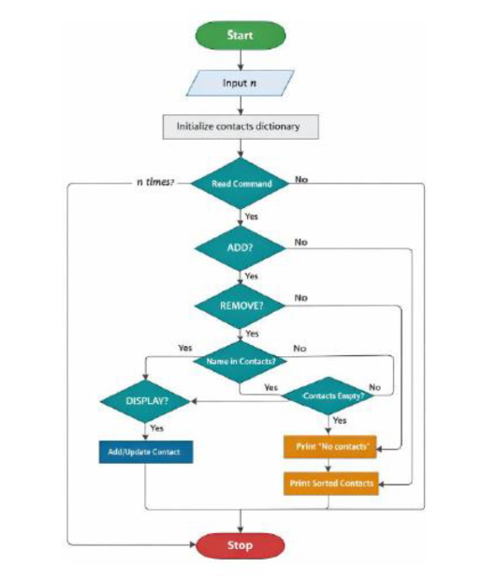

Code
