Practice 11.1.2
Write a recursive function sum_of_digits_recursive(n) that calculates the sum of the digits of a given non-negative integer n.
Algorithm:-
- Start.
- Define Function: Create a recursive function sum_of_digits_recursive(n).
  - Base Case: If is equal to , return . (This stops the recursion).
  - Recursive Step: If is not , return the last digit added to the result of a recursive call to the same function with the remaining digits .
- Input: Read an integer from the user and store it in the variable number.
- Function Call: Call the function sum_of_digits_recursive using number as the argument.
- Store Result: Assign the final value returned by the function chain to the variable result.
- Output: Print the result.
- Stop.
FlowChart:-
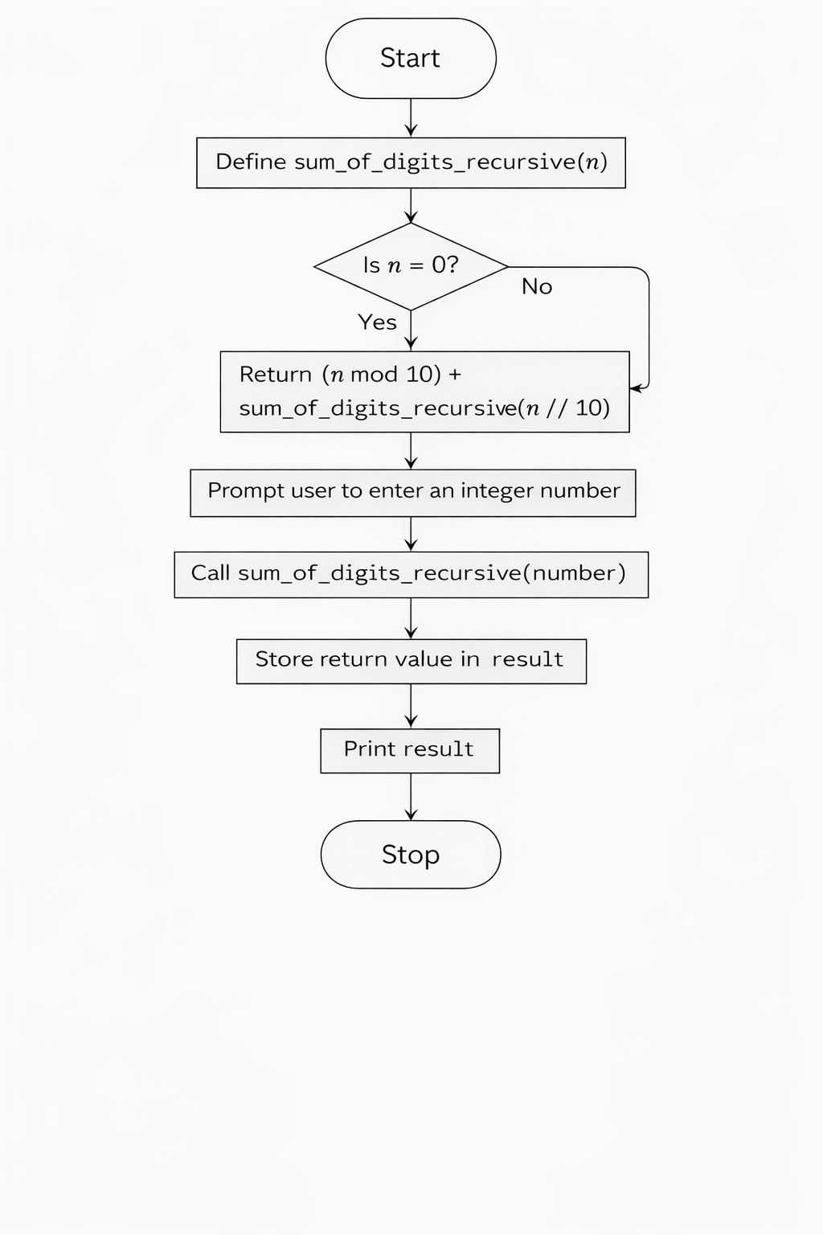
Code:-
