Experiment - 5.1.2. Student Grade Based
on Aggregate
1. Aim
To design and implement a Python program that calculates a student's total marks, aggregate
percentage, and final grade based on the marks obtained in four subjects. The program
determines the grade using a specific set of percentage-based conditions.
2. Pseudocode
1. START
2. READ four space-separated integers from the user and STORE them in variables m1, m2, m3, and m4.
3. CALCULATE the sum of the four subjects and STORE it in the variable total (total = m1 + m2 + m3 + m4).
4. CALCULATE the aggregate percentage by dividing the total by 4 and STORE it in the variable percentage.
5. CHECK the value of percentage to determine the grade:
○ IF percentage > 75, STORE "Distinction" in grade.
○ ELSE IF percentage >= 60, STORE "First Division" in grade.
○ ELSE IF percentage >= 50, STORE "Second Division" in grade.
○ ELSE IF percentage >= 40, STORE "Third Division" in grade.
○ ELSE, STORE "Fail" in grade.
6. PRINT the total marks.
7. PRINT the percentage formatted to two decimal places.
8. PRINT the grade.
9. END
3. Flowchart
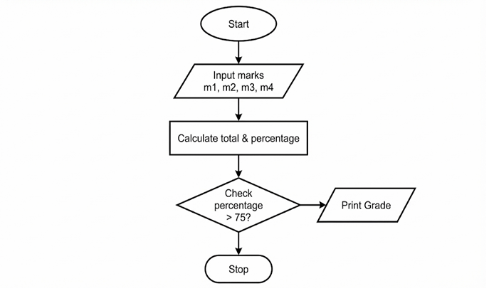

4. Code
