Practicle 3.1.1
Aim :- Write a Python program that prompts the user to enter three integers. Print the largest of the three integers.
Algorithm :- Step 1. Start: The entry point of the program.
Step 2. Input a, b, c: You enter the three integers.
Step 3. Decision 1 (is a >= b AND a >= c?):
- Yes: largest = a.
- No: Move to the next check.
Step 4. Decision 2 (is b >= a AND b >= c?):
- Yes: largest = b.
- No: By elimination, largest = c.
Step 5. Output: Print the value of largest.
Step 6. End: The program terminates.
Flowchart :-
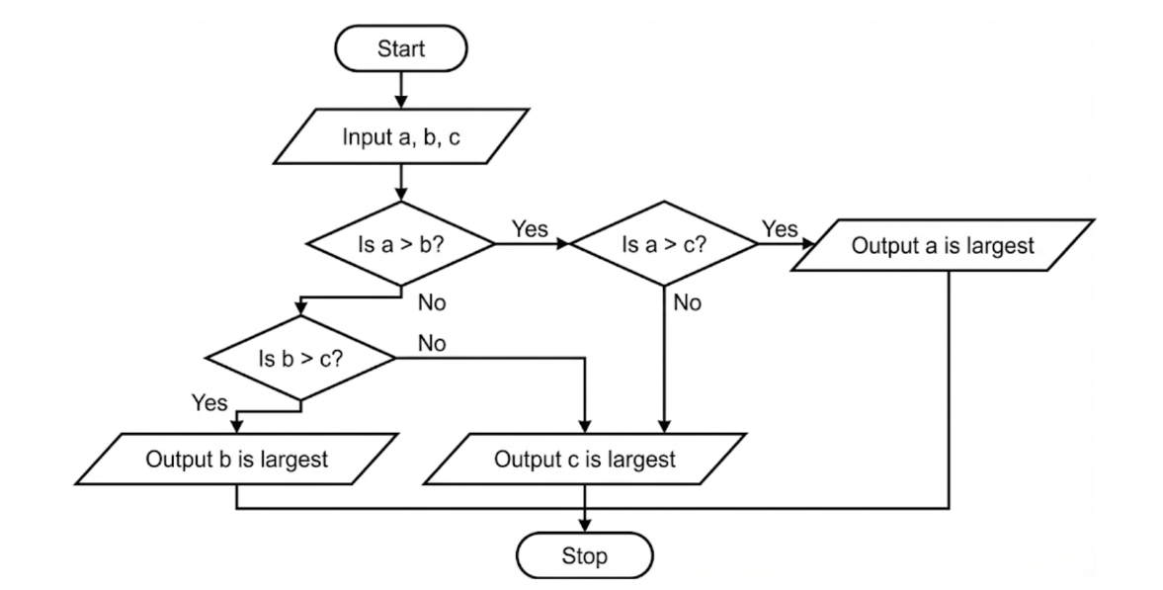
Code:-
