Practicle 5.1.2
Aim :- Write a program to calculate the total marks, aggregate percentage, and grade of a student based on marks in four subjects. The grade is determined as follows:
Algorithm:-
Step 1: Start
Step 2: Read four integers m1, m2, m3, m4
Step 3: Calculate total = m1 + m2 + m3 + m4
Step 4: Calculate aggregate = total / 4
Step 5: Display total and aggregate up to two decimal places
Step 6:
- If aggregate > 75, print Distinction
- Else if aggregate ≥ 60, print First Division
- Else if aggregate ≥ 50, print Second Division
- Else if aggregate ≥ 40, print Third Division
- Else print Fail
Step 7: Stop
FlowChart:-
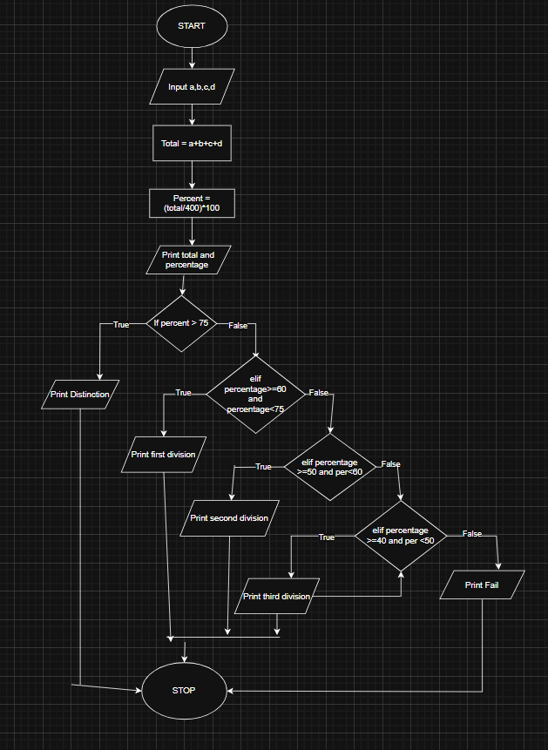

Code:-
