Practicle 6.1.1
Aim:- Write a Python program to check if a given date is valid. If the date is valid, print the next day's date (incremented date). If the date is invalid, print "Invalid Date".
Algorithm:-
Step 1 Start
Step 2 Input d, m, y
Step 3 Set flag ← 1
Step 4 If y < 0 OR m < 1 OR m > 12, set flag ← 0
Step 5 Determine maxdays:
- If m in {1,3,5,7,8,10,12} → 31
- If m in {4,6,9,11} → 30 Else (February): o If y % 2 == 0 → 29 o Else → 28
Step 6 If d < 1 OR d > maxdays, set flag ← 0
Step 7 If flag == 1:
- d ← d + 1
- If d > maxdays: o d ← 1, m ← m + 1
- If m > 12:
o m ← 1, y ← y + 1
- Print date in dd-mm-yyyy format
Step 8 Else print "Invalid Date"
Step 9 Stop
FlowChart:-
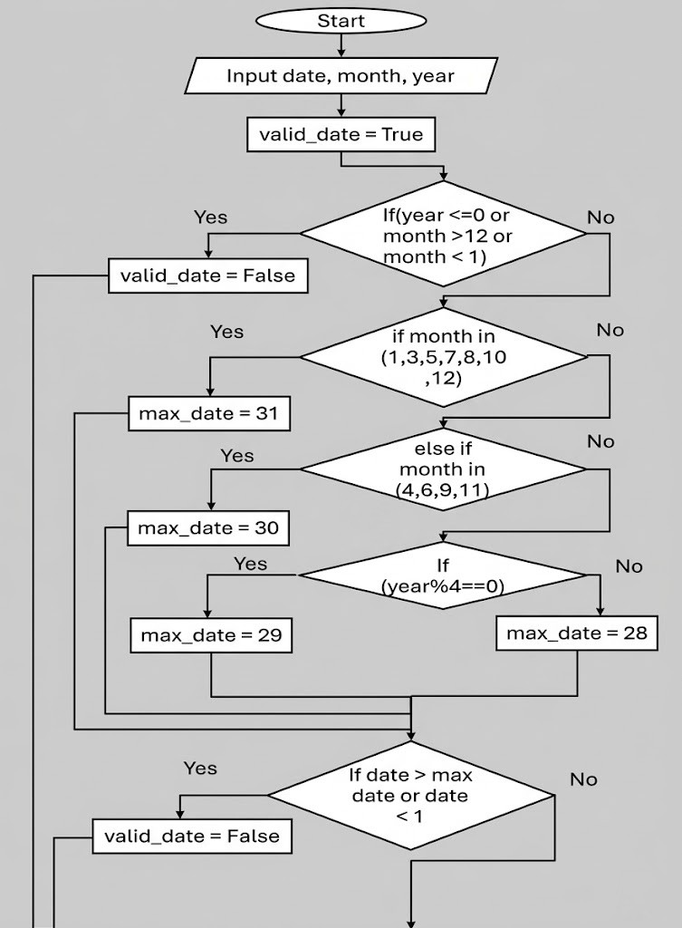
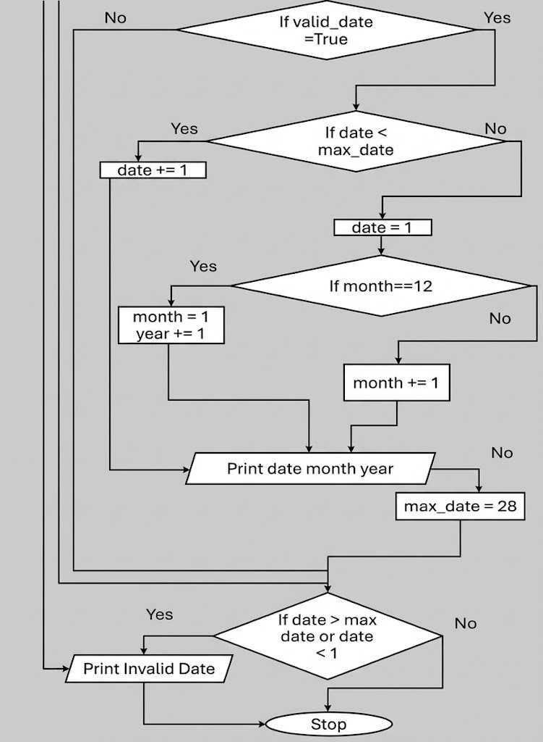
Code:-

