Practicle 6.1.2
Aim:- Write a Python program to calculate the factorial of a number n using loops.
Algorithm :-
Step 1: Start
Step 2: Input integer a
Step 3: Set fact ← 1
Step 4: For i from 1 to a do: fact ← fact × i
Step 5: Print fact
Step 6: Stop
Flowchart:-
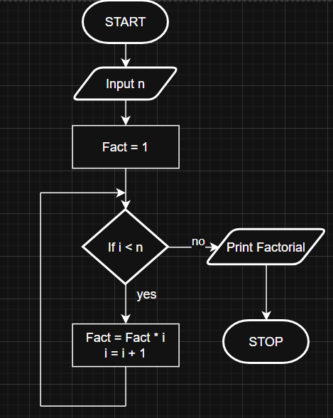
Code:-
