Practicle 7.1.2
Aim :- Write a Python program to accept three digits and print all possible 3-digit combinations that can be formed using those three digits. Each digit should be used exactly once in each combination.
Algorithm:-
Step1. Start
Step2. Input three values a, b, c.
Step3. Store them in a list digits = [a, b, c].
Step4. Use three nested loops for i, j, k from 0 to 2.
Step5. Check if i, j, k are different (i ≠ j, j ≠ k, i ≠ k).
Step6. Print digits[i] + digits[j] + digits[k].
Step7. Stop
Flowchart:-
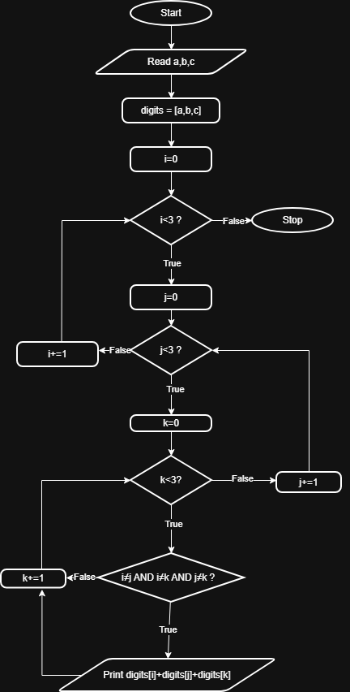

Code:-
