Practicle 8.1.1
Aim:- Write a Python program to perform the multiplication of two square matrices. The program should take two matrices as input and output their product.
Algorithm:-
Step 1: Start
Step 2: Read the dimension n of the square matrix.
Step 3: Initialize an empty matrix A.
Step 4: Read elements of the first matrix
- For i = 0 to n-1
  - Read a row of n integers.
  - Store the row in matrix A.
Step 5: Initialize an empty matrix B.
Step 6: Read elements of the second matrix
- For i = 0 to n-1
  - Read a row of n integers.
  - Store the row in matrix B.
Step 7: Create a result matrix C of size n × n and initialize all elements to 0.
Step 8: Perform matrix multiplication
- For i = 0 to n-1
  - For j = 0 to n-1
    - For k = 0 to n-1
      - Calculate
C[i][j] = C[i][j] + (A[i][k] × B[k][j])
Step 9: Display the resultant matrix
- For i = 0 to n-1
  - Print all elements of row C[i].
Step 10: Stop.
Flowchart:-
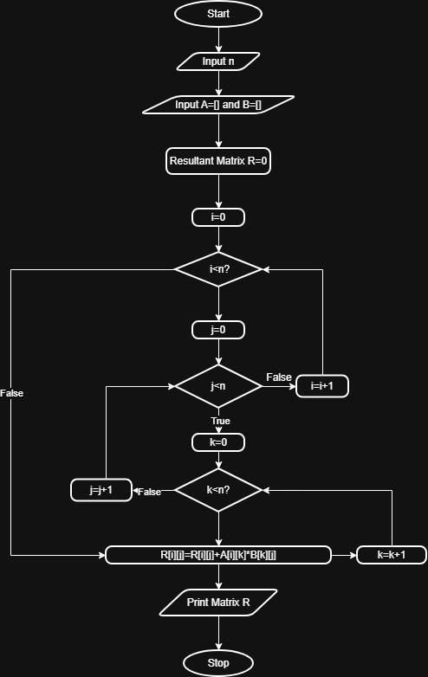
Code:-
