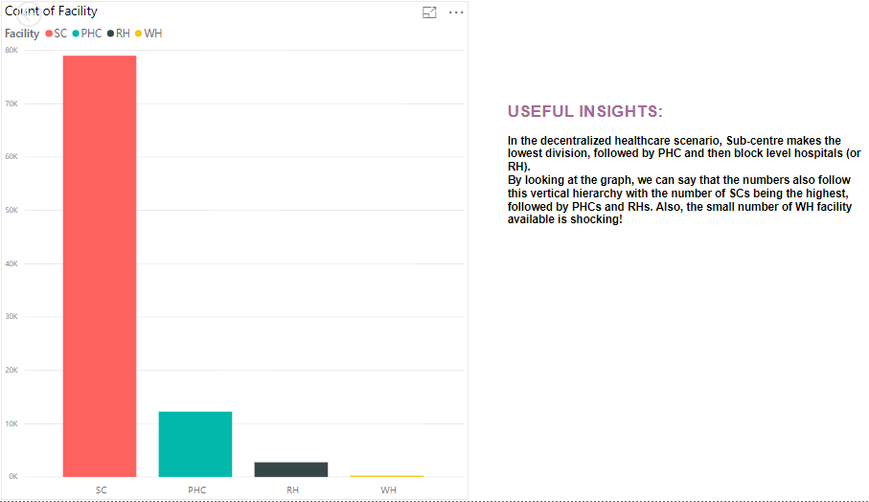

1. This graph above shows that the number of SCs is very high as compared to the other facilities like PHC, RH and WH. The interactive visualizations can be seen using the PowerBI dashboard zip as attached.
2. The graph below shows the total entries, hence larger the entries, worse are the health conditions in that area.

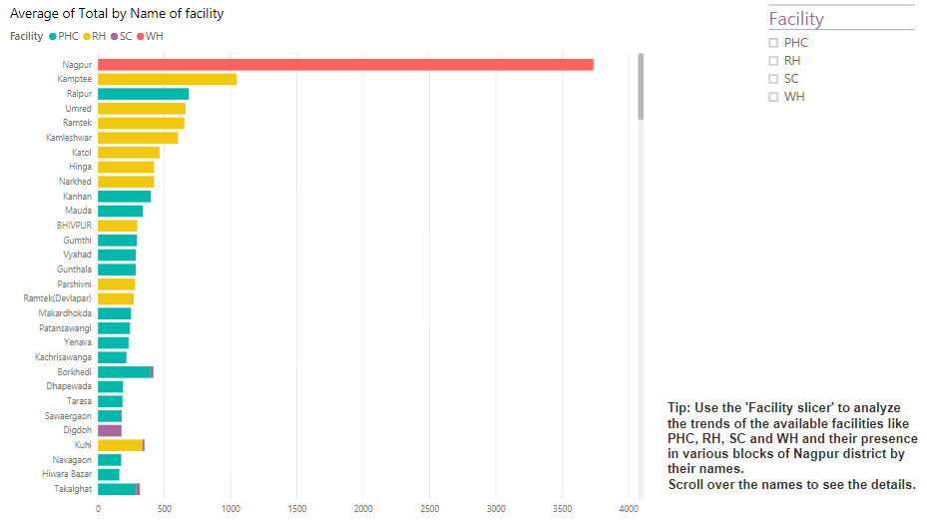

1. This shows that the worst health conditions are there in the Nagpur block of Nagpur district.
2. Comparing the above two visualizations we can see that the worst health conditions are in Nagpur block, but the presence of SCs, RHs or PHCs is not there in that block. Only WHs are present, which are pretty low themselves as shown in the first graph.
3. This can be the reason for such bad health conditions in Nagpur block, the absence of proper health care facilities. The PHCs are below average.

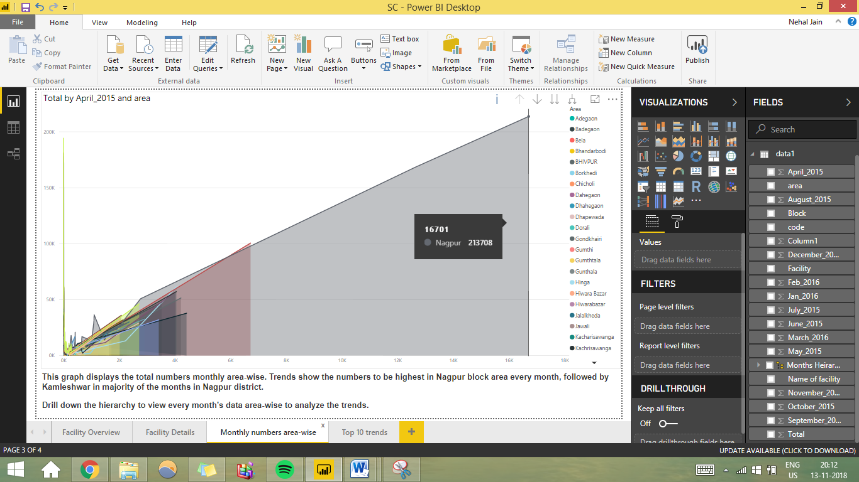

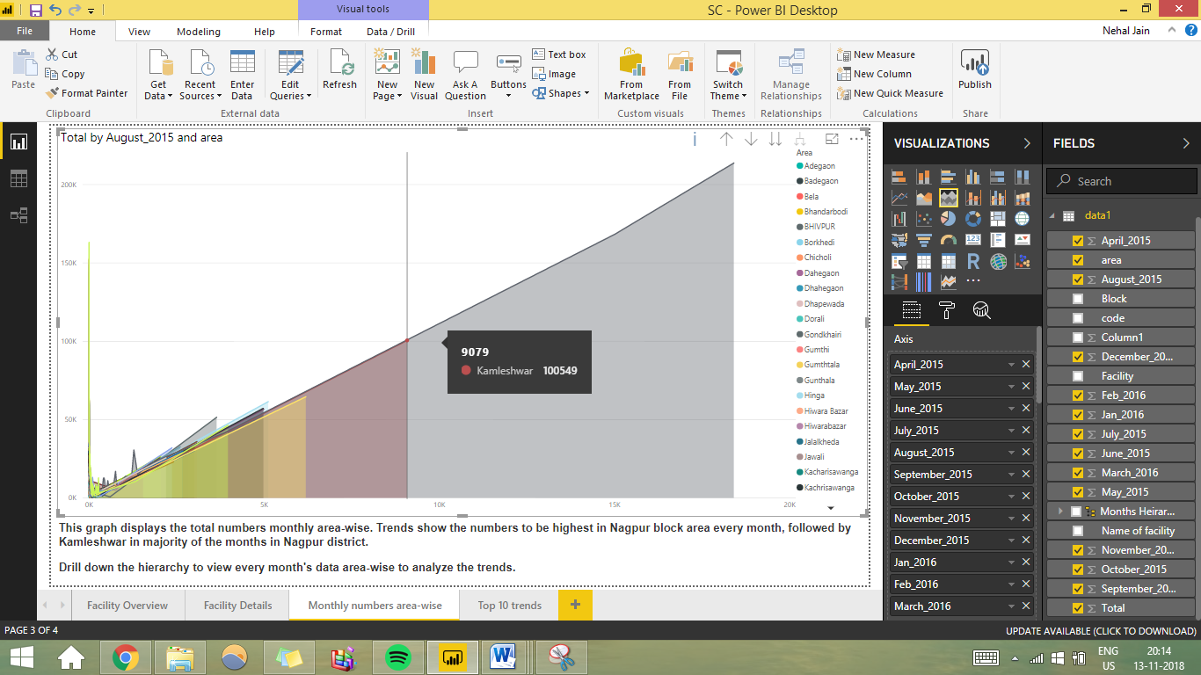

1. The graphs above show the total entries area-wise in blocks of Nagpur with Nagpur block having highest percentage of entries in all the months followed by Kamleshwar block in most of the months. \*Use the drill down function in the interactive dashboard to see monthly trends from April 2015 to March 2016.

Top 10 health-care scenarios

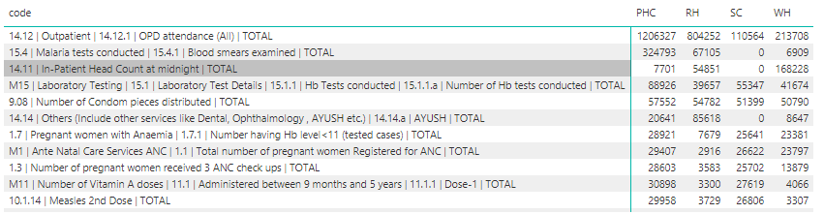

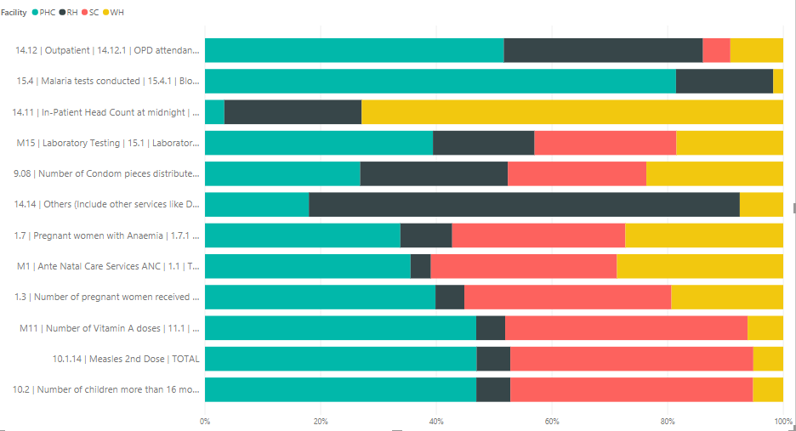

1. Top 10 health trends from the data are mentioned as follows:
   1. Even though the percentage of WHs present is very low, the entries of ‘Outpatients (OPD Attendance)’ and ‘In-Patient Head Count at midnight’ is very high for WH (present only in Nagpur block) expressing the poor health of the people in that area. The number of WHs should be increased or more SCs, PHCs and RHs should be set up in that area to improve the health conditions.
   2. SCs don’t have Malaria tests conducted as per the data. ‘Malaria tests conducted’ is one of the top most entries, indicating high number of Malaria cases. SCs being the most accessible should conduct Malaria tests for better health of the people in that region.
   3. The ‘Hb tests conducted’ shows a good number in all the facilities indicating that a good service for this is available and since ‘Low Hb’ is not present amongst the top few, it means that Hb levels are healthy in the people of that area.
   4. Although the ‘number of condom pieces distributed’ are almost equally distributed amongst the facilities but overall the number is very low. Also, abortion rate, sterilization rate, IUD insertion rates and oral pills distribution rate is very low. This means that people are yet not indulged in family planning and are unaware. Hence, the government must set up awareness programs and schemes because this can be a major factor behind high maternal mortality rates.
   5. Another trend suggests that the dental, ophthalmology, AYUSH facilities are not available in SCs. Since SCs are most easy to access, this trend should be taken into consideration.
   6. Next, a very important point shows that the number of pregnant women with Anaemia is very high. This can also be a huge reason behind the high maternal mortality rates.
   7. The ‘total number of women registered for ANC’ and the ‘number of women receiving 3 ANC check-ups’ is very low. This number must be increased to prevent maternal mortality and proper medicines like IFA tablets must be made available. TT1 and TT2 given to pregnant women must be increased highly.
   8. ‘Number of vitamin A doses administered between 9 months and 5 years’ decreases after Dose-1. Hence, the government must try and spread awareness to bring in more children for Dose-5 and Dose-9. Child health should be taken into consideration and all 9 doses must be completed.
   9. Next few trends show extremely low vaccination usage.
   10. Another shocking trend is the unexpectedly low number of ‘Total number of times an ambulance was used for transporting the patients during the month’. This is a major concern and can lead to severe difficulties in case of emergencies.
   11. Lack of medicines, pregnancy kits, ‘deliveries conducted at public institutions’, ‘number of new borns breast fed within 1 hour’ shows a great disappointment too. These can be a major factor contributing towards maternal mortality and clearly depict the poor health conditions of the mother.