**Name: Pavana kruthi .S**

**Class: 9std English medium**

**School: G H S Bettahalasuru**

**Class Teacher: t r Santha**

**H m: candrakala**

* **My name is pavana kruthi**
* **My father name is sendhil kumar**
* **My mather name is manjula**
* **My sister name is yashsvini**
* **My best friends name is tejomayee,priya, shwetha**
* **My favorate colour is blue**
* **My favorate food is chapatti**
* **My favorate subject English**
* **My favorate book harry potter series**
* **My hobbies are dancing**

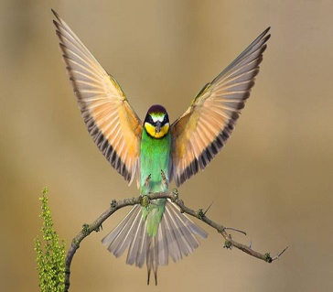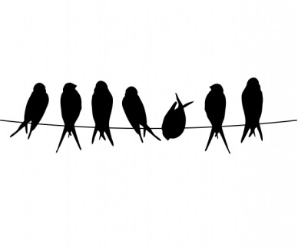

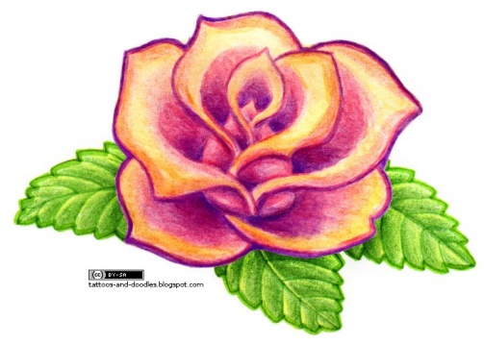

|  |  |
| --- | --- |
| **English** |  |
| **kannada** |  |
| **hindi** |  |
| **maths** |  |
| **Science** |  |
| **Social science** |  |