**WELCOME**

* My friend name is roopa.

I am studying in 9th standard.

My school name is G.H.S bettahalasur

My favourate is SARVAMANGALA

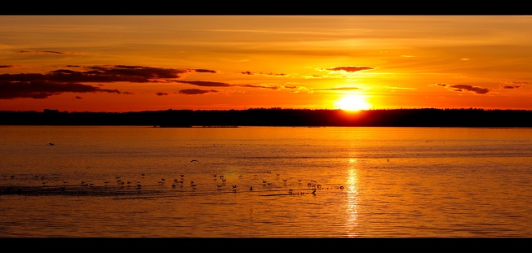

|  |  |  |
| --- | --- | --- |
| PAST TENSE | PRESENT TENSE | FUTURE TENSE |
|  |  |  |
|  |  |  |
|  |  |  |
|  |  |  |
|  |  |  |



