Problem Statement:

Write a program to implement word count using Pig.

Word count text file:

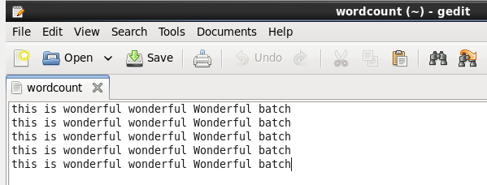

Pig file:

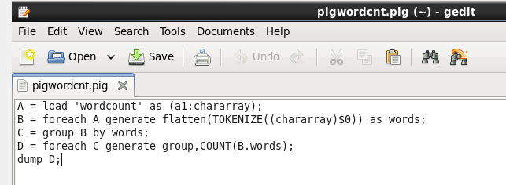

Execution of pig file for word count:

