Problem Statement:

1. Write a pig script find the average age of male and female persons died in the titanic tragedy
2. Write a pig script to find the number of people died and survived in each class

Code:

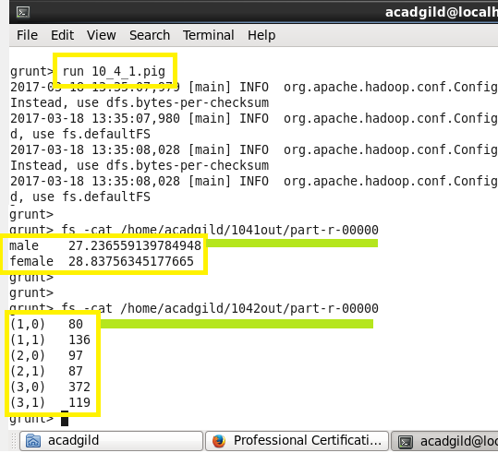

Output:

