Problem Statement:

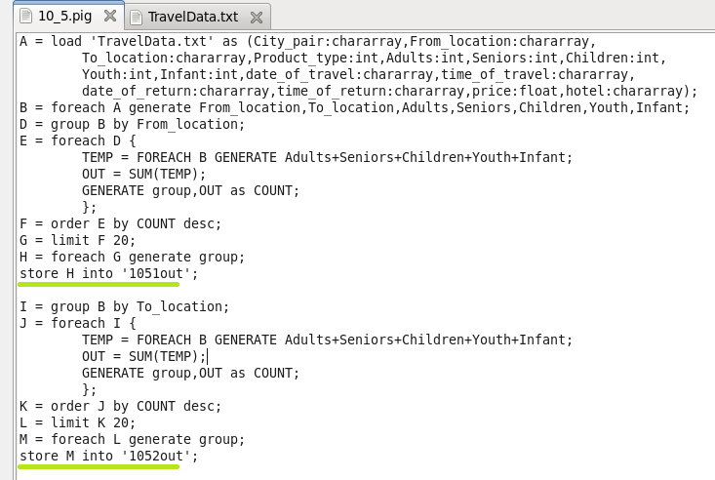

1. Write a pig script to find the top 20 destination people travel the most: Based on the given data

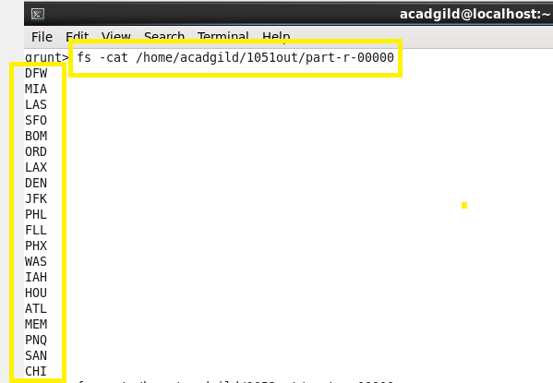

1. Write a pig script to find the top 20 locations from where people travel the most

