Problem Statement

1. Write a pig script to find the minimum temperature observed in a given weather station in a particular year.

2. Write a pig script to find the maximum temperature observed in a given weather station in a particular year.

3. Write a pig script to find the number of readings given by each weather station according to the dataset.

Code:

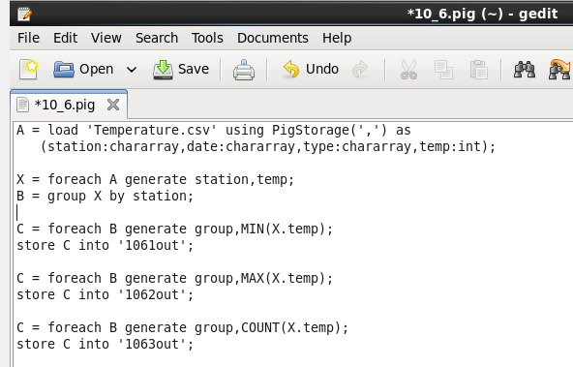

Running pig script:

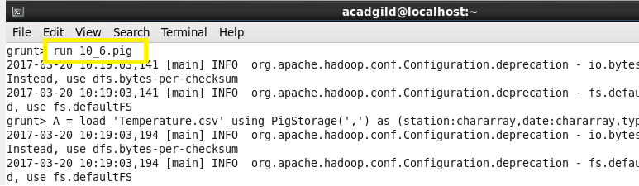

Problem 1 output:

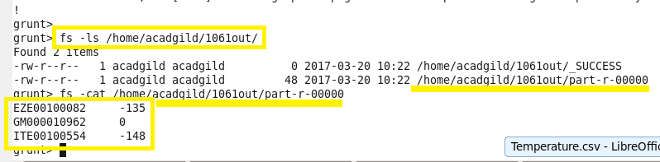

Problem 2 output:

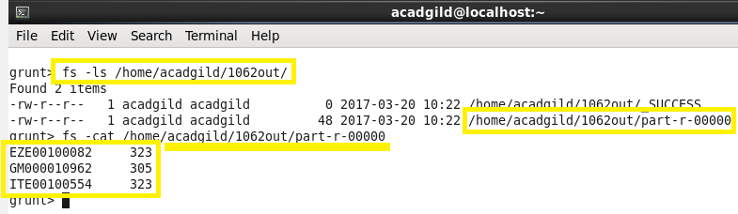

Problem 3 output:

