Write the Pig codes to analyze the petroleum data set.
1. What is the total amount of petrol in volume sold by every distributor?
2. Which are the top 10 distributors ID's for selling petrol? Also display the amount of petrol sold in volume.
3. List 10 years where consumption of petrol is more with the distributer id who sold it.
4. Find the distributer name who sold petrol in least amount.

Pig script:
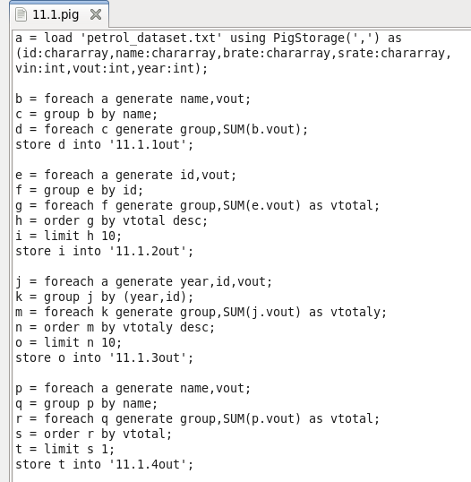

Running pig script:

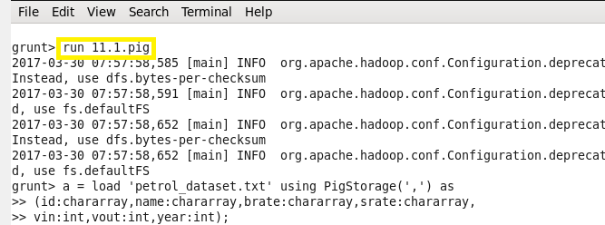

Output:

Problem 1:
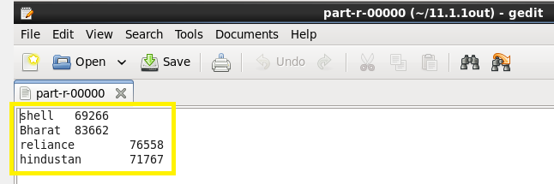

Problem 2:

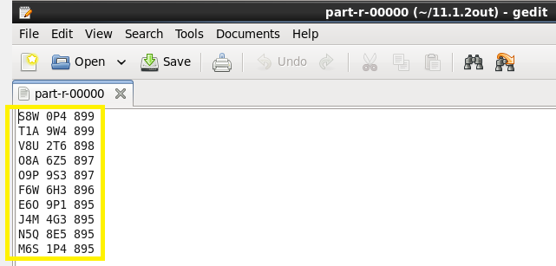

Problem 3:

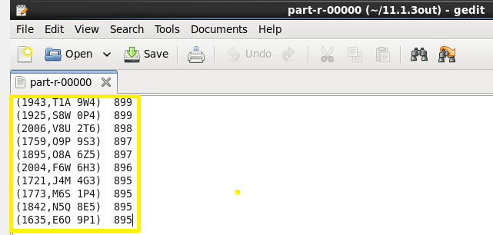

Problem 4:

