Write a Pig UDF to find the tweets posted by @realDonaldTrump from the given dataset.

UDF:

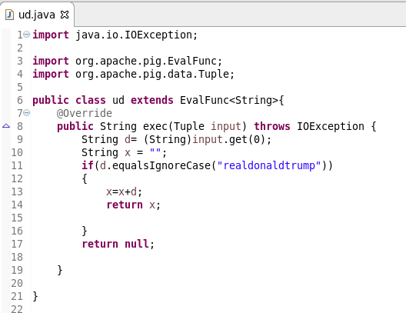

Pig script:

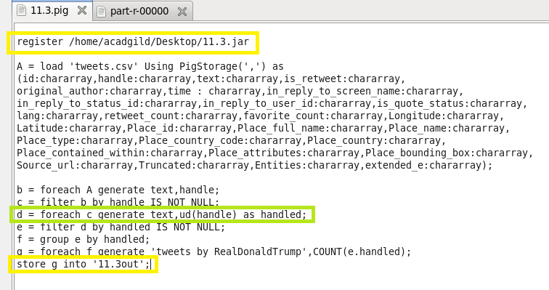

Running pig script:

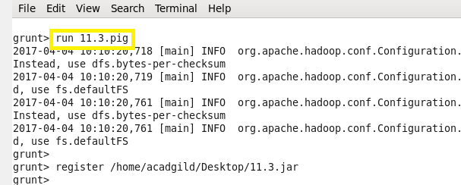

Output:

