Problem statement:

Problem Statement Perform word count operation in local mode (In windows environment). Share the code, explain the execution steps, and attach the output screenshot

Task class:

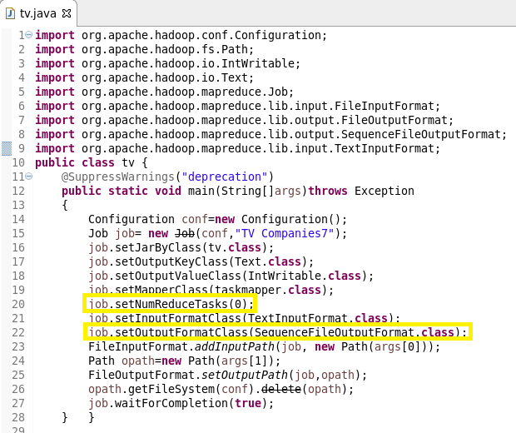

Mapper class:

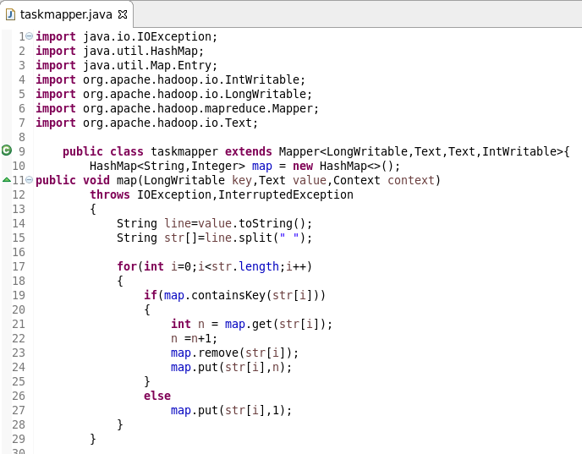

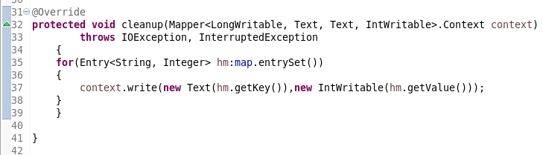

Setting run configuration:

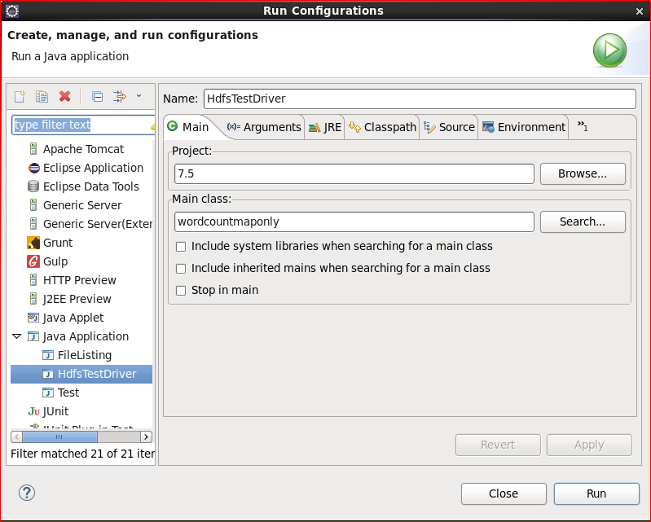

Setting arguments:

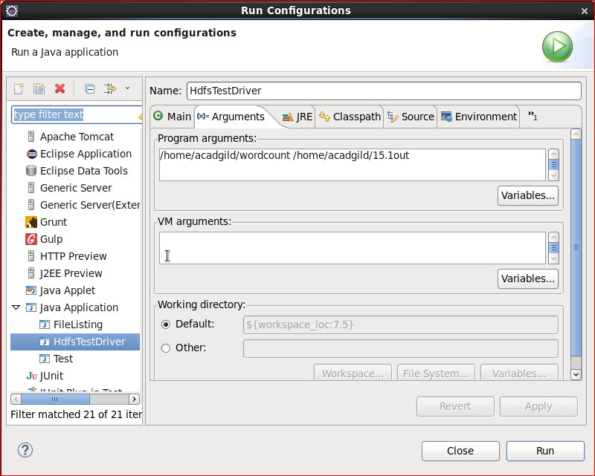

Console details:

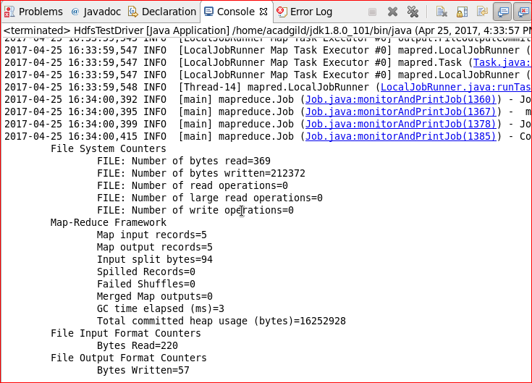

Output:

