Problem Statement

Build and Deploy Hadoop word count program using Maven.

Maven installation:

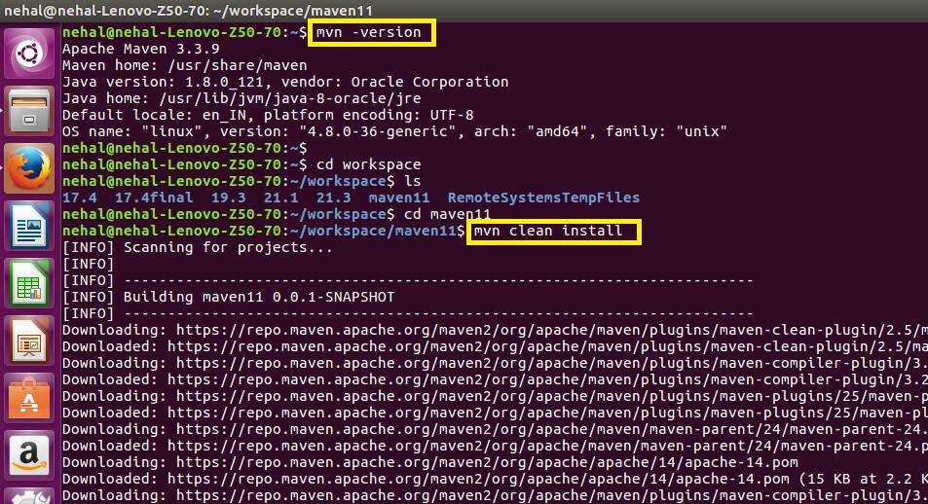

Maven project built successfully:

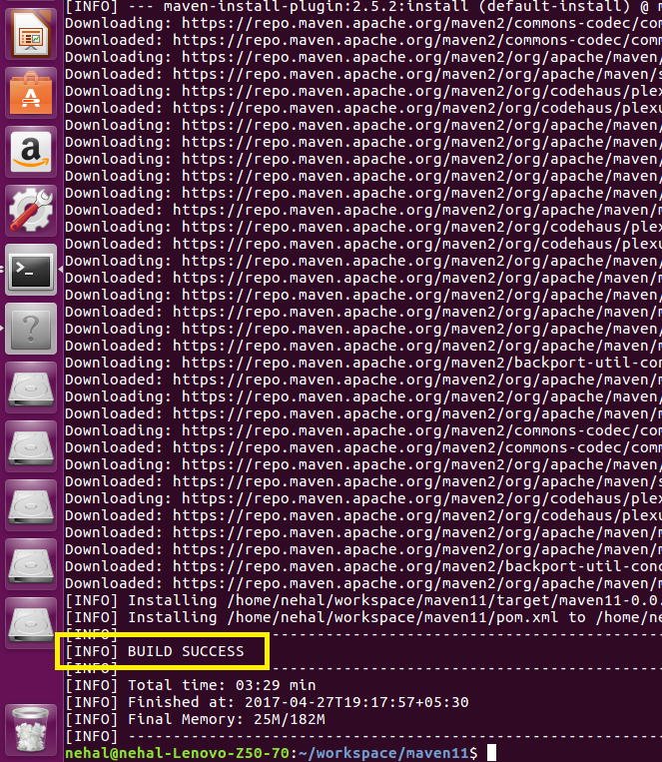

Java code for word count:

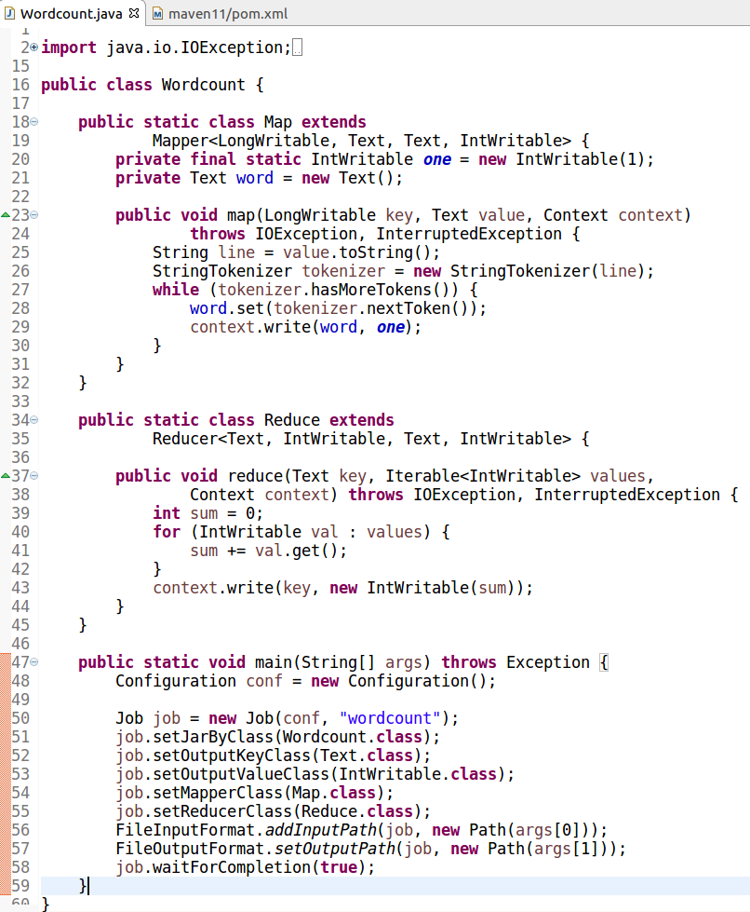

Pom.xml file:

All dependencies are included in this file.

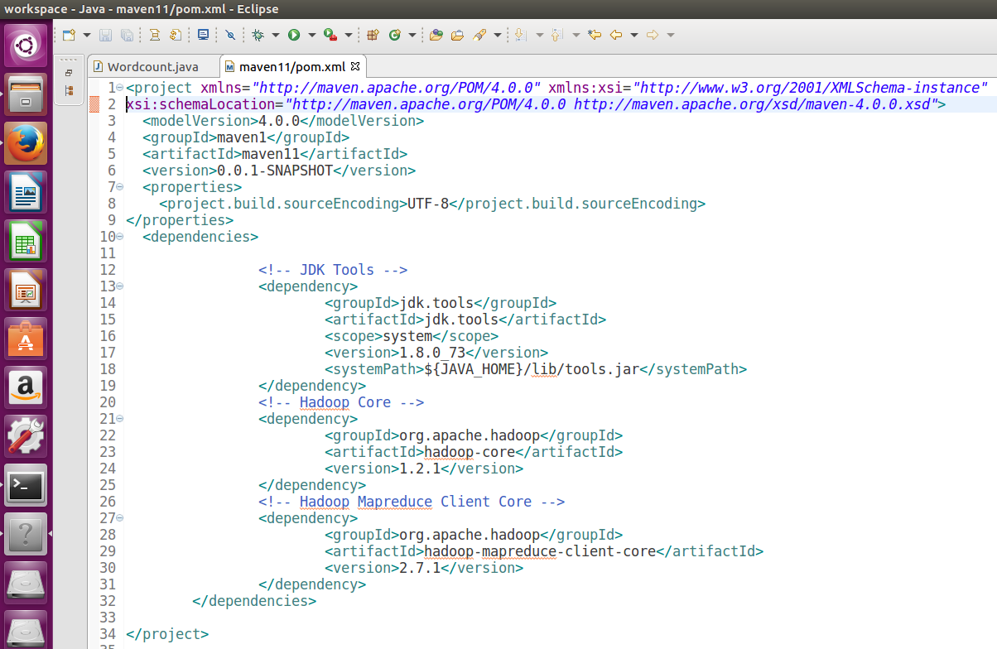

Dataset:

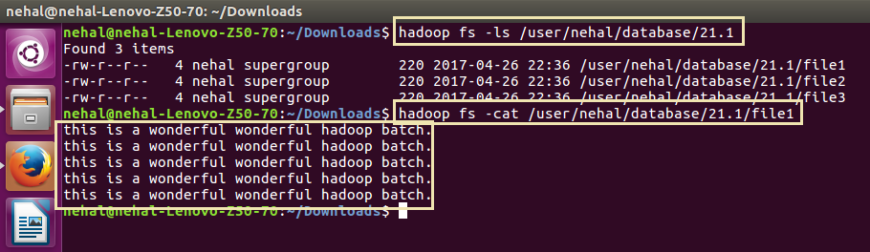

Running maven project (jar file):

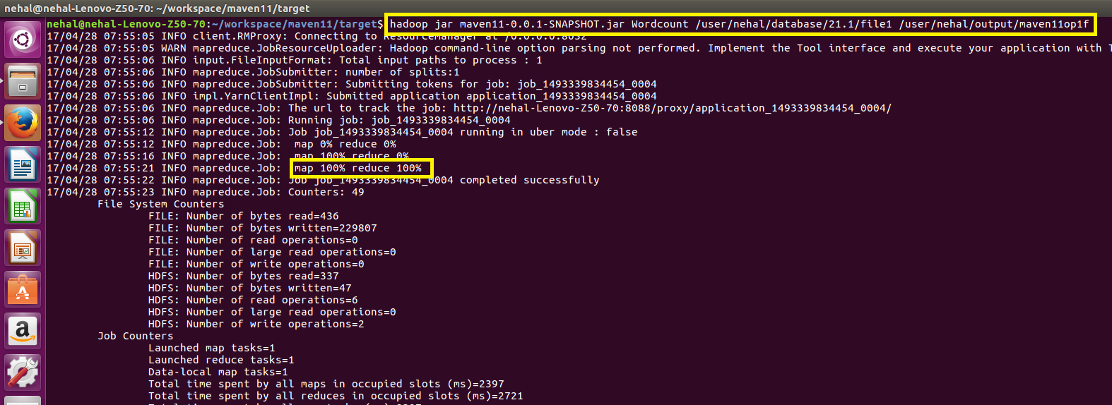

Output:

