Problem Statement

Build and Deploy Hadoop word count program using SBT

Note: You can use any program of your choice

SBT build:

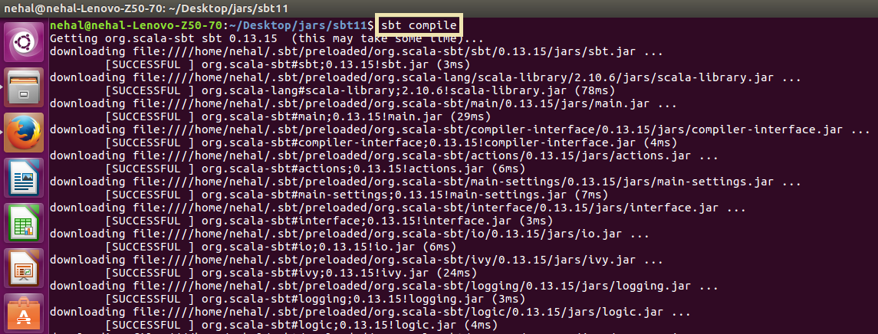

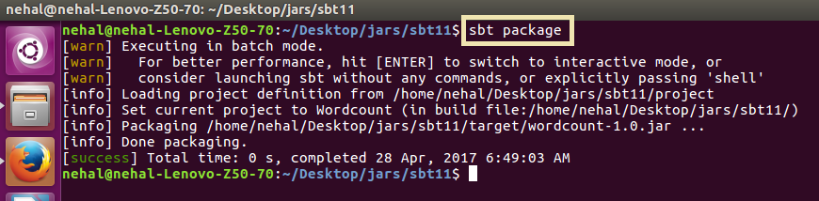

SBT build file:

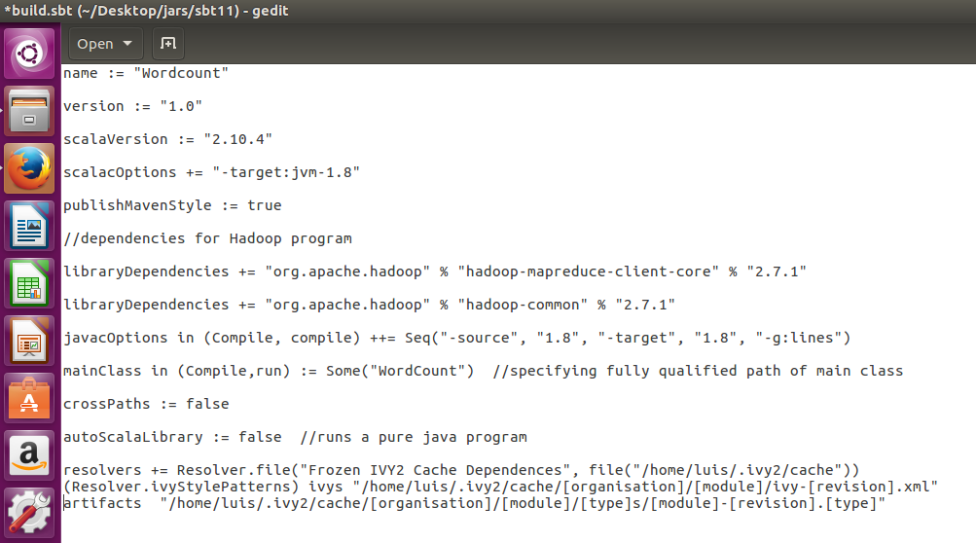

Word count program:

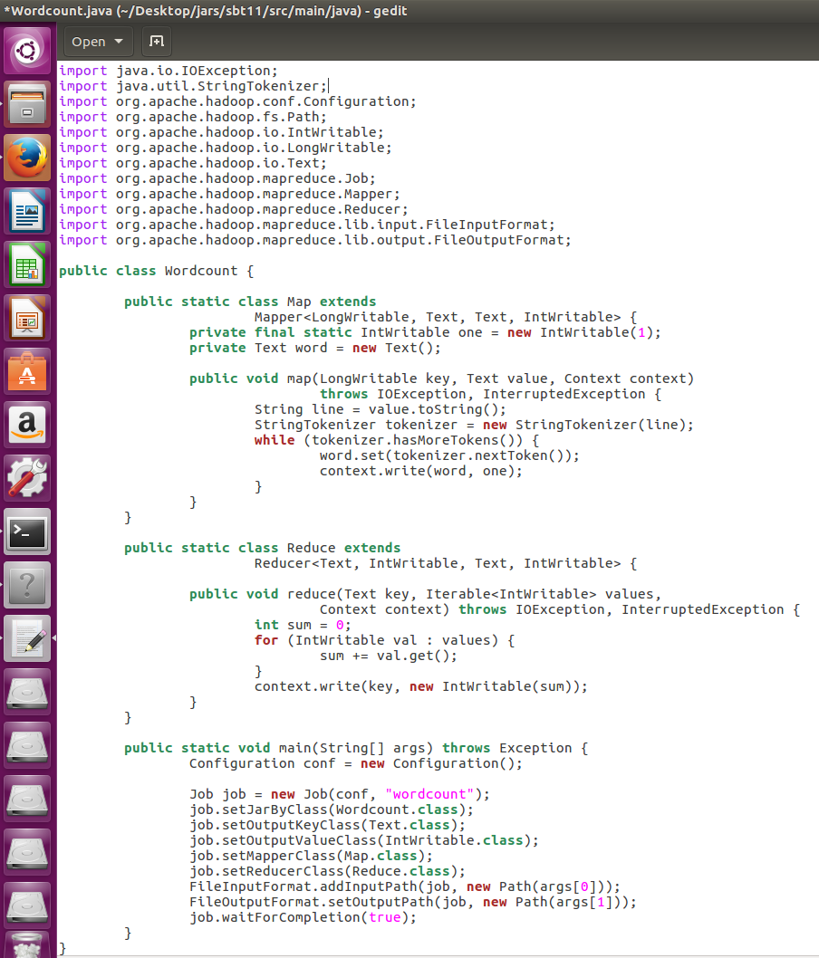

Dataset:

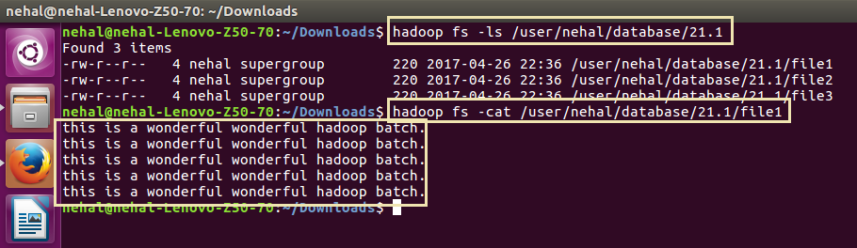

Running SBT project (jar file):

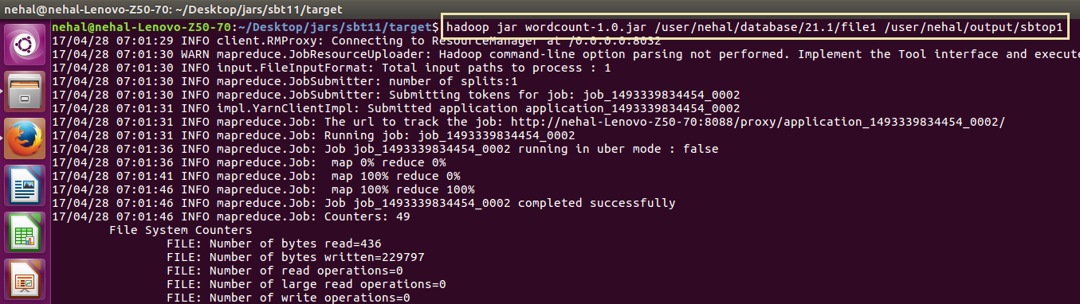

Output:

