Problem Statement

Build and Deploy Hadoop word count program using Gradle.

Note: You can use any program of your choice.

Gradle project build:

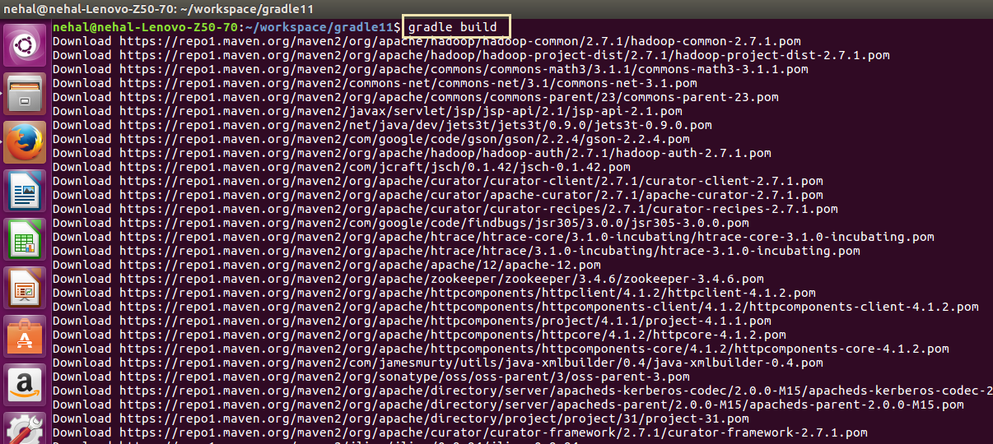

Gradle build file:

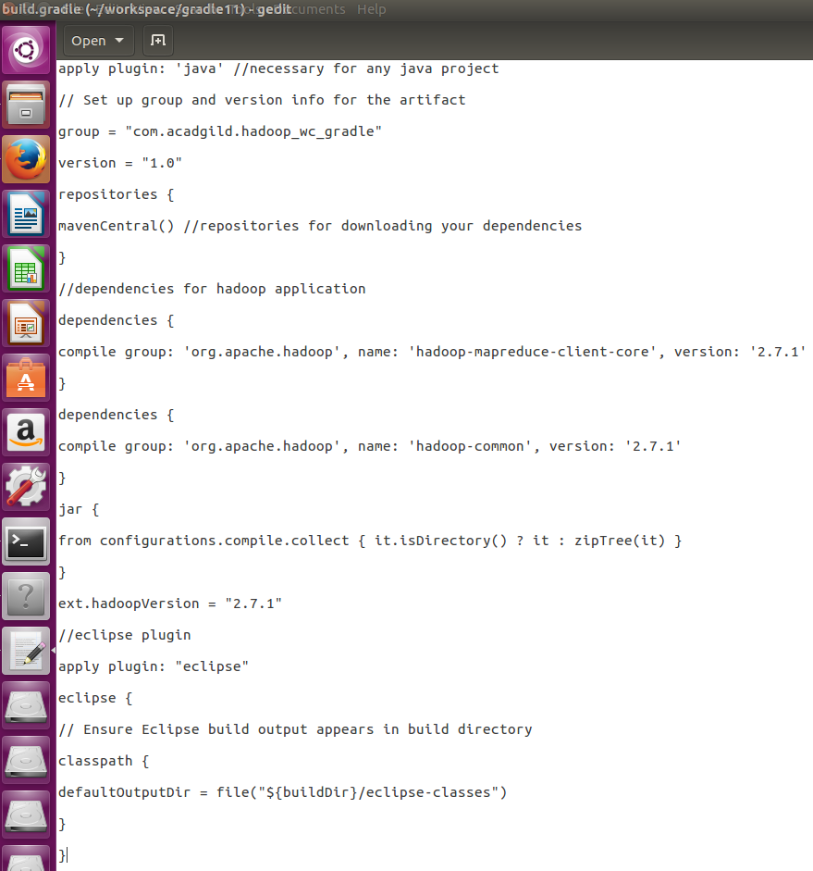

Word count program (java code):

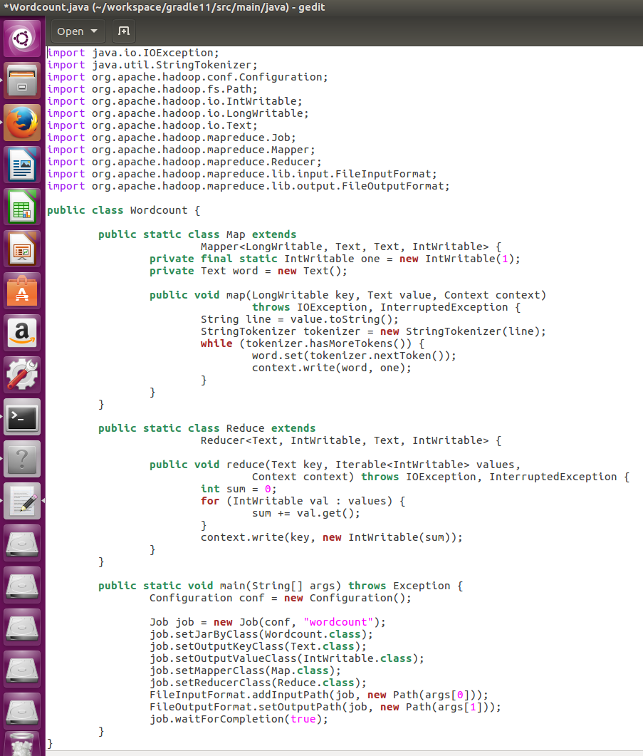

Dataset:

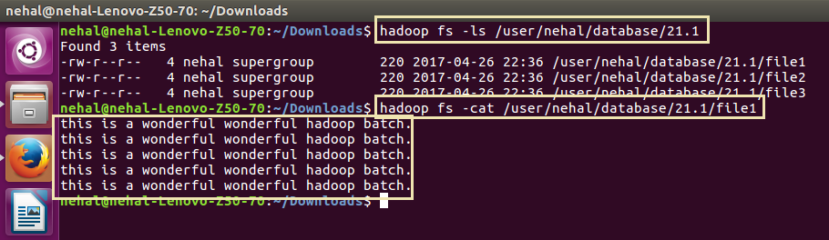

Running gradle project (jar file):

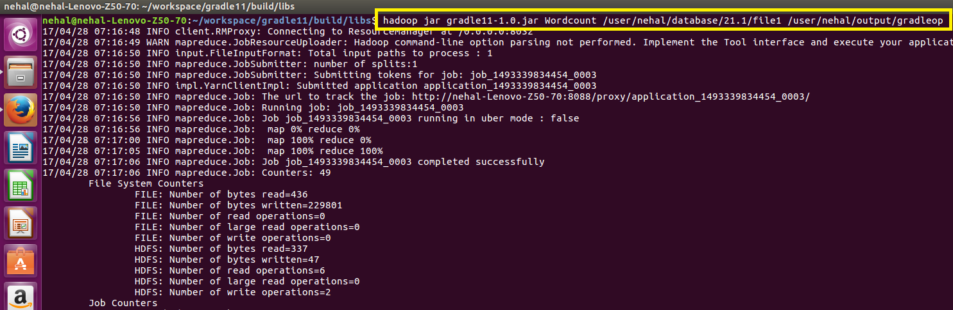

Output:

