Problem Statement

Write a map reduce program to design a custom counter to count number of people are affected with 'PULMONARY' disease and 'BRONCHITIS & ASTHMA' in the state 'CA'.

Task class:

In this example we will just create the Map only job, we are concentrating only on implementation of counters

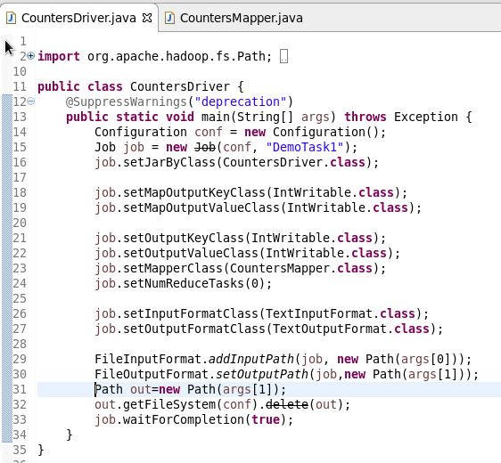

Mapper class:

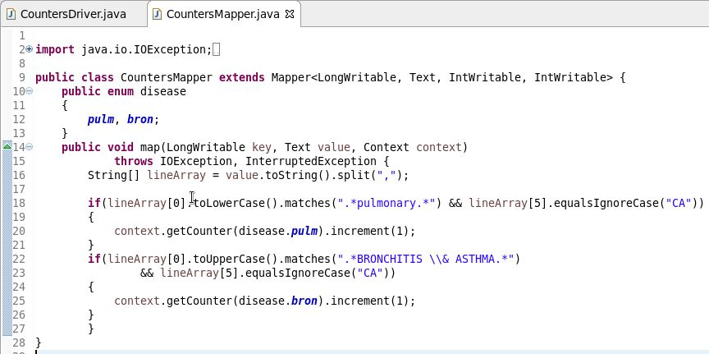

Counters are defined by a Java enum, which serves to group related counters.

Step 1: Create the ENUM for counters.

Since we are counting 2 types of diagnosis ENUM will become the group and fields will become the counters.

Step 2: Find the counters in Mapper and increase the counter

Output:

Step3:

By using the above use case we have got the details of all the types of counters discussed and refer the below screen shot for the same:

