1.Problem statement:

● Run a map only job on the word count program using static configurations

Dataset:

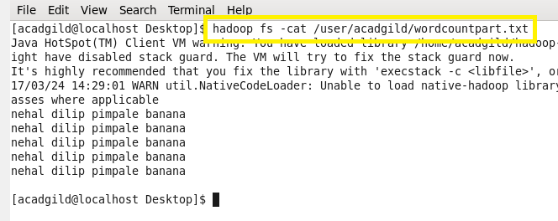

Codes:

Task class:

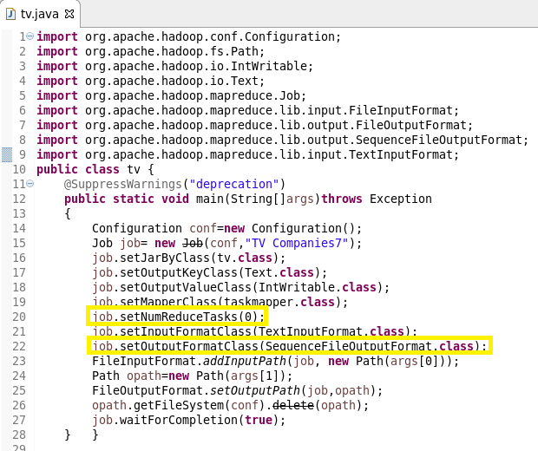

Here, we are setting NumReduceTask to ‘0’ statically. This is the static configuration.

So, no reducer will work and the output will be the map only word count.

Mapper class:

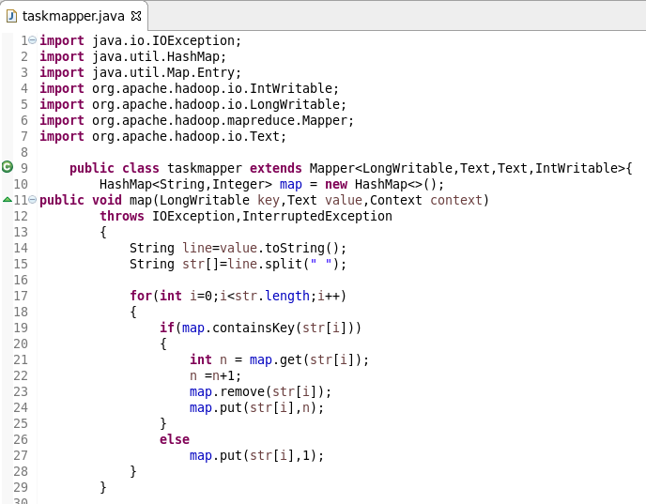

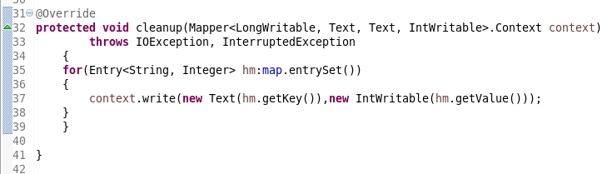

In mapper class we are adding unique keys and their respective values to a hashmap in map method. After processing all the data by map method, cleanup method is getting executed. In cleanup method, we are writing all the unique words and their occurrences into a text file with the help of context.write().

Running jar:

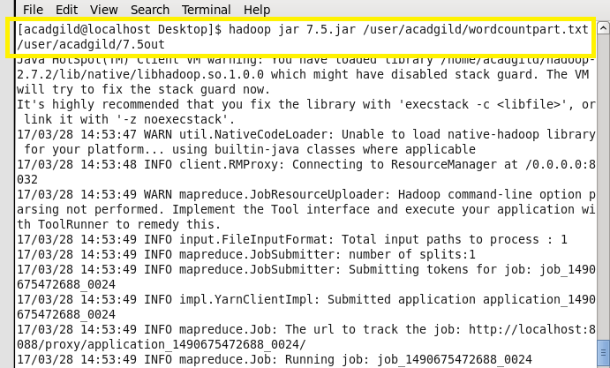

Output:

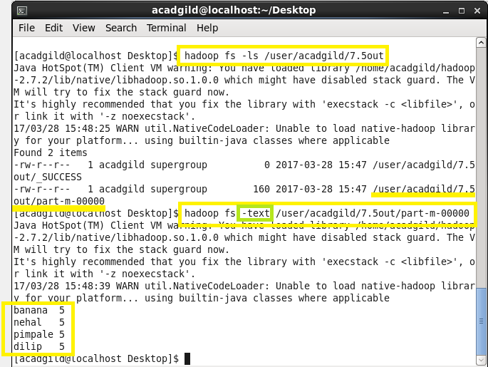

2. Problem Statement:

●Run the map reduce word count program and set the number of reducers to 2 using static configurations.

Code:

Dataset:



Task class:

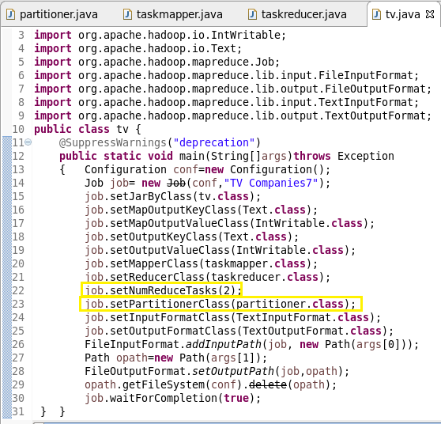

Here we are setting NumReduceTask to ‘2’. So 2 reducers will be running and the keys handled y each reducer depends on the hash code which is generated by the partitioner class.

This is the static configuration.

Partitioner class:

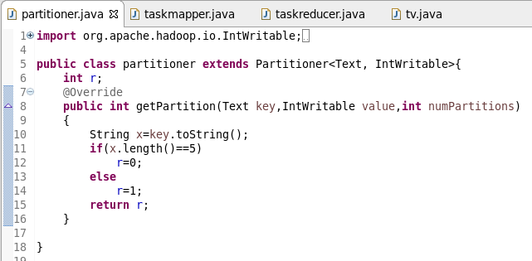

Mapper class:

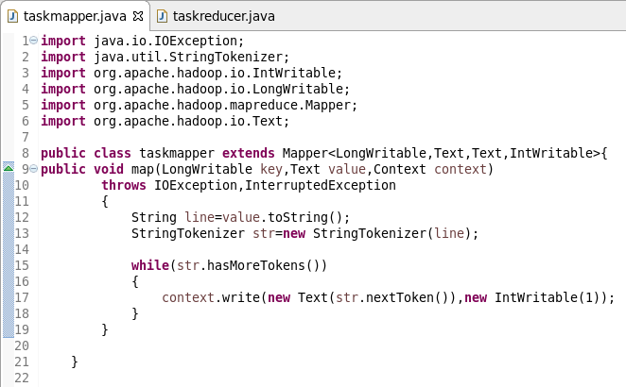

Reducer class:

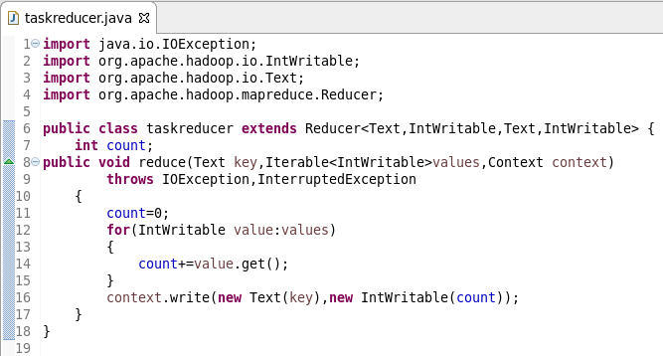

Running jar:

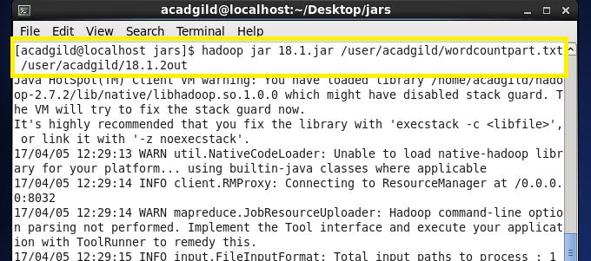

Output:

