Problem Statement:

Convert XML File into Json File Format. You can consider below example XML, save it in the hdfs cluster and then to convert into Json File Format.

Input:

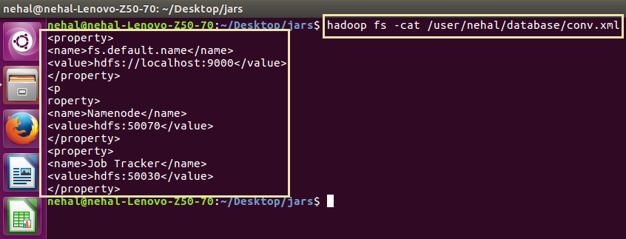

Code:

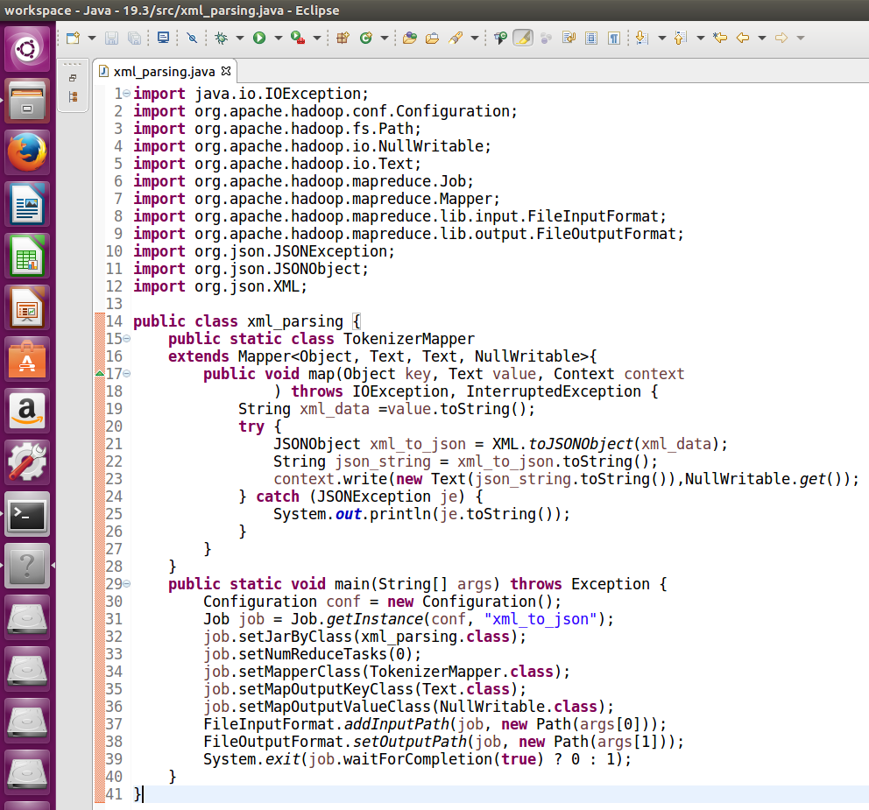

Running jar file:

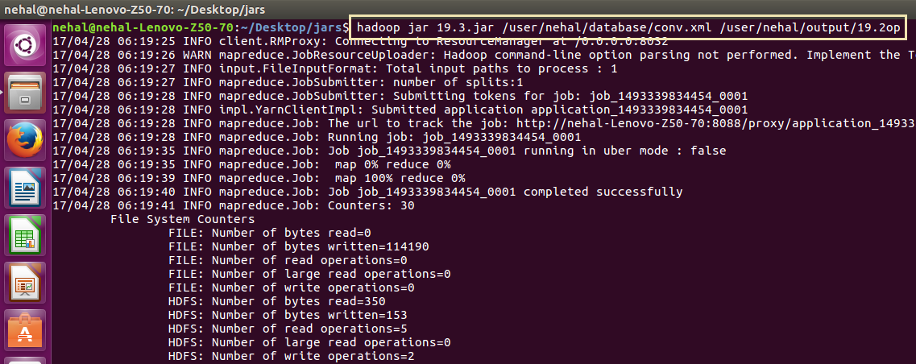

Output:

