Problem Statement:

Task 8:

Write a MapReduce program that takes the output of Task 5 (refer session 7, assignment 1) as input, and produce output which is sorted on the total units sold. You may use a single reducer for the sorting. Use Sequence File formats as output of Task 5 and as input for this task.

Input:

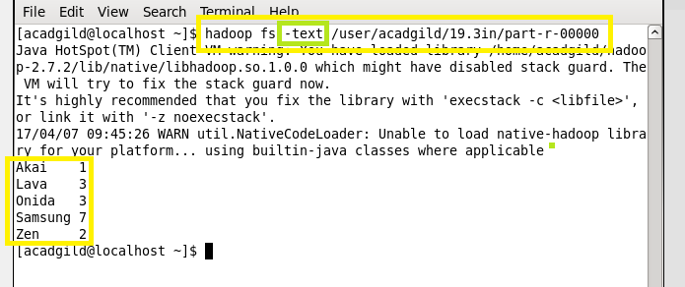

Task class:

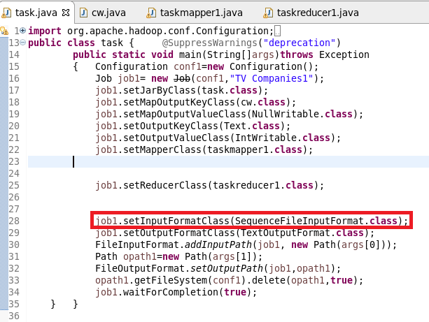

Mapper class:

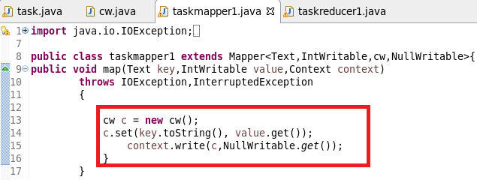

Reducer class:

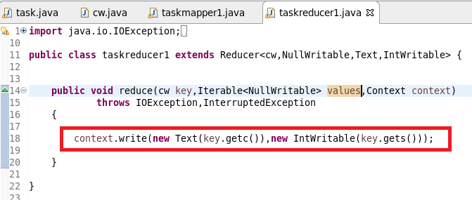

Composite key class:

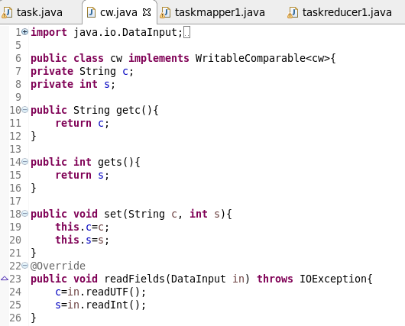

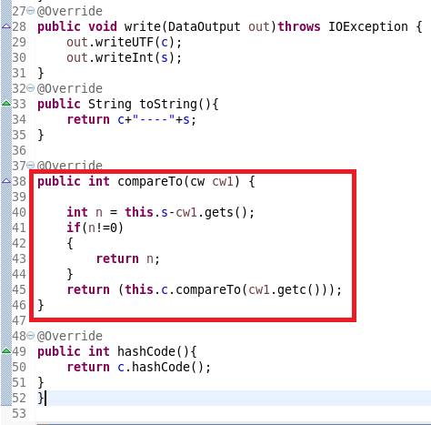

Running jar:

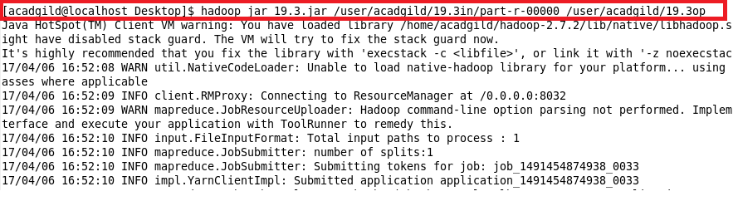

Output:

