Problem Statement

Task 9:

Enhance the MapReduce program of Task 8 (refer session 19, assignment 3) to use multiple reducers for sorting. The driver should accept three additional values: the minimum units sold, the maximum units sold and number of reducers to use.

Input:

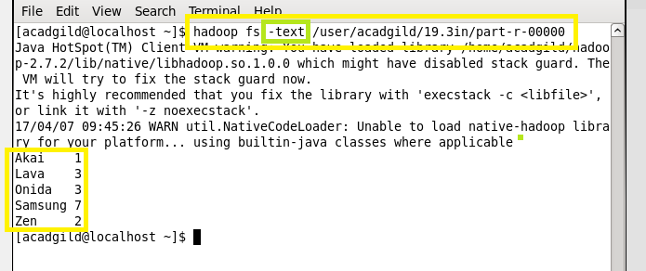

Task class:

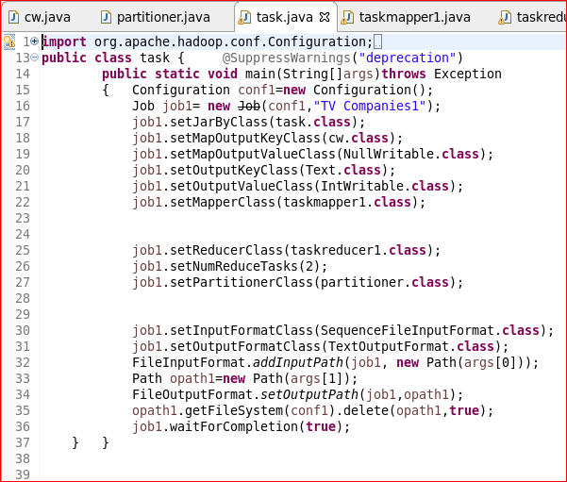

Mapper class:

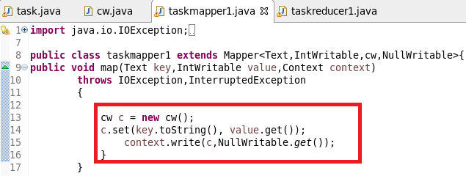

Reducer class:

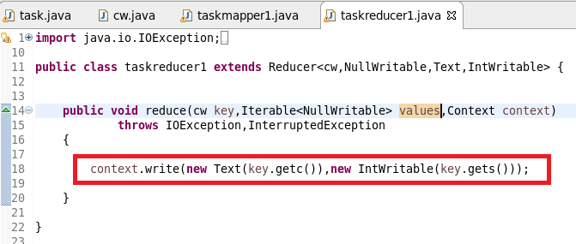

Composite key class:

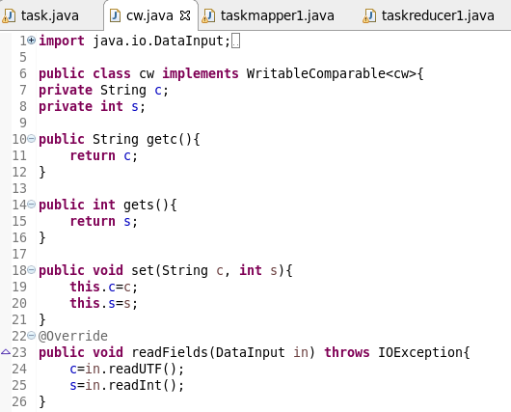

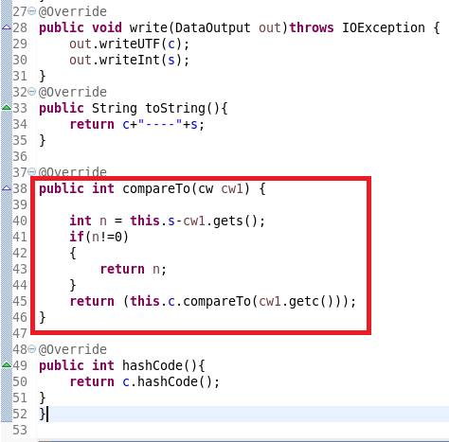

Partitioner class:

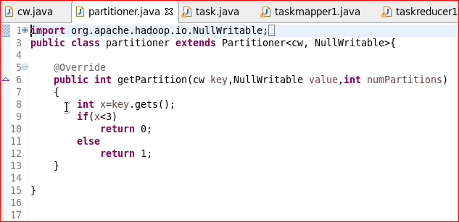

Running jar:

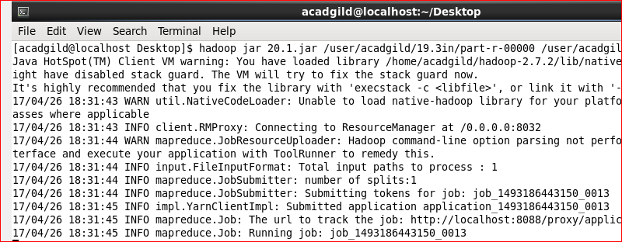

Output:

