Problem Statement:

Write a mapreduce program to use CombineFileInputFormat. Pass a directory containing multiple small files. The program should be able to pick multiple files in a single mapper.

Task class:

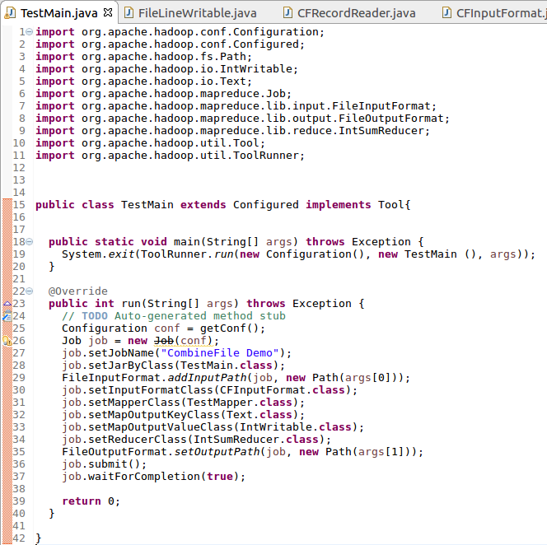

Mapper class:

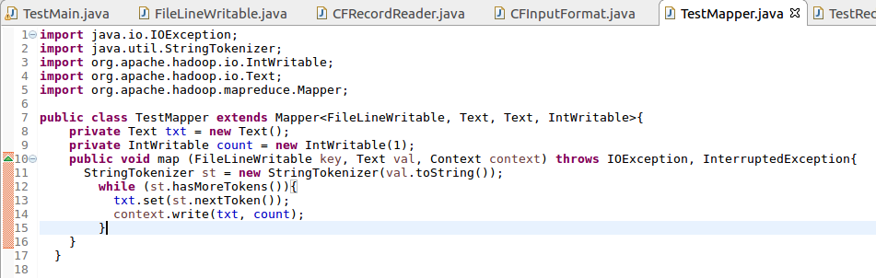

Reducer class:

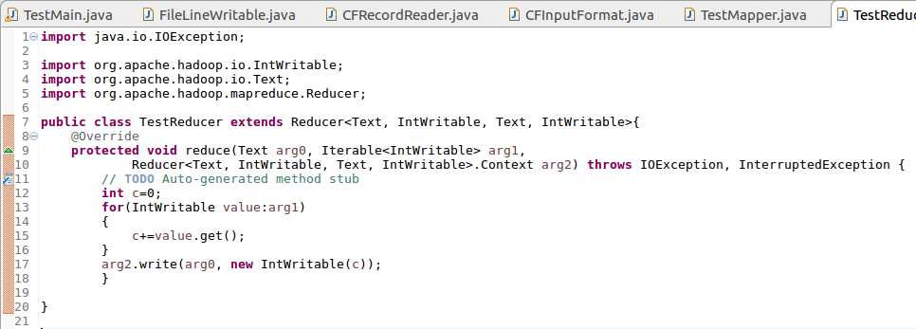

Writable comparable class:

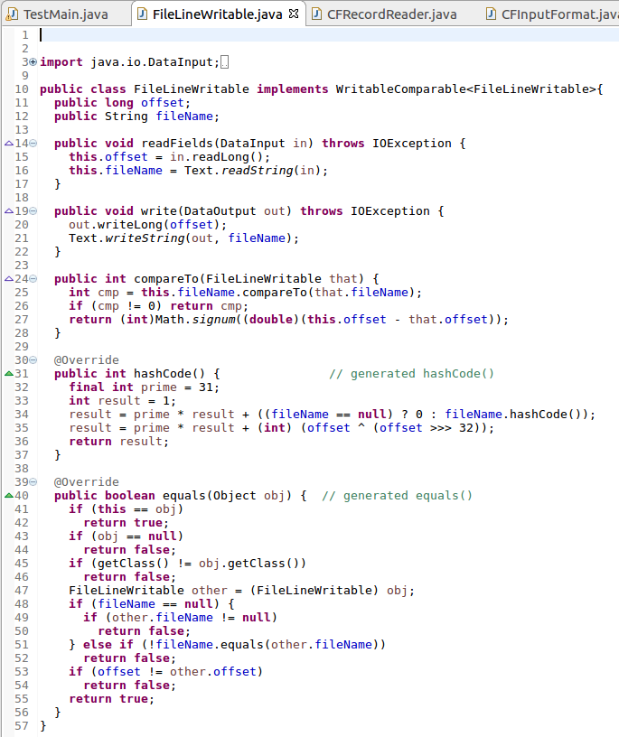

Record reader class:

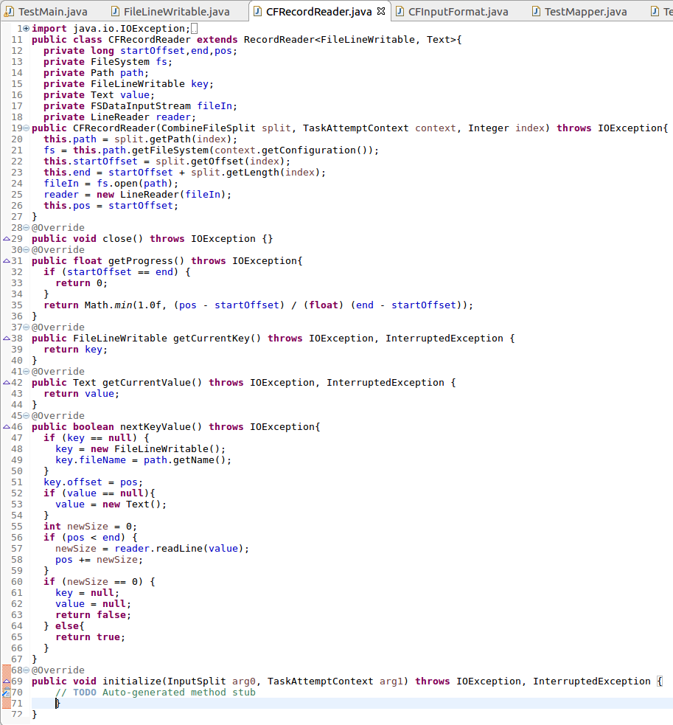

Combined file input format class:

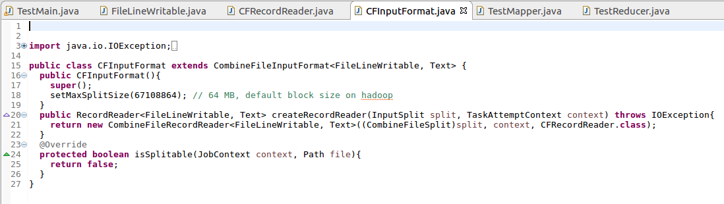

Running jar:

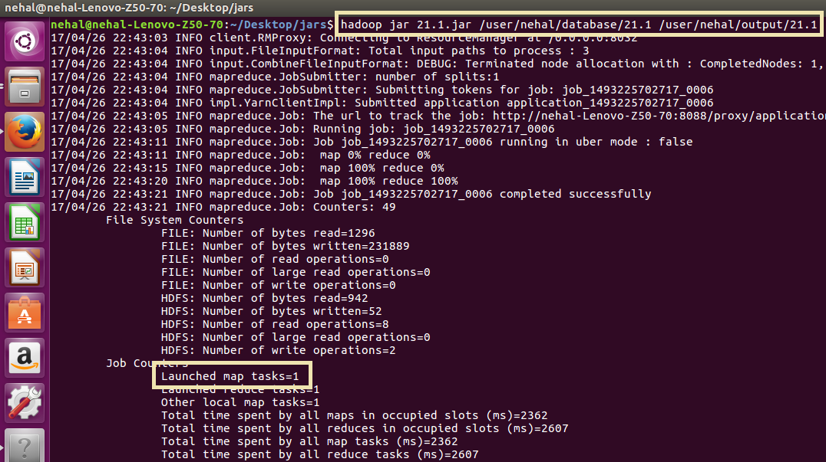

Output:

