Problem Statement:

This dataset consists of two columns i.e., first_name & last_name &city use custom input format to read the key as the combination of first_name and last_name and arrange the output of the program should be the key sorted by last_name.

Task class:

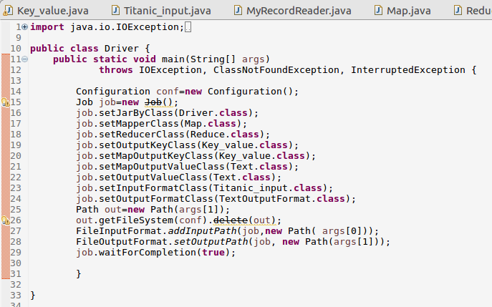

Mapper class:

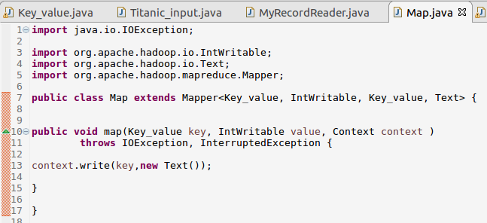

Reducer class:

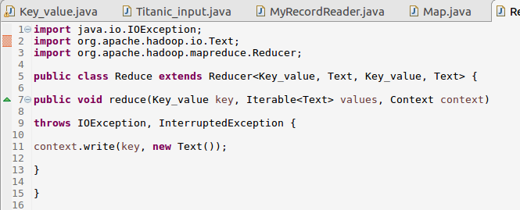

Writable comparable class: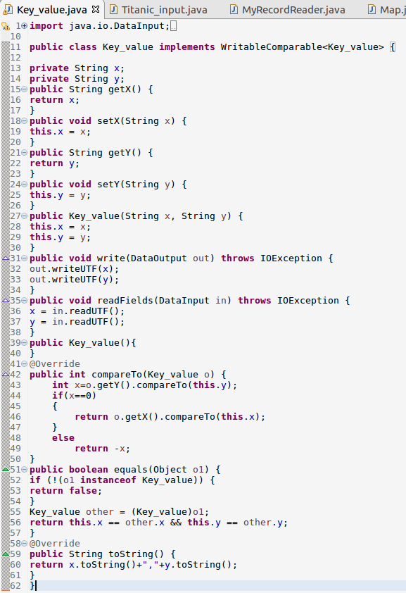

Record reader class:

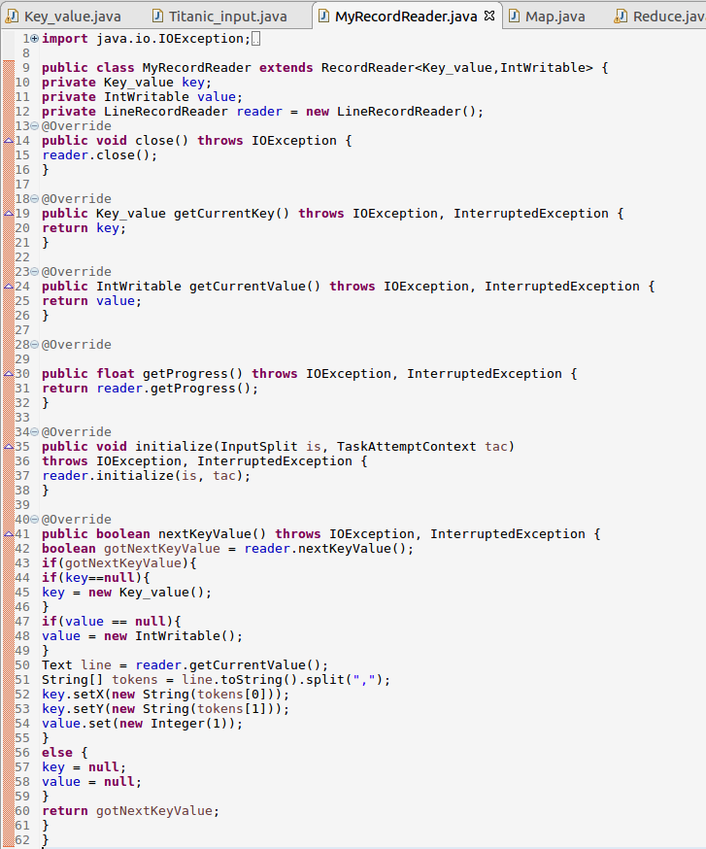

File input format class:

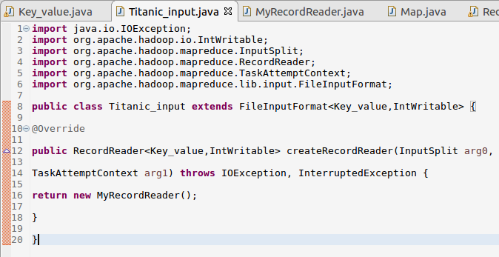

Running jar:

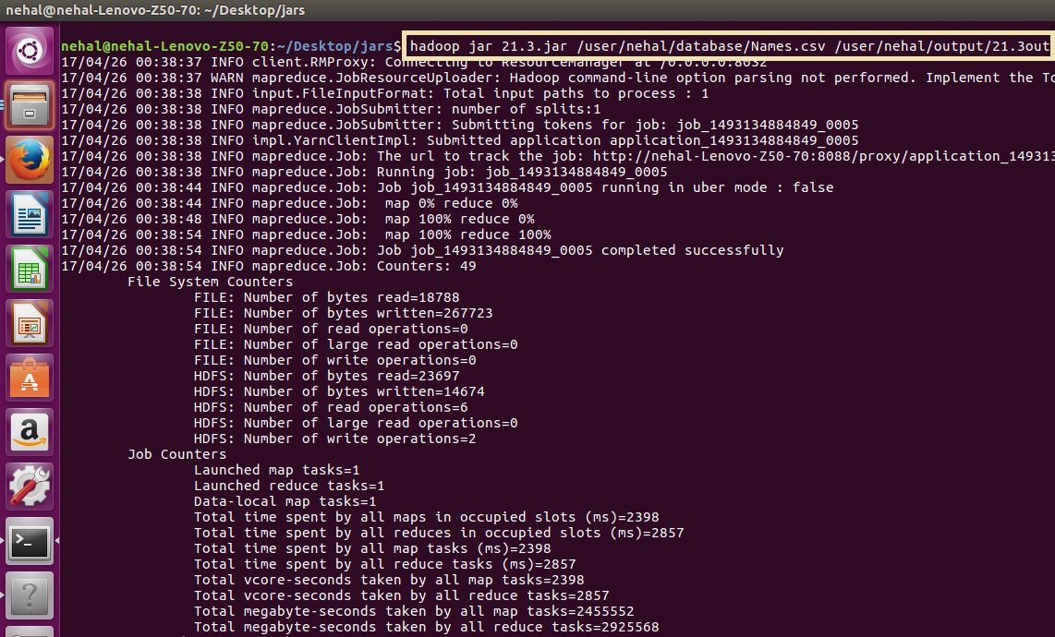

Output:

