PROBLEM STATEMENT 1

Find out what are the top 5 categories with maximum number of videos uploaded.

PROBLEM STATEMENT 2

Find the top 10 rated videos in YouTube.

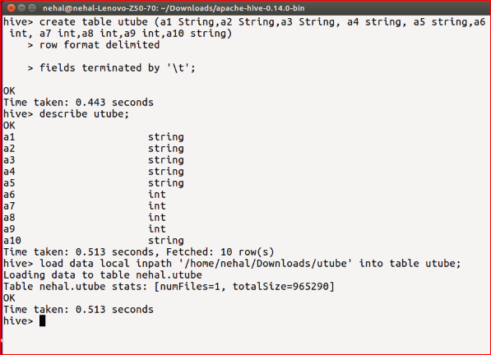

Solution 1:

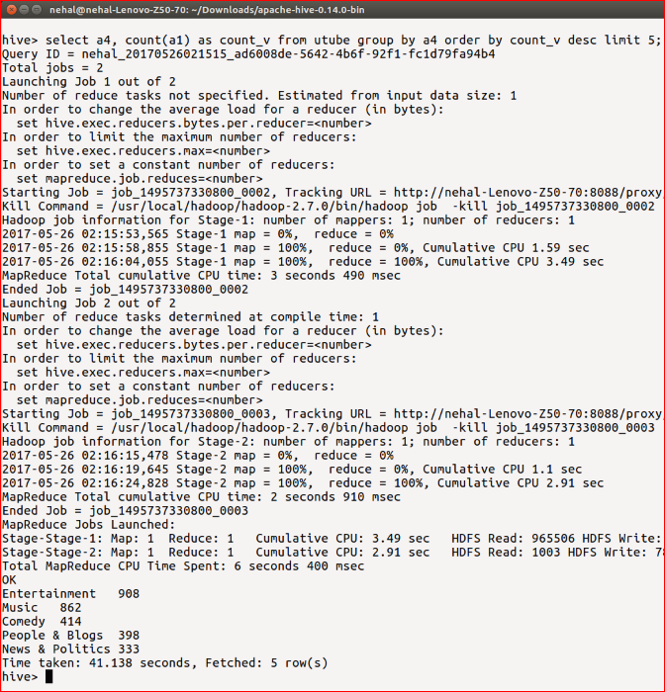

Solution 2:

