Problem Statement:

1. Write a hive query find the average age of male and female persons died in the titanic tragedy

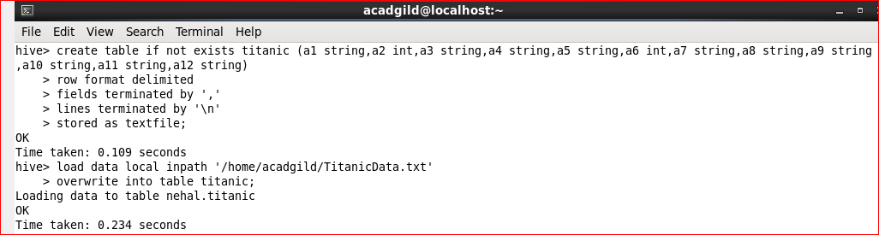

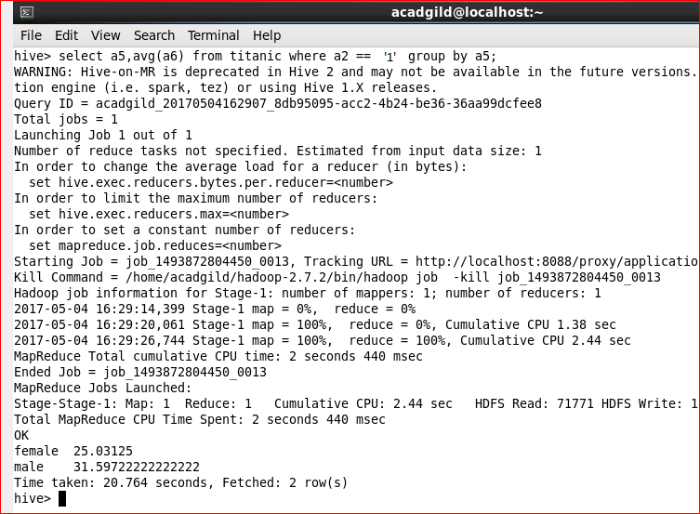

2. Write a hive query to find the number of people died and survived in each class

