Problem Statement:

Create a hive table and load the dataset into the table and evaluate the below problem statements

1. Find out the average HP (Hit points) of all the Pokémons

2. Find out the average Defense of all the pokemon

3. Find out the average Sp.Atk of all the pokemons

4. Find out the average sp.Def of all the pokemons

5. Find out the average Speed of all the pokemons

Solution:

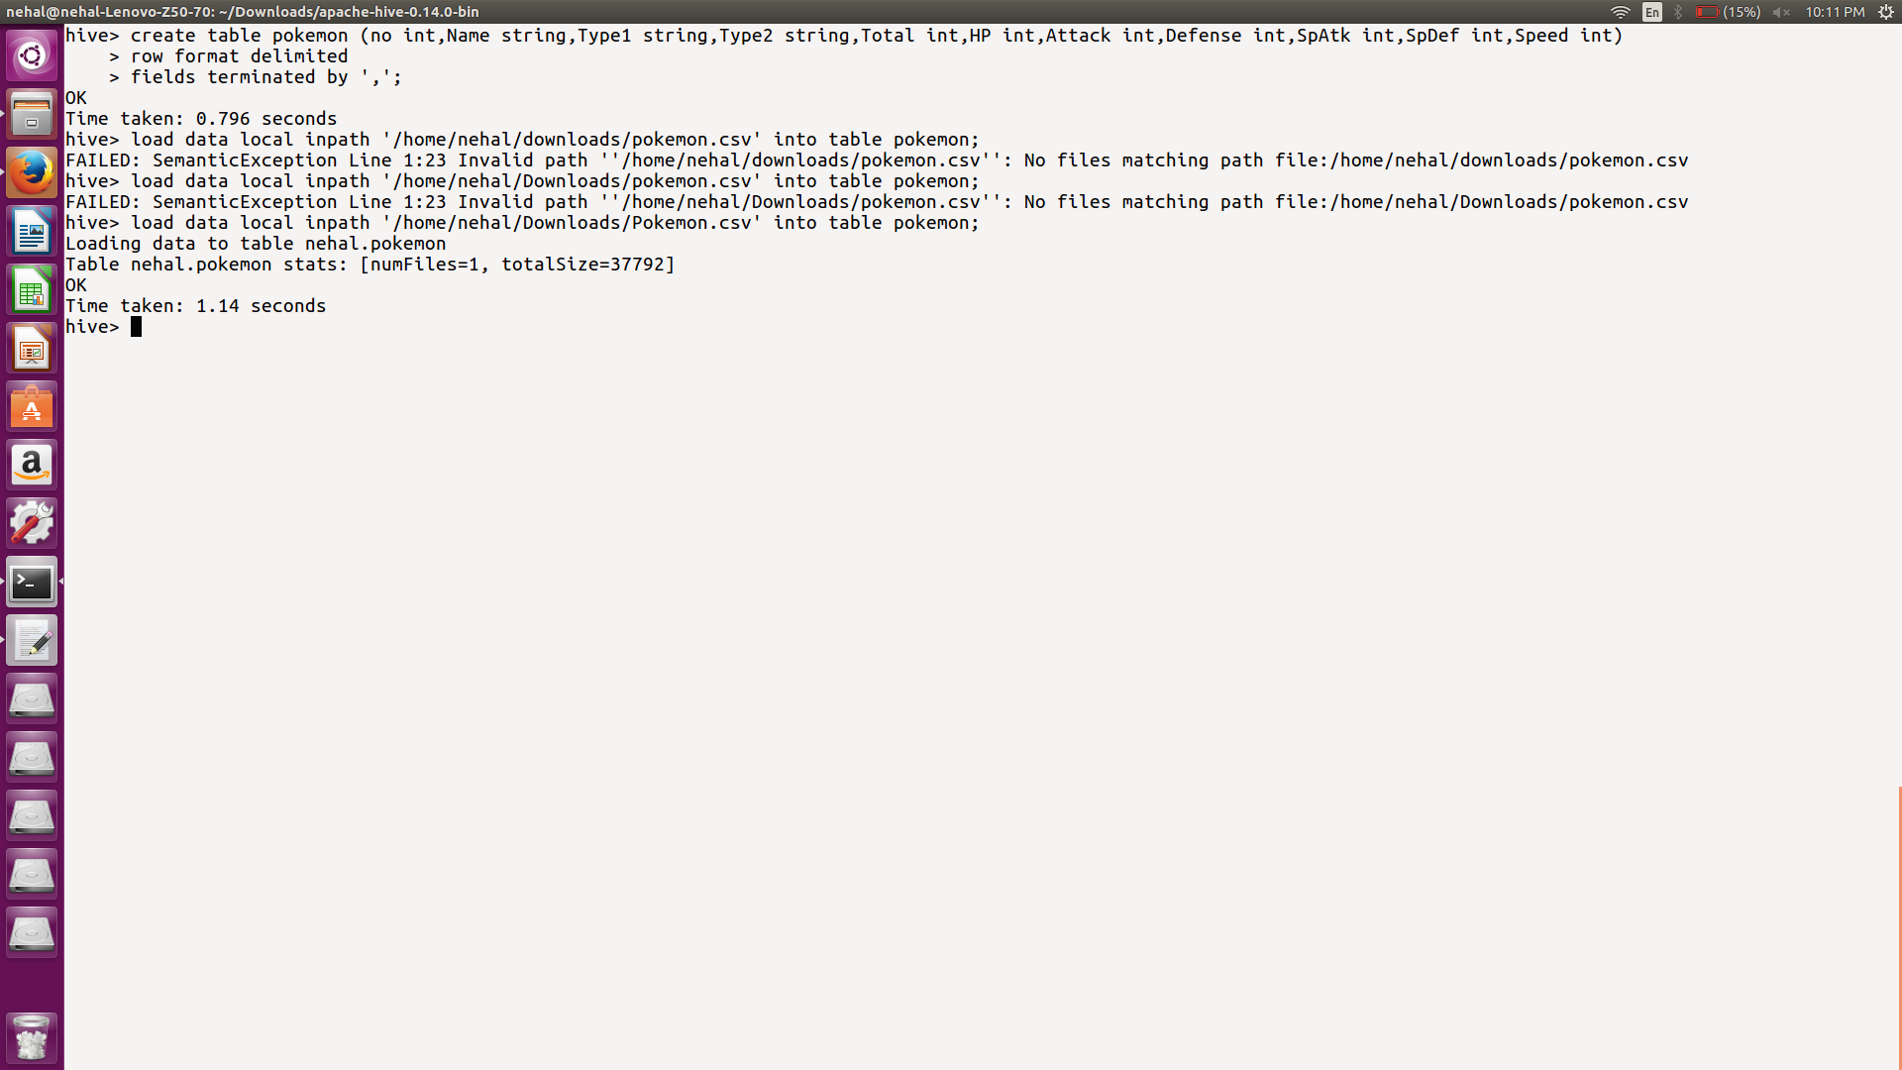

Table creation and loading data:

Solution problem 1: Find out the average HP (Hit points) of all the Pokémons

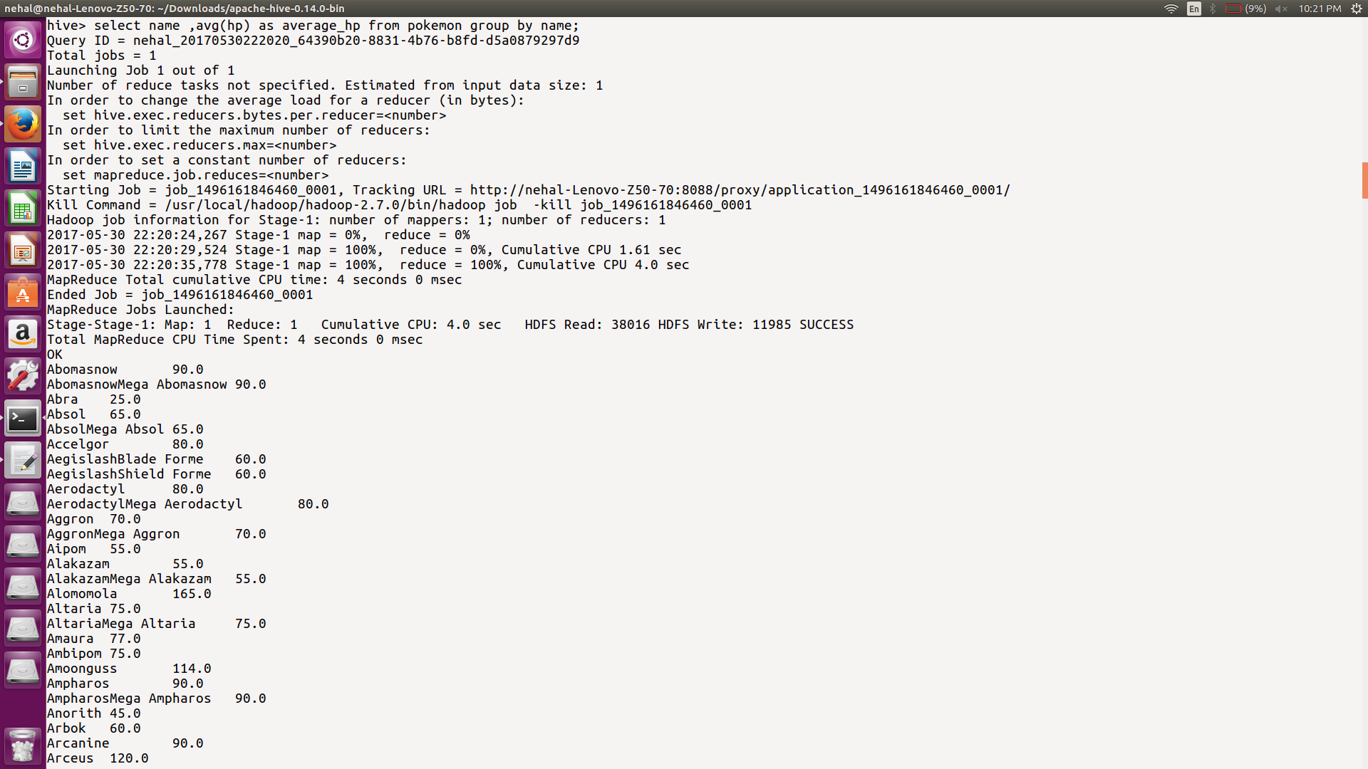



Solution problem 2: Find out the average Defense of all the pokemon

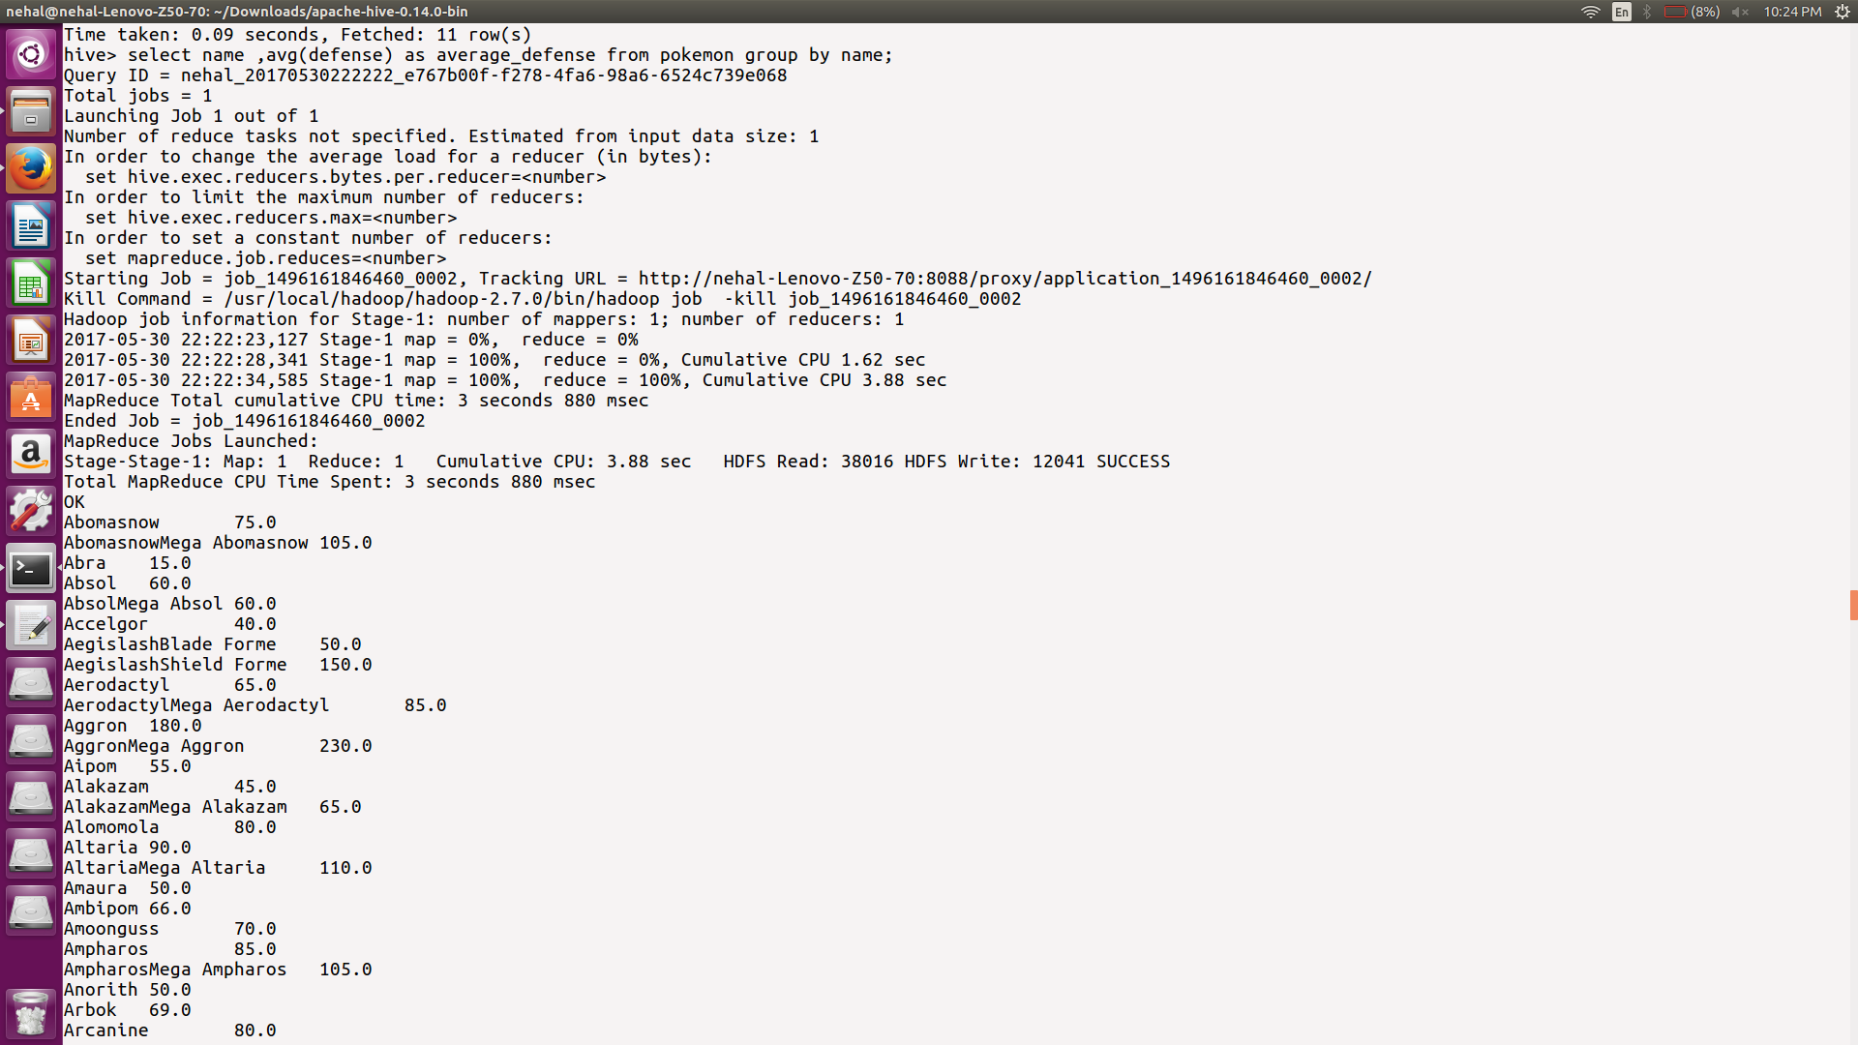



Solution problem 3: Find out the average Sp.Atk of all the pokemons

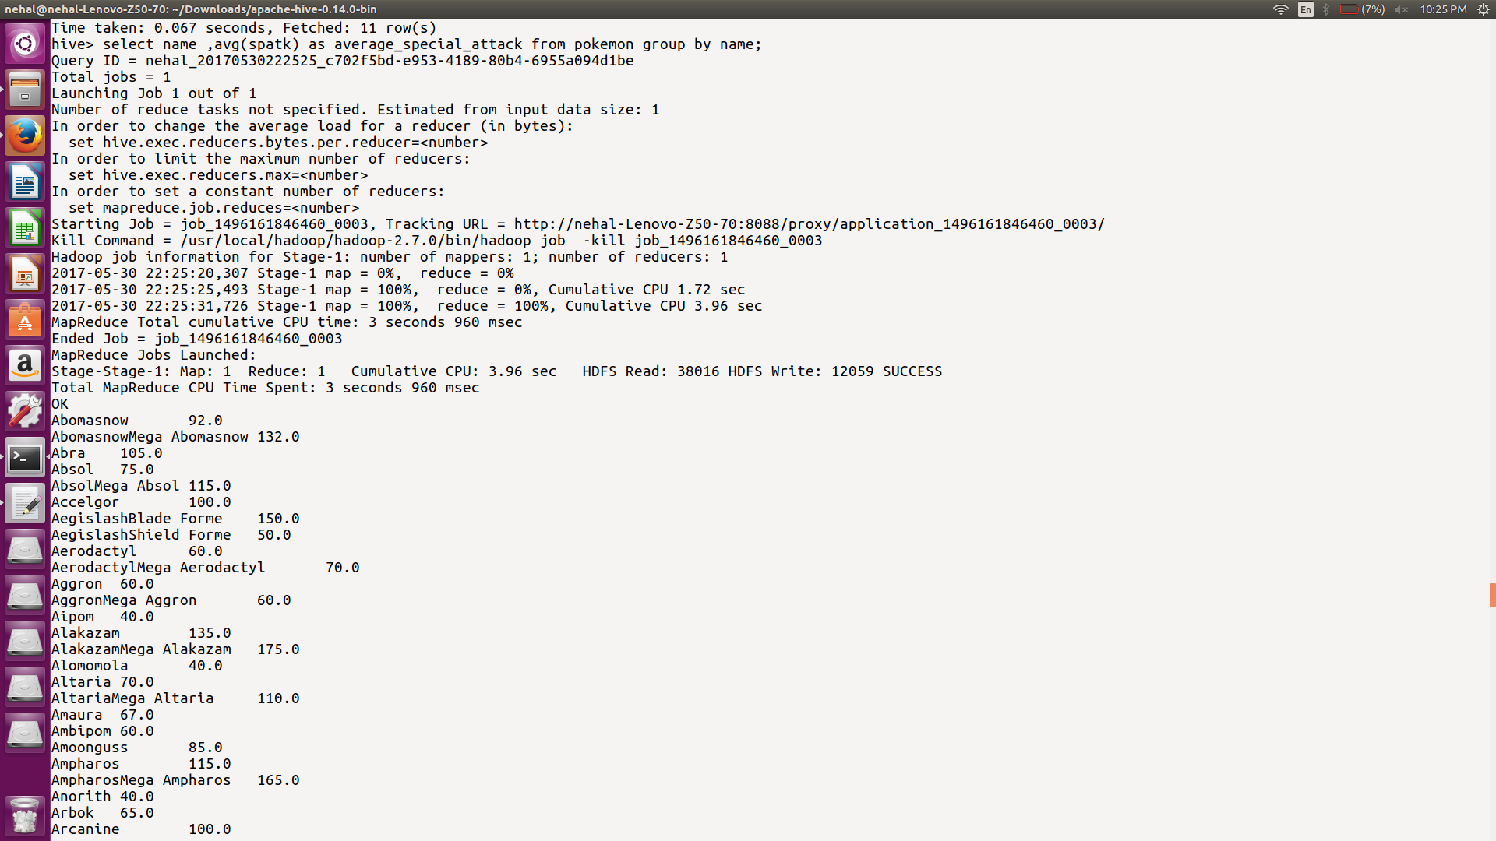



Solution problem 4: Find out the average sp.Def of all the pokemons

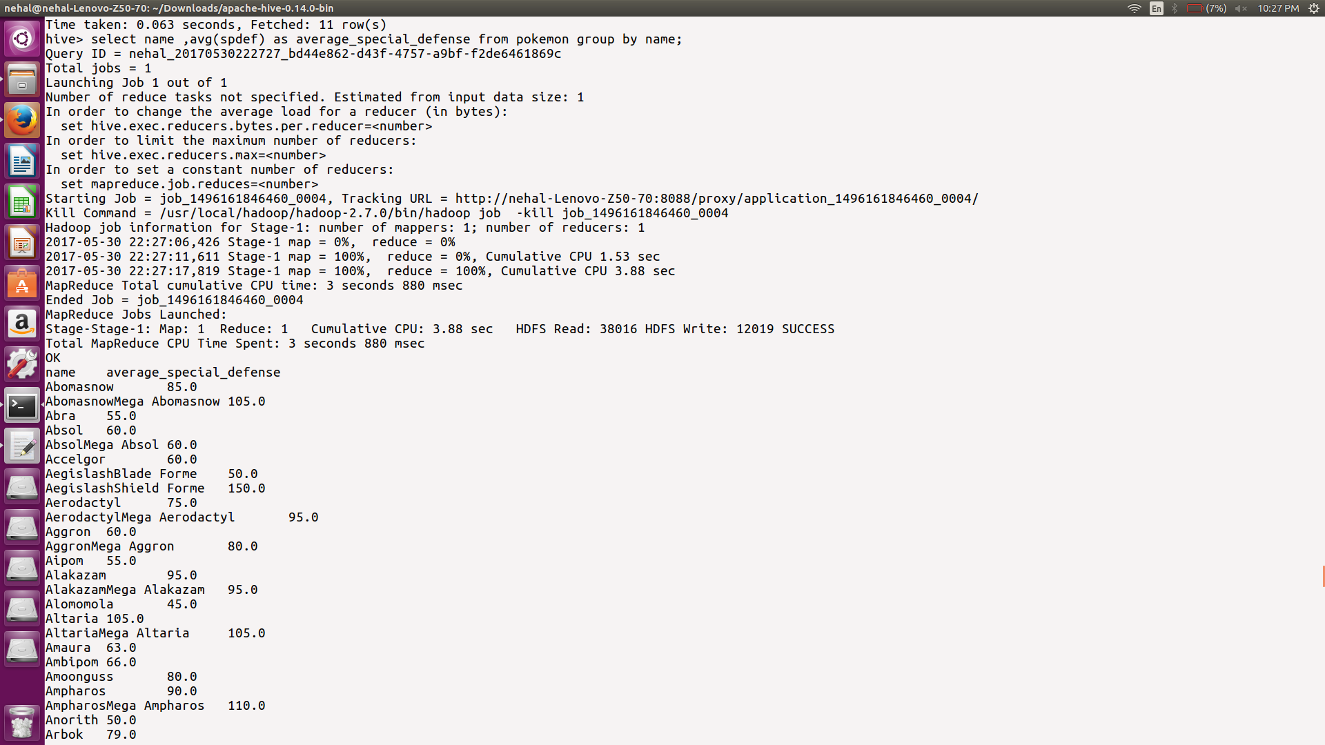



Solution problem 5: Find out the average Speed of all the pokemons

