Problem Statement:

Write a Hive program to find the number of medals won by each country in swimming.

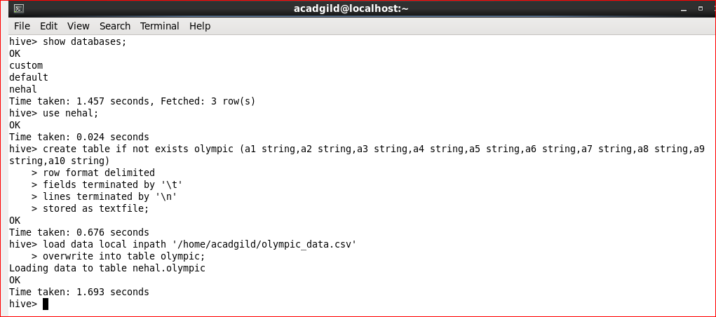

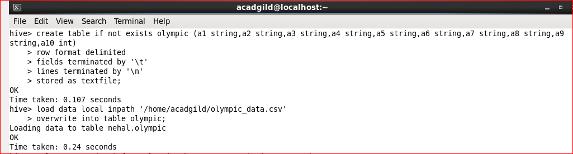

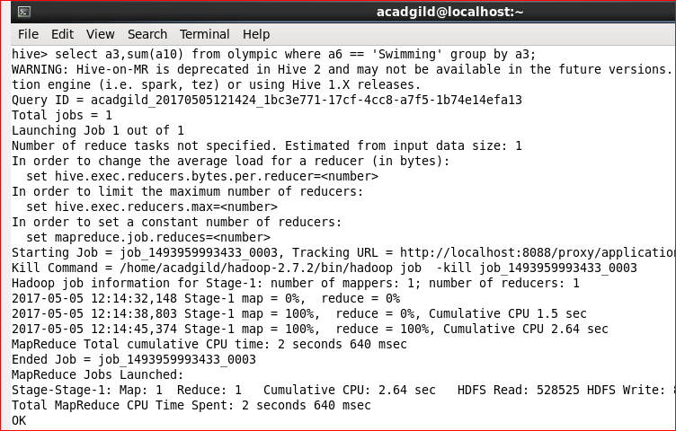

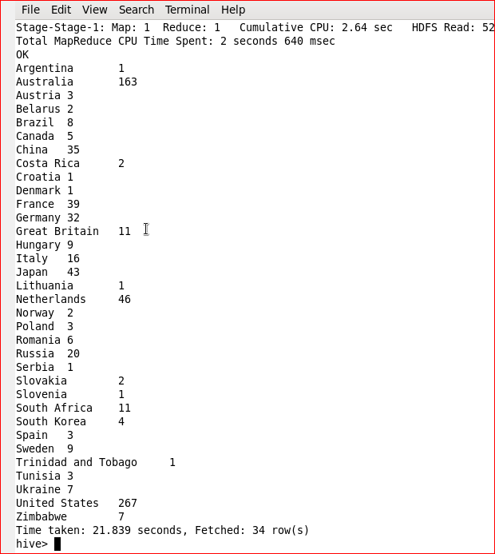

Problem Statement:

Write a Hive program to find the number of medals that India won year wise.

