Problem Statement:

Use real_estate to solve queries.

● Create table RealEstate in Hive database, with all the columns present in dataset.

● Load dataset into table realEstate.

● Using Dynamic partition get separate lists of residential apartments with more than 2 beds and include columns in following order City, Baths, Sq_feet, Price, flat_type, Beds respectively.

1. creating table realestate and loading whole data into the table:

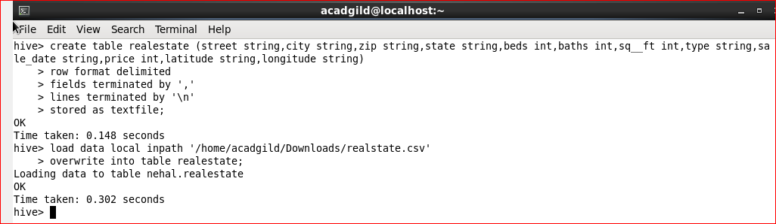

Using dynamic partitioning:

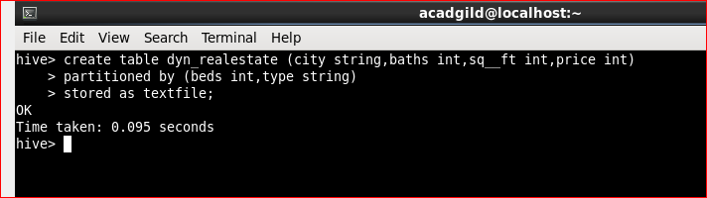

Inserting data into the partitioned table from main table:

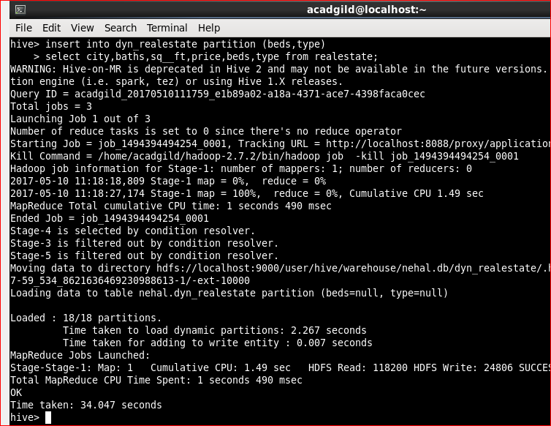

Selecting data from table:

