Problem Statement:

Implement view in hive.

First we created table temperature_data and loaded data into it.

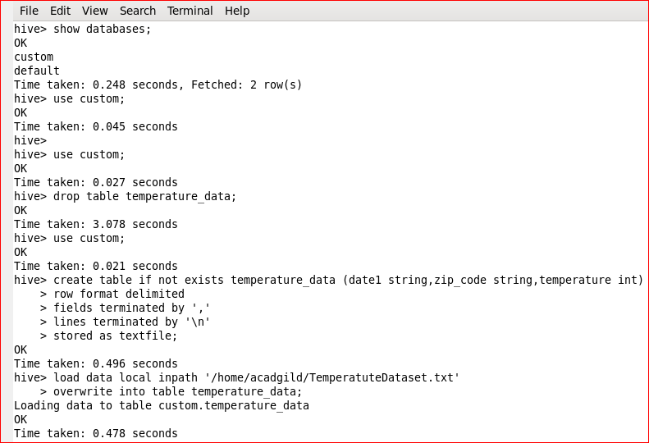

Created view on table temperature_data to find out maximum temperature year-wise.

