Problem Statement:

Run parallel jobs in hive by following the steps in the below blog link

<https://acadgild.com/blog/hive-parallel-jobs/>

Solution:

Hive sometimes can take lot of time to complete a job.   
  
The jobs may have many different stages to get completed. By default, Hive executes these stages one at a time.   
Different stages may include a Map stage, Reduce stage, a sampling stage, a merge stage, a limit stage, or other possible tasks Hive needs to do.  
  
A particular job may consist of some stages that are not dependent on each other and could be executed in parallel, possibly allowing the overall job to complete more quickly.

Hive can converts a query into one or more stages and to save time executes multiple jobs parallely.

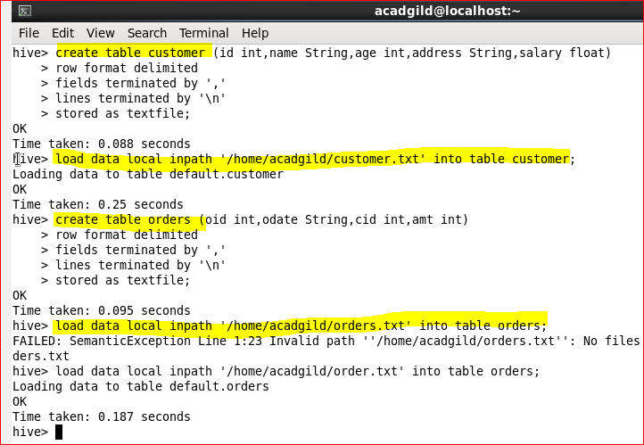

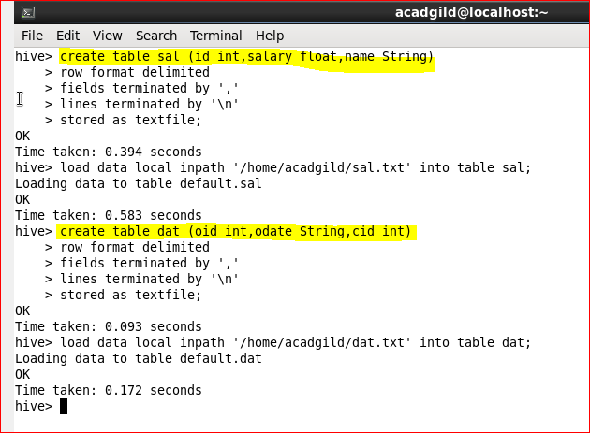

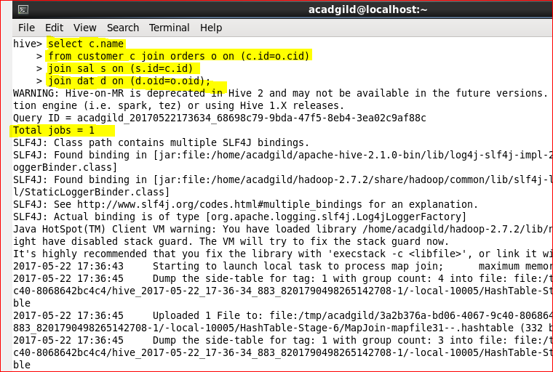

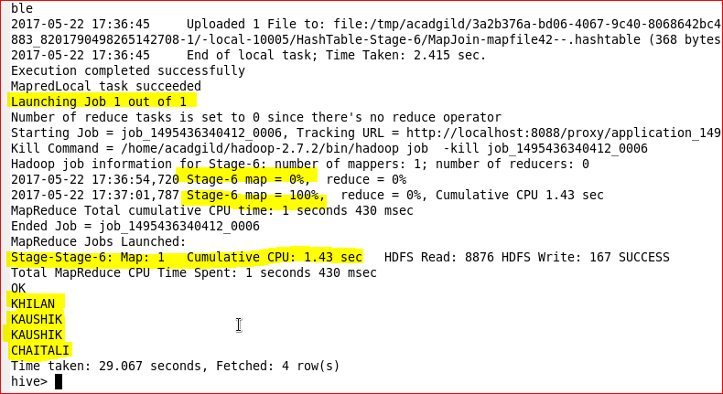

If the query is optimized and more stages are run simultaneously, the job may complete much faster.   
However, if a job is running more stages in parallel, it will increase its cluster utilization.

