Problem Statement:

Write a hive UDF that implements functionality of string concat_ws (string SEP, array). This UDF will accept two arguments, one string and one array of string. It will return a single string where all the elements of the array are separated by the SEP.

UDF class:

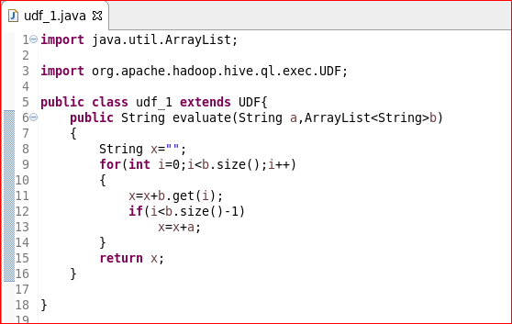

Adding jar:

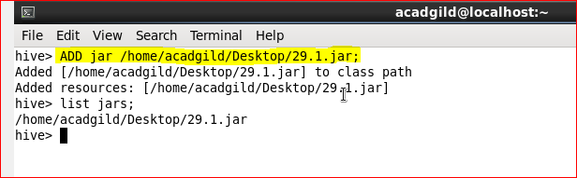

Creating table and loading data into the table:

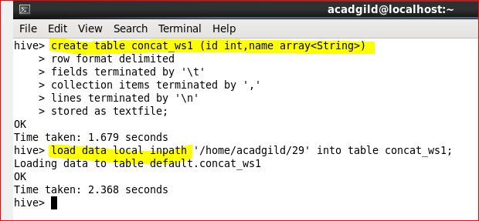

Creating temporary function and using that UDF:

